

**Department of Computing**

**Algorithms and Data Structures**

**(55-508810-AF-202324)**

**Name: Jordan Hanson**

**Student ID: c2030270**

**Table of Contents**

1. Project 1 4

1.1 Computational Complexity 4

1.1.1 Justification using mathematical notation. 5

1.1.2 Proof using the formal definition of Big-O 8

1.1.3 Concluding statement. 9

1.2 Incorporation of formative feedback 9

2. Project 2 10

2.1 Algorithms in an Algorithmic Language, such as ADL 10

2.2 Data Structures 14

2.3 Software and its Presentation, including testing (and video link) 19

2.4 Descriptive Report, including artefacts. 19

2.4.1 Transitioning algorithms to implementation 19

2.4.2 Problem-solving strategy 19

2.5 Incorporation of formative feedback 19

3. Project 3 20

3.1 Algorithms in an Algorithmic Language, such as ADL 20

3.2 Data Structures 20

3.3 Software and its Presentation, including testing (and video link) 21

3.4 Descriptive Report, including artefacts. 21

3.4.1 Transitioning algorithms to implementation 21

3.4.2 Problem-solving strategy 21

3.5 Incorporation of formative feedback 21

4. Project 4 22

4.1 Introduction 22

4.1.1 Bubble Sort and Quick Sort 22

4.2 Data Structures 30

4.1.1 Bubble Sort 31

4.2.2 Quick Sort 31

4.3 Implementation 32

4.4 Results 38

4.5 Testing 49

4.6 Software and its Presentation, including testing (and video link) 72

4.7 Incorporation of formative feedback 72

5. Project 5 73

5.1 Introduction to the Problem 73

5.2 Solution Representation and Data Structures 74

5.3 Heuristic Search 77

5.3.1 Random Restart Hill Climbing 77

5.3.2 Small Change Strategy 80

5.4 Incorporation of formative feedback 82

6. Project 6 83

6.1 Experiment Results 83

6.2 Discussion 84

6.3 Testing 91

6.4 Software and its Presentation, including testing (and video link) 91

6.5 Incorporation of formative feedback 91

References: 91

# 1. Project 1

## 1.1 Computational Complexity

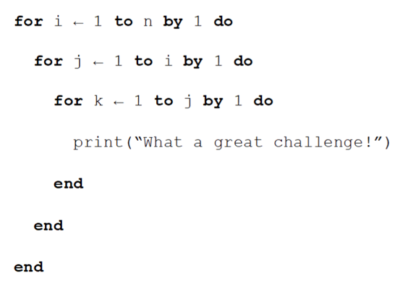

The above algorithm consists of nested for loops and its time complexity depends on the number of times each statement runs. All the for loops within this algorithm are dependent on the input ‘n’ which means we cannot possibly have a constant time complexity, but we do not know the final complexity just yet.

However, these loops are all nested and not independent of one another, i runs n times, j runs i times, and k runs j times, all of them ending in a print statement. The print statement has a complexity of $O(1)$ as it relies on no input, and the nested loops all run n times, resulting in an equation where we can work out an equation for the Big O complexity of the algorithm.

$O(n)×O(n)×O(n)× O(1)$ $≡ O\left(n^{3}\right)×O(1)$ $≡ {O(n}^{3}$)

However, this equation has mainly be done intuitively and from first glance at the algorithm given, but I also want to justify the algorithmic complexity here, and this can be done using mathematical notation.

This is because the above algorithm consists of nested for loops and each for loop is dependent on a term (i, j, k) and increments by 1 for each pass of the statement. For example, our outermost for loop runs n times. We can write out how the loop increments like this:

$$i=1+2+3+…+\left(n-2\right)+\left(n-1\right)+n$$

The nested for loops also follow this, the first inner loop iterates i times:

$$j=1+2+3+…+\left(i-2\right)+\left(i-1\right)+i$$

And the final loop iterates j times:

$$k=1+2+3+…+\left(j-2\right)+\left(j-1\right)+j$$

Now that we can see how each loop iterates and increments, we can see that these loops are part of an arithmetic series. This mean that we can express them in the form of a summation whereby we can write them in a compact form using sigma notation.

### 1.1.1 Justification using mathematical notation.

### 

We can start by defining our algorithm as a function, $T(n)$ where $n$ is some measure of the size of the input problem e.g. $n$ may be the number of entires in a database application, or in a numerical context, $n$ may be the number of digits in an inputted number. The output of this algorithm is the (worst-case) running time for an input of size $n$.

$$T\left(n\right)=runtime$$

Due to the fact we noticed that each loop can be written as an arithmetic series, the function can be represented with multiple summations, like this:

$$T\left(n\right)=\sum_{i=1}^{n}{\sum_{j=1}^{i}{\sum_{k=1}^{j}{c}}}$$

Where $c$ is our constant, or in the case of the algorithm, our $O(1)$ statement which is the print command. This will have no impact on the overall complexity of the algorithm.

To start finding the complexity of our algorithm, we must start from the most inner summation:

$$\sum_{k=1}^{j}{c}$$

However, since our summation does not contain our index $k$, we must rewrite our summation to represent this. The sum of any constant C is equivalent to the upper bound multiplied by the summand. In our case, our upper bound is j and our summand/constant is c.

To further explain this, we can say that our summation:

$$\sum_{k=1}^{j}{c}$$

Could also be written as an expression where we factor out the constant:

$$c×\sum_{k=1}^{j}{j}$$

As such here we can say that the sum of j 1’s is simply just j, so our expression for the summation of the final for loop is just simply:

$$cj$$

Now we can finally rewrite our original summation, and this leaves us with:

$$T\left(n\right)= \sum_{i=1}^{n}{\sum_{j=1}^{i}{cj}}$$

From here, we must start with our innermost summation once again.

$$\sum_{j=1}^{i}{cj}$$

Now we have our lower bound included in the index. We can now work with this and use a formula. We can factor out our constant $c$ which leaves us with just an arithmetic sum. This sum can be represented using Gauss’ formula for the sum of the first n positive integers.

$$\sum_{k=1}^{n}{k}= \frac{n(n+1)}{2}$$

However, in our case the upper bound is $i$ and we are using $j$ in the place of $k$ since we factored out our constant $c$. This can be rewritten as:

$$\sum_{j=1}^{i}{j}= \frac{i(i+1)}{2}$$

And plugged into our original summations, it now looks like:

$$T\left(n\right)= \sum_{i=1}^{n}{c×\frac{i(i+1)}{2}}$$

We can simplify this to expand the brackets and make it easier to work with:

$$T\left(n\right)= \sum_{i=1}^{n}{\frac{c}{2}(i^{2}+i)}$$

Now we can work with this much easier by factoring out our constant $\frac{c}{2}$ and expanding the brackets into separate summations, leaving us with:

$$T(n)= \frac{c}{2}\left[\sum_{i=1}^{n}{i^{2}}+\sum_{i=1}^{n}{i}\right]$$

Once again, we can use Gauss’ formulas for the sum of the first $n$ positive integers, but this time we also need to use the formula for the sum of the squares of the first $n$ positive integers.

$$\sum_{i=1}^{n}{i}= \frac{n(n+1)}{2}$$

$$\sum_{i=1}^{n}{i^{2}}= \frac{n(n+1)(2n+1)}{6}$$

Substituting these into our problem, our function for the runtime now looks like:

$$T\left(n\right)= \frac{c}{2}\left[\frac{n(n+1)(2n+1)}{6}+\frac{n(n+1)}{2}\right]$$

This is now a closed form expression which means there is no longer any summations to deal with and we can now work out the complexity of our algorithm using basic operations. However, I want to simplify our expression so that the answer is clearer, and the complexity is easier to derive. To do this I will ignore the constant and begin to expand out our brackets and multiply the secondary fraction by a factor of 3 to be able to add them together. After all the simplification is done with terms in the square bracket, our expression now looks like:

$$T\left(n\right)= \frac{c}{2}\left[\frac{2n^{3}+6n^{2}+4n}{6}\right]$$

When calculating and writing Big-O Complexity of an algorithm, we need to look for the fastest-growing term as the input grows larger and larger, and as such we ignore any coefficients or constants within the equation as they will have little impact. This is because Big-O is a measure of an algorithms worst-case complexity and that is why the dominant term, or term with the most impact, is the most important.

Looking at the expression, I can see that the dominant term for this expression is ${2n}^{3}$ as this is the part that will have the most impact on the runtime of our algorithm as our input $n$ increases. This also means that we will consider all other terms to be insignificant as their impact on the rate of growth is less than that of ${2n}^{3},$ regardless of coefficients.

To further showcase and prove the choice of dominant term in the expression, here are some test values inputted into the individual terms, without coefficients or constants, to showcase the rate of growth of each one individually.

|  |  |  |  |
| --- | --- | --- | --- |
| **Input ($n$)** | $$n^{3}$$ | $$n^{2}$$ | $$n$$ |
| 1 | 1 | 1 | 1 |
| 2 | 8 | 4 | 2 |
| 3 | 27 | 9 | 3 |
| 4 | 64 | 16 | 4 |
| 5 | 125 | 25 | 5 |
| 10 | 1000 | 100 | 10 |
| 50 | 125000 | 2500 | 50 |
| 100 | 1000000 | 10000 | 100 |
| 1000 | 1000000000 | 1000000 | 1000 |

Additionally, we can also represent our expressions via graphing their equations.

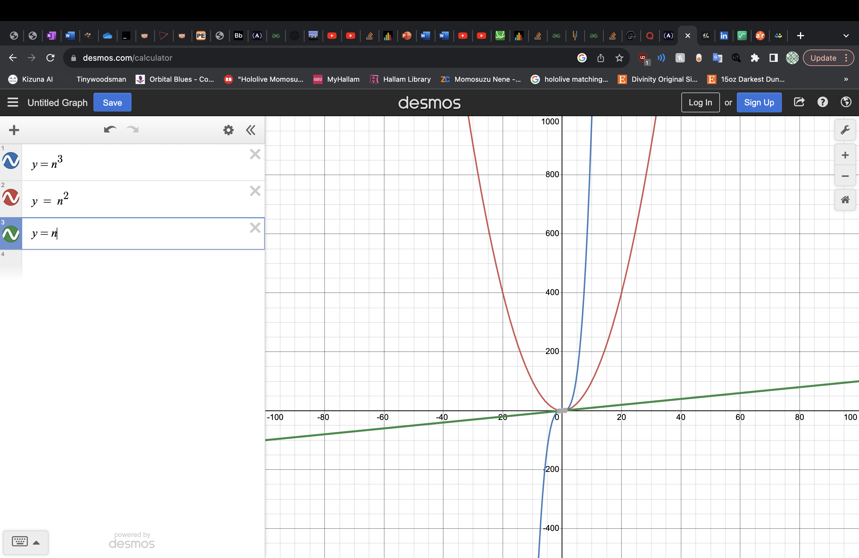

Here we can see that as our input value $n$ grows larger and large, tending towards infinity, $n^{3}$ grows much faster than either of the other two terms, and as such it must be the dominant term in our expression.

From this we can conclude our findings, as we have found the complexity of our algorithm. For our original algorithm, a series of nested for loops with a print statement, written in ADL, ultimately has a Big-O complexity of $O(n^{3})$

### 1.1.2 Proof using the formal definition of Big-O

If we want to look at proving the statement from a different perspective, then we can look at showing that $\frac{{2n}^{3}+{6n}^{2}+4n}{6}$ belongs to $O(n^{3})$ using the formal definition of Big-O notation.

The formal definition for Big-O notation is:

$f\left(n\right)=O\left(g\left(n\right)\right)$ if there exists such positive constants $c, k$ such that:

$f\left(n\right)≤cg(n)$ for all $n≥k$ where $k$ is an integer value

And where $f$ and $n$ are functions that only take integer arguments.

So, if we want to show that our expression has a complexity of $O(n^{3})$ we must show that:

$$\frac{{2n}^{3}+{6n}^{2}+4n}{6} ≤cn^{3}$$

This is because we want to find a function g(n) that is bigger than our function f(n) and the best way to do this is to express our new equation in terms of only $n^{3}$. So, we can write our expression like this:

$$\frac{{2n}^{3}+{6n}^{2}+4n}{6} ≤ \frac{{2n}^{3}+{6n}^{3}+4n^{3}}{6}$$

However, we must also show the values for which this is true for. If we substitute $n=0$ into the equation then our expression is not valid since it does not make sense to have a computational complexity of 0, as well as the formal definition requiring a positive constant. However, if we substitute $n=1$ into the equation then it becomes a valid statement. From here we can say that our expression:

$$\frac{{2n}^{3}+{6n}^{2}+4n}{6} ≤ \frac{{2n}^{3}+{6n}^{3}+4n^{3}}{6}$$

Is true for all $n ≥1$ ($k=1$)

Now that we have our new inequality, we can combine like terms to give us a new expression:

$$\frac{{2n}^{3}+{6n}^{2}+4n}{6} ≤ \frac{{12n}^{3}}{6}$$

Or:

$${12n}^{3}+3{6n}^{2}+24n ≤ {72n}^{3}$$

Or, simplified further:

$$n^{3}+3n^{2}+2n ≤ {6n}^{3}$$

Where 6 is our constant $c$

With this information we can prove our function belongs to Big-O notation using the formal definition.

$$\frac{{2n}^{3}+{6n}^{2}+4n}{6}=O\left(n^{3}\right)$$

Where $n≥1$

And $c$ = 6

### 1.1.3 Concluding statement.

Regardless of whether we take a Top-down or bottom-up approach to justifying the reasoning behind the claim that the algorithm given has a certain Big-O complexity, both approaches to the question result in the same answer. The computational complexity for the given algorithm, written in ADL, is $O(n^{3})$ whereby $n$ is some input value.

## 1.2 Incorporation of formative feedback

|  |  |  |
| --- | --- | --- |
| **Date received** | **Feedback received** | **Incorporation of feedback** |
| 13/10/2023 - Mehmet | Showed brief outline of the work I had conducted thus far for Project 1. Mehmet commented that it was not finished and pointed out a few statements made in my description that would have to be reviewed.  Also pointed me in the direction of course resources that would aid me, giving a brief description of the context and reasoning. | Reviewed my statements, namely the one claiming that each for loop in this algorithm runs n times. I looked at the resources given regarding summations and series provided on blackboard and began reading, incorporating the knowledge I learnt into my description where possible. |
| 19/10/2023 – Mehmet | Showed essentially the summary of working out done so far, now being able to show additions made in response to formative feedback from the previous week.  Mehmet commented that earlier explanations before the mathematical approach started were not necessarily needed and could be removed or edited. He also said that once the mathematical approach starts, there were a couple parts that could possibly have extra details added to them to provide a further explanation | Looked over my original explanation and proof for the complexity and reviewed it according to feedback. I deleted a few beginning aspects that were meant to be removed at an earlier date since they had no impact on the later explanation.  I also provided additional explanations for some of the reasonings behind choices made with the summations e.g. why the algorithm could be written as a triple summation, as well as some of the simplifications made when rewriting my expressions. |

# 2. Project 2

## 2.1 Algorithms in an Algorithmic Language, such as ADL

The challenge within this project is to go from an Infix expression, which is in the form ‘a operator b’ where an operator is in between every pair of operands, and convert it to a Postfix expression, which is in the form ‘a b operator’ where every pair of operands is followed by an operator.

The reason we want to do this is because whilst Infix expressions are easily readable by humans, when a compiler scans through each part of the code, it reads expressions from left to right or vice versa, and it must evaluate expressions depending on their priority (i.e. multiplication takes place before addition) and may have to do multiple scans depending on the length of the expression. For example, with the expression a + b * c + d, would require the compiler to scan the expression to evaluate c*d, then scan again to add a, and finally another scan is performed to add d to the end.

This repeated amount of scanning is very inefficient, and this is a problem when it comes to a compiler because if the problem scales, we will lose more and more time efficiency each time, so we want to be able to convert it and simulate how a compiler would read the expression and then evaluate that same expression to get its result.

Issues may arise when dealing with the order in which operators should be evaluated, as an expression may mean different things depending on what the programmer wants. For example, if we have an expression X which is defined by X 🡨A/B **C +D * E – A * C, and our variables are defined with A = 4, B = C = 2, D = E = 3, then we might assign X a value by doing the following:

$$4 / \left(2**2\right)+\left(3*3\right)-\left(4*2\right)$$

$$=\left(4/4\right)+9-8$$

$$=2$$

However, the programmer may not have wanted this to be the case and instead wanted to assign X the value:

$$\left(\frac{4}{2}\right)**\left(2+3\right)*\left(3-4\right)*2$$

$$=\left(2\right)**\left(5\right)*\left(-1\right)*2$$

$$=\left(2**5\right)* -2$$

$$= -64$$

Which should have been specified using parentheses.

To fix this order of evaluation, we must assign a priority or a precedence to each operator. After this, we understand that within any pair of parentheses, the operators with the highest priority are evaluated first. The order of priority I am going to use is that from Fundamentals of Data Structures by Ellis Horowitz and Sartaj Sahni.

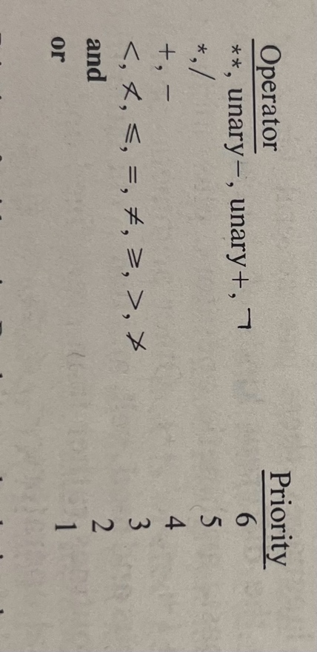

C# also has an assigned priority for each operator, and based on these priorities, the expression is evaluated.

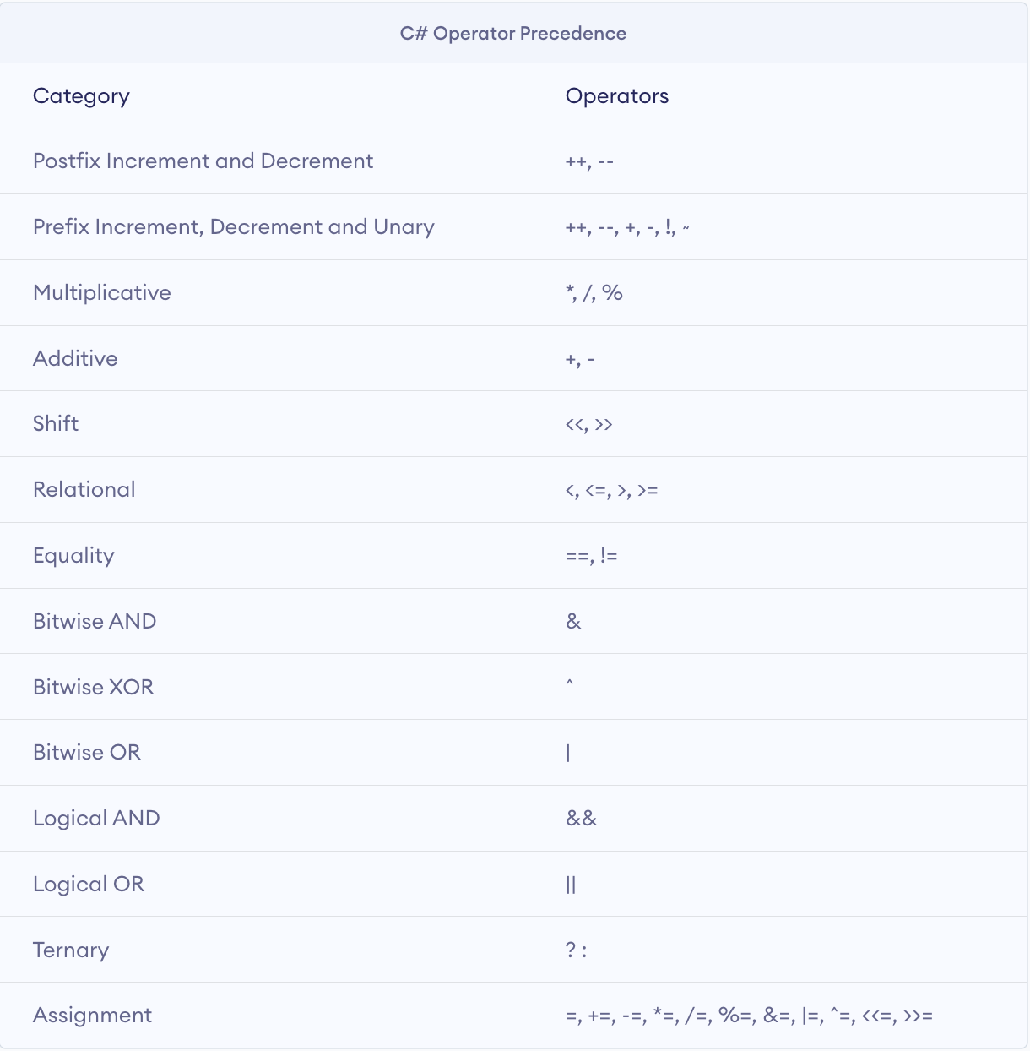

To begin with this project, I want to start by writing it in the format of a more easily readable language, which has the intention of describing the computational processes or writing down algorithms to be executed, known as an Algorithmic Language. This has the advantage of being much easier to read, write and check as well as aiding me with the transition from these algorithms to a proper implementation in C#. For this project I have decided to use a similar style to that used in Schaum’s Outline of Theory and Problems of Data Structure by Seymour Lipschutz.

Stack declaration:

*Data*: Stack [0…MaxStack], MaxStack, Top, Item

*OPERATIONS*:

//creates a stack

Create (Top, Stack) // this procedure creates a stack

Top = 0

Return Stack

Empty (Stack, Top) // this procedure checks if the stack is empty

If Top = 0, then return TRUE

Else Return False

Full (Stack, Top, MaxStack) // this procedure checks if the stack is full

If (Top = MaxStack), then return TRUE

Else Return FALSE

Push (Stack, Top, MaxStack, Item) // This procedure pushes an Item onto the stack

If Full () returns TRUE then print OVERFLOW and Return

Else set Top = Top + 1 //Increases Top by 1

and set Stack [Top] = Item // inserts item into new Top position

Return.

Pop (Stack, Top, Item) // this procedure deletes the Top element of the Stack and assigns it to the variable Item

If Empty () returns TRUE then print UNDERFLOW and Return

Else set Item = Stack [Top] //assigns Top element to Item

And set Top = Top – 1 //decreases Top by 1

Return

Peek (Stack, Top) // this procedure returns the Top element of the Stack

Return Stack [Top]

**Priority**

Priority(operator)

Depending on Priority table labelled previously, returns different values depending on operator.

**Infix expression to postfix expression procedures:**

postfixEvaluation(Postfix)

Declare new Stack.

Scan Postfix from left to right for the length of the expression.

Declare ch as the current element in the expression.

If ch is an operand

Call Push() for the ch to push it onto stack.

Else

Call Pop() for the operand on top of the stack

Call Pop() for the next operand on the stack

Perform operation using operator encountered on the two operands.

Call Push() to push result back to top of the stack.

Return top element of the stack as the final result.

infixToPostfix(Expression, Postfix)

Declare new Stack

Declare result

Scan Expression from left to right for the length of the expression

Declare x as the current element in the expression

If x is an operand

Add to result string

Else if x is an opening bracket

Call Push() for the current element to push it onto the stack

Else if x is a closing bracket

Checks if stack is empty and whilst Empty() returns False

Also checks if current element is not a opening bracket

Calls Pop() and adds to result string

Call Pop to clear out the stack

Else x is an operator

While Empty() does not return True and Priority of element at top of stack is greater than x

Calls Pop() and append it to result string

Once priority of x is greater than stack, push x onto stack

Finally, once everything has been scanned and while Stack calling Empty() does not return True

Call Pop() to clear the stack and append it all to the result string

Return Postfix expression.

## 2.2 Data Structures

For this project, I believe that using a Stack data structure is the best solution because it allows us to properly represent the order and precedence we have. This is because we can convert our expression using a single stack where we will push any operators that are encountered when scanning the Infix expression, whilst the operands are simply just appended to the Postfix expression itself (possibly an empty string). Additionally, the reason we use a stack data structure is because we need to store any operators until both of its operands are added to the result expression.

Here is an example of how I intend to use the stack data structure within this problem, whereby I am just trying to convert an inputted Infix expression to its version displayed in Postfix expression.

Consider the infix expression **exp** = **a + b * c + d**

This expression will be iterated through using a for loop with the iterator **i,** which is initialised as I = 0.

1. We have created an empty stack to push any operators onto but first we must start by scanning through our expression. To begin, i = 0, so expression [i] = “a”which is an operand, so this simply gets added to the Postfix expression and the stack remains empty 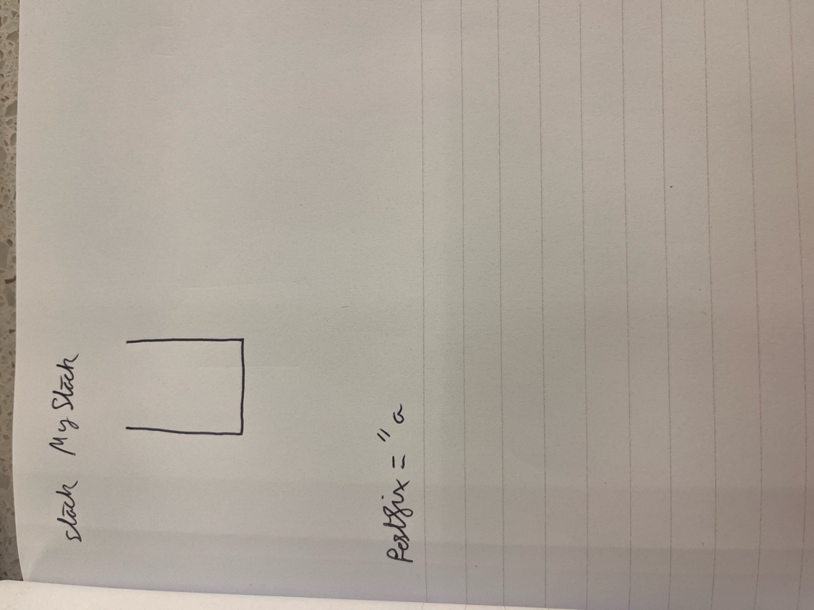
2. Now I = 1, so expression[i] = “+” which is an operand and therefore must be pushed onto the stack.

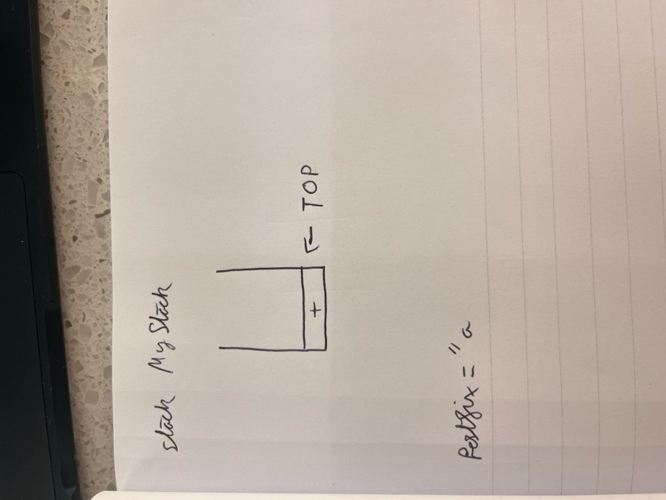

1. Now I = 2, so expression [i] = “b” which is an operand and gets added to the Postfix expression. The stack remains unchanged.

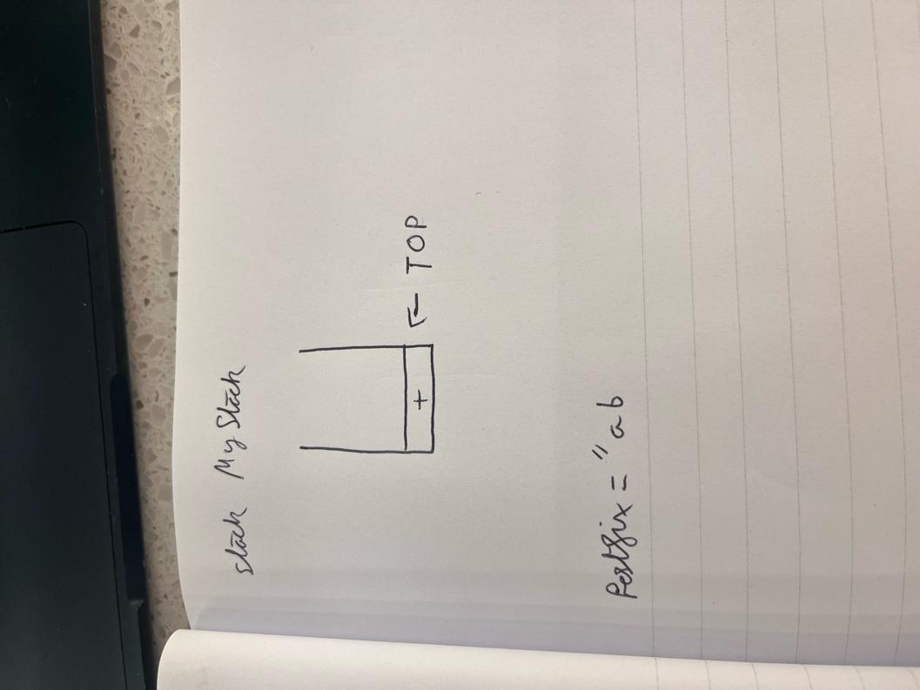

1. Now I = 3, and expression[i] = “*” which is another operator and therefore gets pushed onto the stack. This becomes the new Top element.

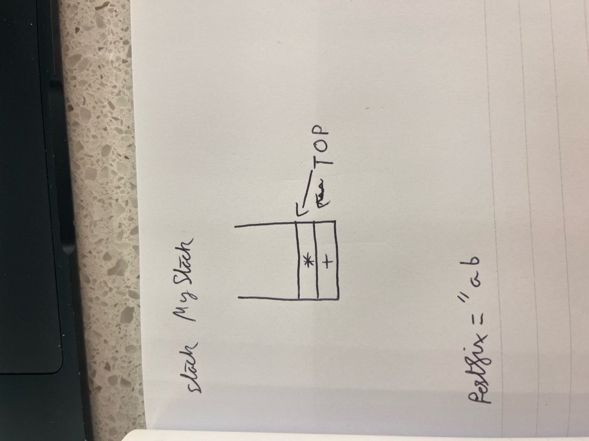

1. Now I = 4, and expression[i] = “c” so we simply add it onto the postfix expression, leaving the stack unchanged.

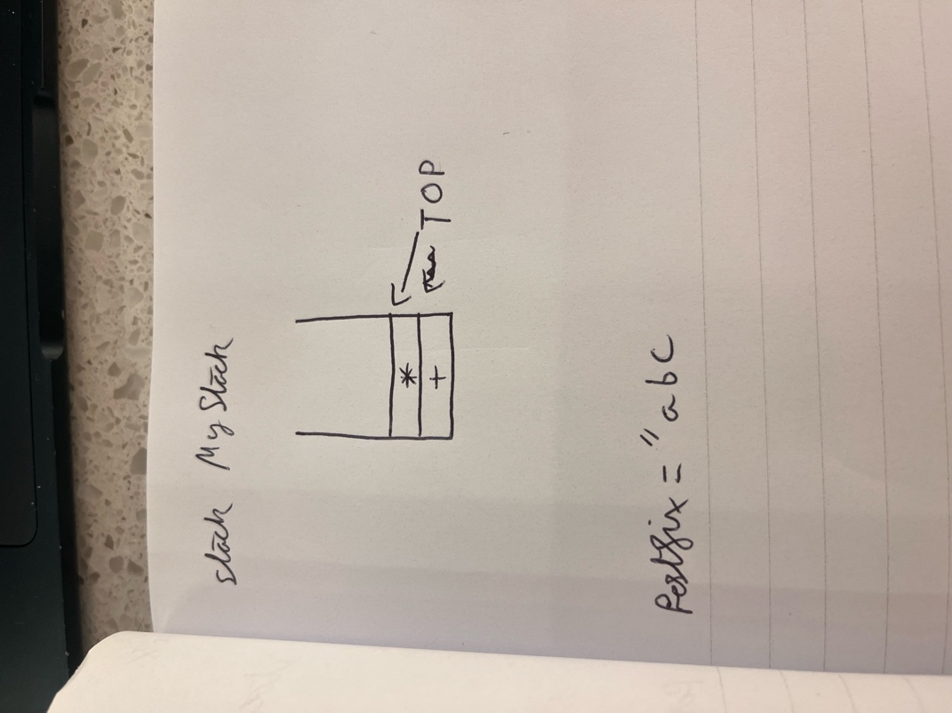

1. Now I = 5, and expression[i] = “+” which is an operator. First, we must check if the Top operator on the stack has a greater than or equal priority to the one just scanned, comparing them using our table of priority. * has a higher priority than the + operator so we start by popping * out of the stack and into the postfix expression

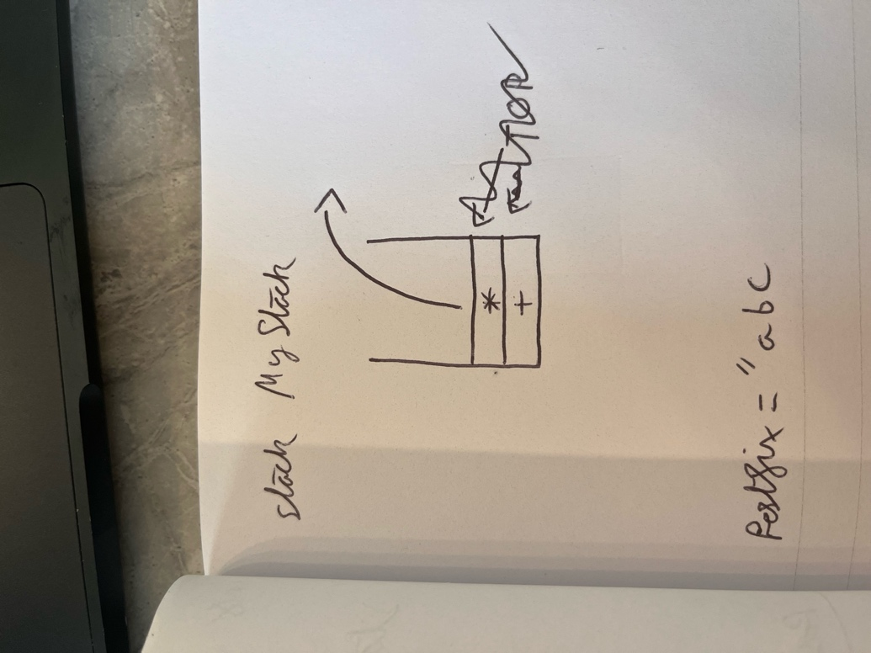

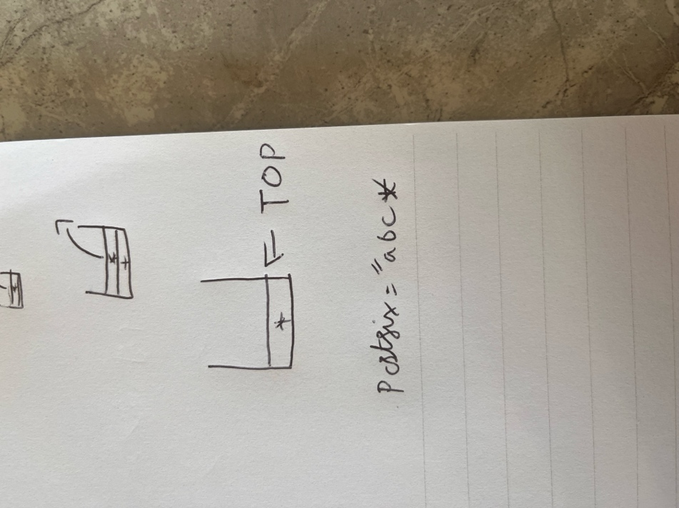

1. We still need to compare the scanned operator + against the remaining elements in the stack, that being another +. These two operators have the same level of priority/the one on the stack doesn’t have less priority, and in C# any binary operators are considered left associative (evaluated from left to right) so this means we will pop the + that is on the stack.

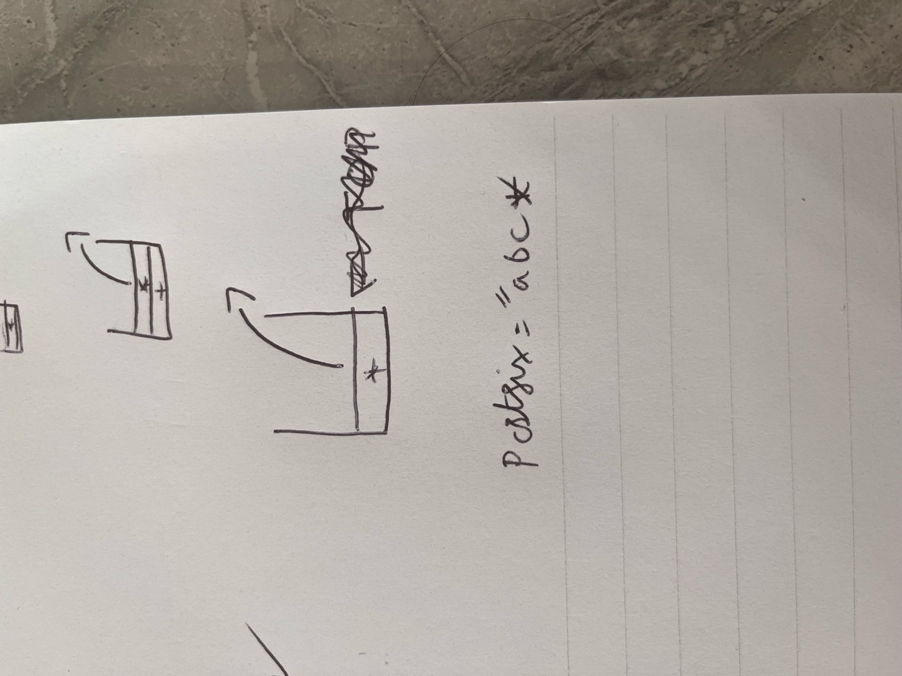

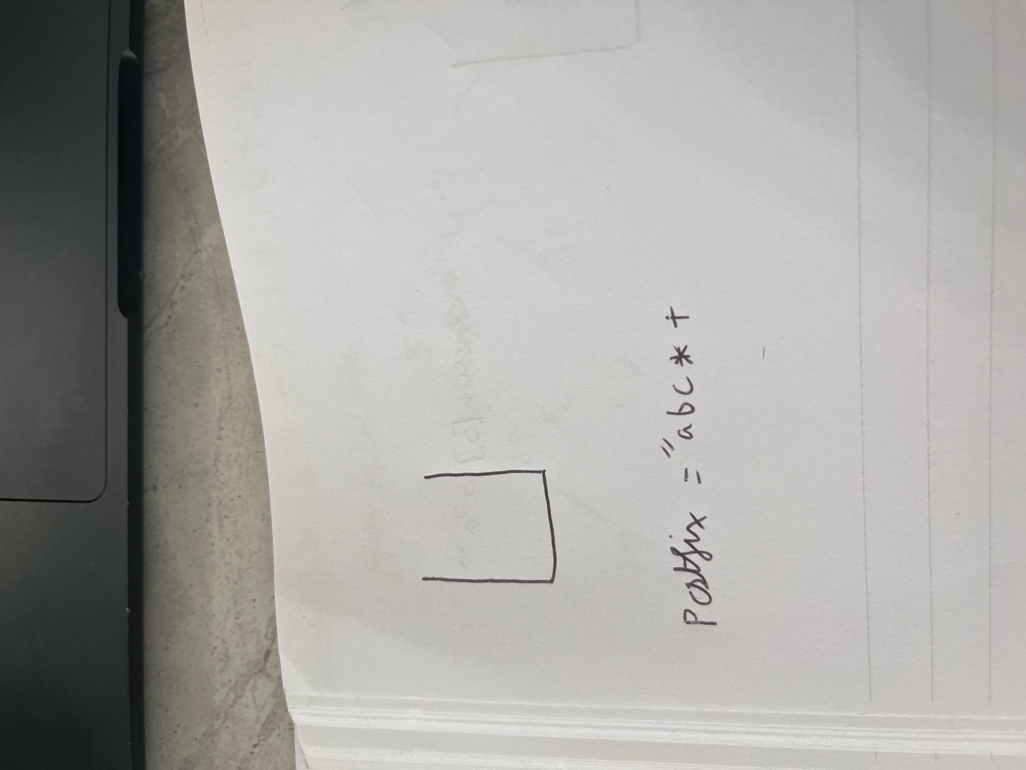

1. Now the stack is empty, and we still have our scanned operator +, so this must be pushed onto the stack.

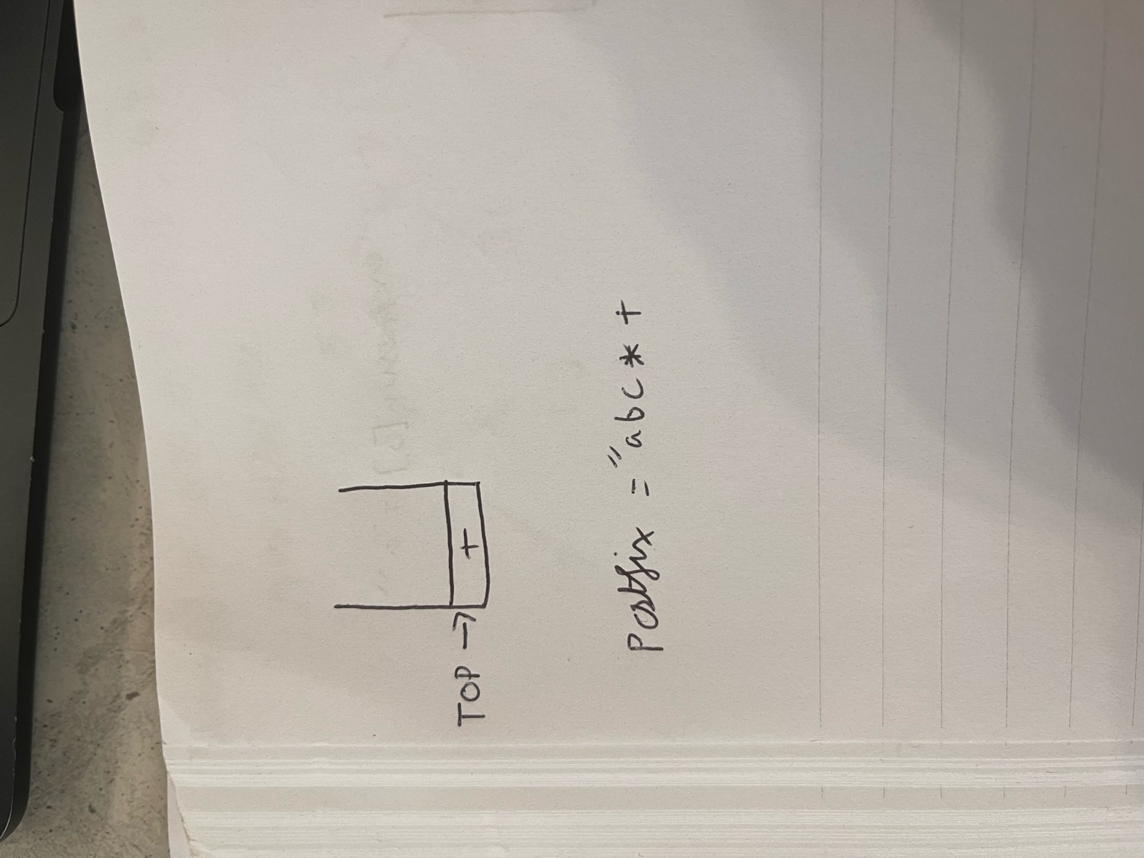

1. Now we iterate once again, I = 6 and expression[i] = d. This is an operand, so it simply gets added to the Postfix expression.

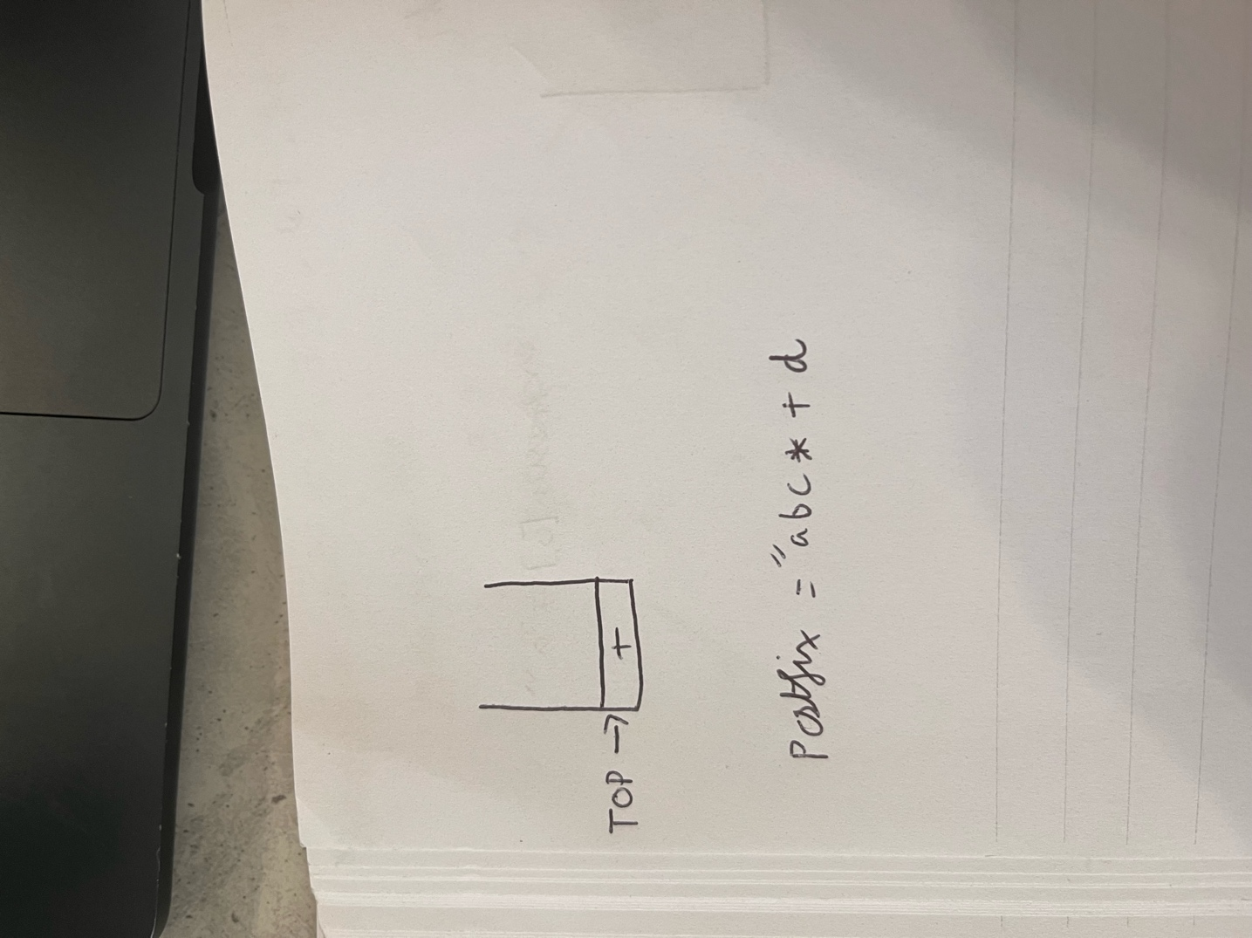

1. There are no longer any elements within the Infix expression to iterate over, so we pop any remaining elements from the stack and add it onto the Postfix expression.

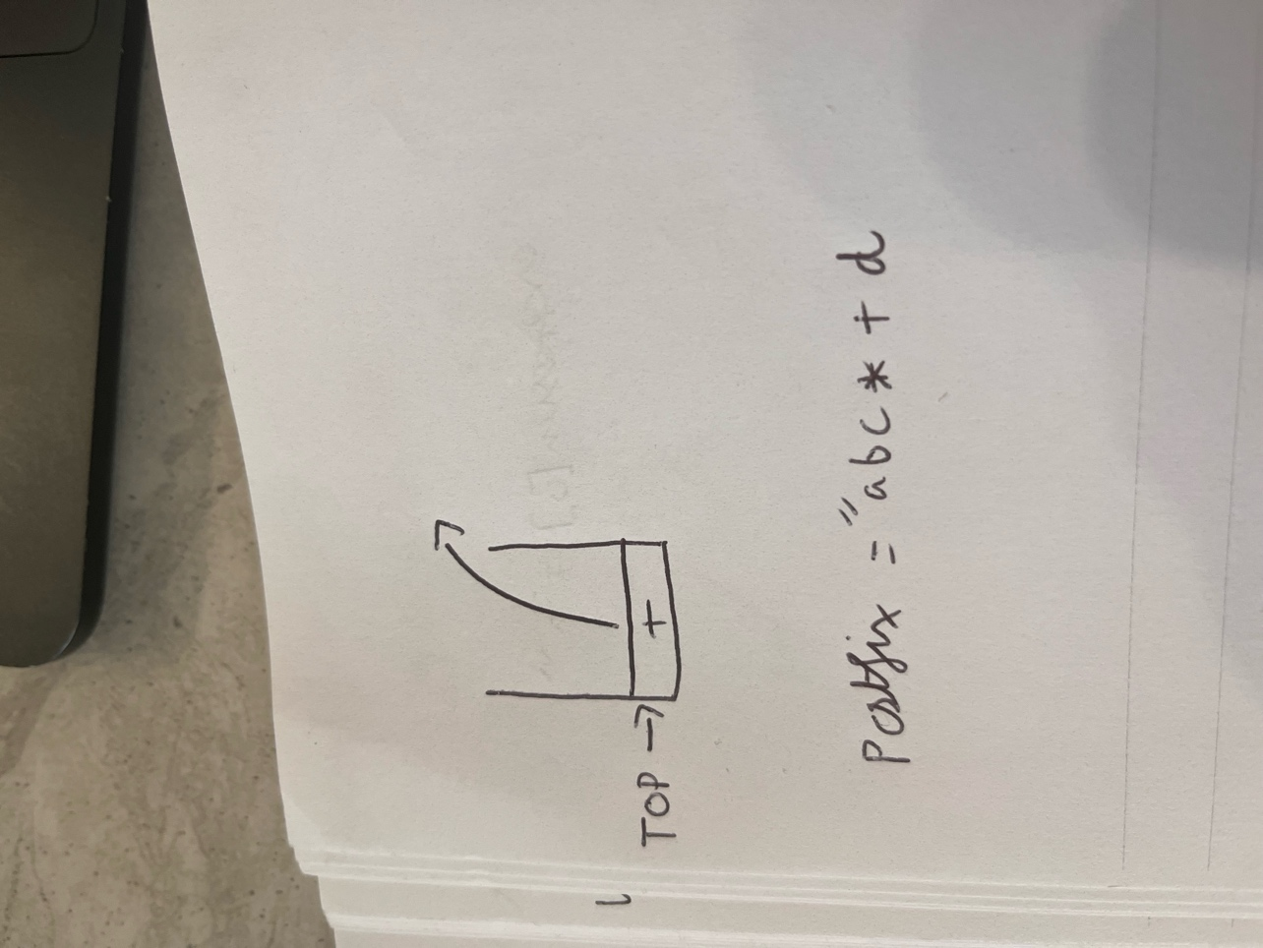

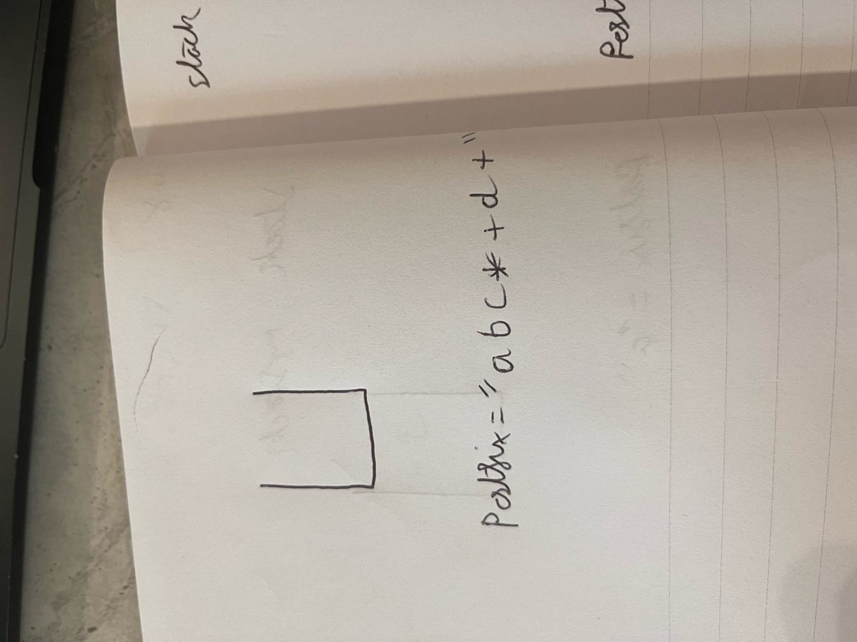

**Alternative data structures**

Whilst it is somewhat possible to use an alternative data structure such as a queue or a list for evaluating a given arithmetic infix expression, doing so would result in significant drawbacks in comparison to a stack as previously stated.

The inherent nature of a stack being Last In, First Out (LIFO) simplifies the management surrounding operator precedence and order, which is a key point when converting and evaluating an expression, and as such offers a much more straightforward and legible solution to the problem. In contrast, queues and lists would introduce some complexities to the problem due to their First In, First Out (FIFO) nature, and difficulties with accessing arbitrary values, respectively. The operations for inserting and deleting values from these data structures may be less efficient due to the possible need for traversal when trying to find a particular value, in comparison to a stack’s efficient design for top-end operations.

Without the natural flow and nature of stacks present when trying to complete this project, additional checks become necessary to handle operator precedence and associativity among other issues. For example, when using a stack for this project domain, and an operator is encountered it gets added to the top of the stack and popped out when needed, which is much more intuitive and easily represents how the conversion is done. These data structures will require much more code and time spent making checks to try and implement them to fit this domain.

In summary, whilst alternative data structures have the possibility to be used to perform infix to postfix conversion, the use of a stack is evidently the clear superior choice, providing a much cleaner, more efficient, and concise solution.

## 2.3 Software and its Presentation, including testing (and video link)

[Project 2 Video Recording](https://youtu.be/fFjYSu67ZAw)

**Acceptance Tests**

|  |  |  |  |  |  |
| --- | --- | --- | --- | --- | --- |
| **Test Number** | **Scenario** | **Value/Input** | **Expected Result** | **Actual Result** | **Pass/Fail** |
| 1 | User prompted for input expression | n/a | Message is correctly displayed to screen | User is presented message in console | Pass |

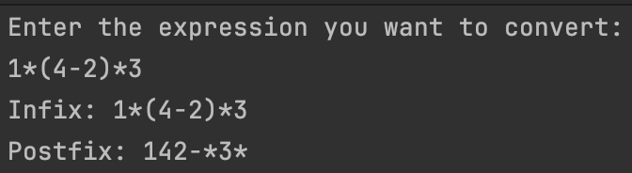

|  |  |  |  |  |  |
| --- | --- | --- | --- | --- | --- |
| 2 | InfixToPostfix function | $$1*(4-2)/3$$ | Expression to have been converted from an infix expression to a postfix expression | User input was correctly converted, and expression is now in postfix. | Pass |



|  |  |  |  |  |  |
| --- | --- | --- | --- | --- | --- |
| 3 | Evaluation function | $$1*(4-2)/3$$ | Expression is correctly evaluated within the function and result is displayed to user. | A result is displayed to user, but it does not match up to what the result of the expression should be | Fail |

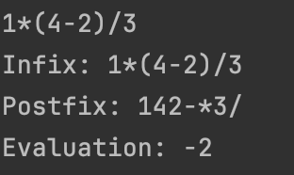

|  |  |  |  |  |  |
| --- | --- | --- | --- | --- | --- |
| 4 | User prompted with input | A+B-7 | User is prompted to enter values for the variables and then they are used within the function to convert to postfix | User is able to give values for the variables and conversion to postfix is done correctly | Pass |

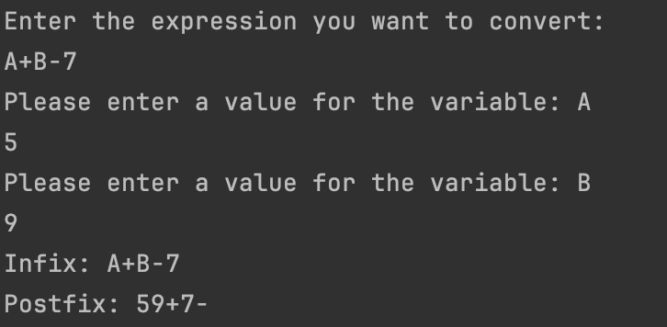

## 2.4 Descriptive Report, including artefacts.

### 2.4.1 Transitioning algorithms to implementation

Coming up with a basic implementation of converting Infix to Postfix expression from the code written in ADL was relatively easy as the basic code simply involves a stack and multiple checks using for, if and else statements.

The functions I created within C# generally represent the algorithms crafted in ADL, in terms of their general flow and statements although there may be a few extra, possibly unnecessary checks within my own implementation

**Main Function**

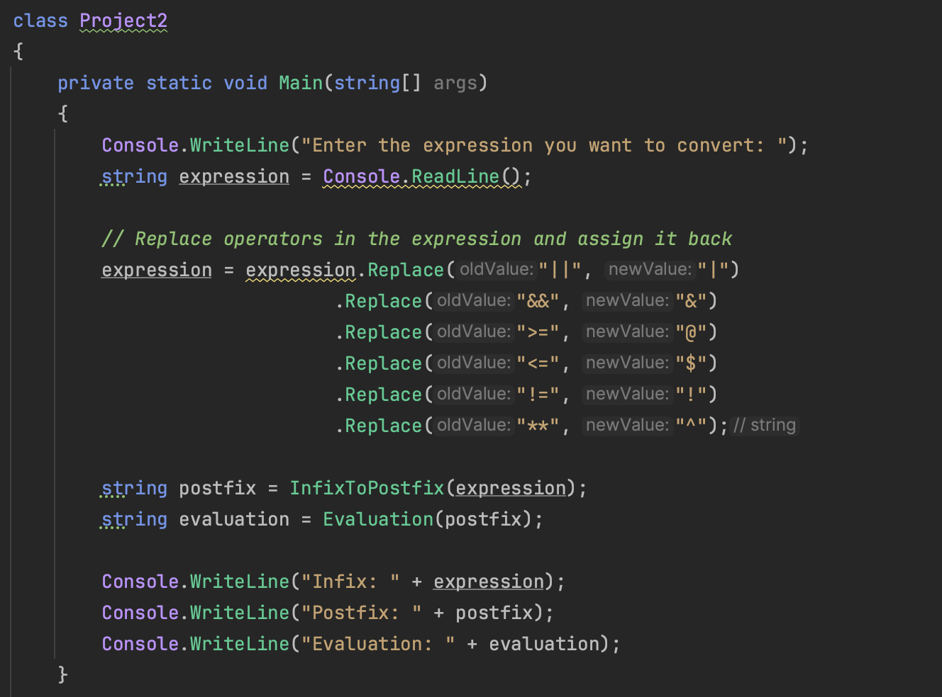

**Infix to Postfix function**

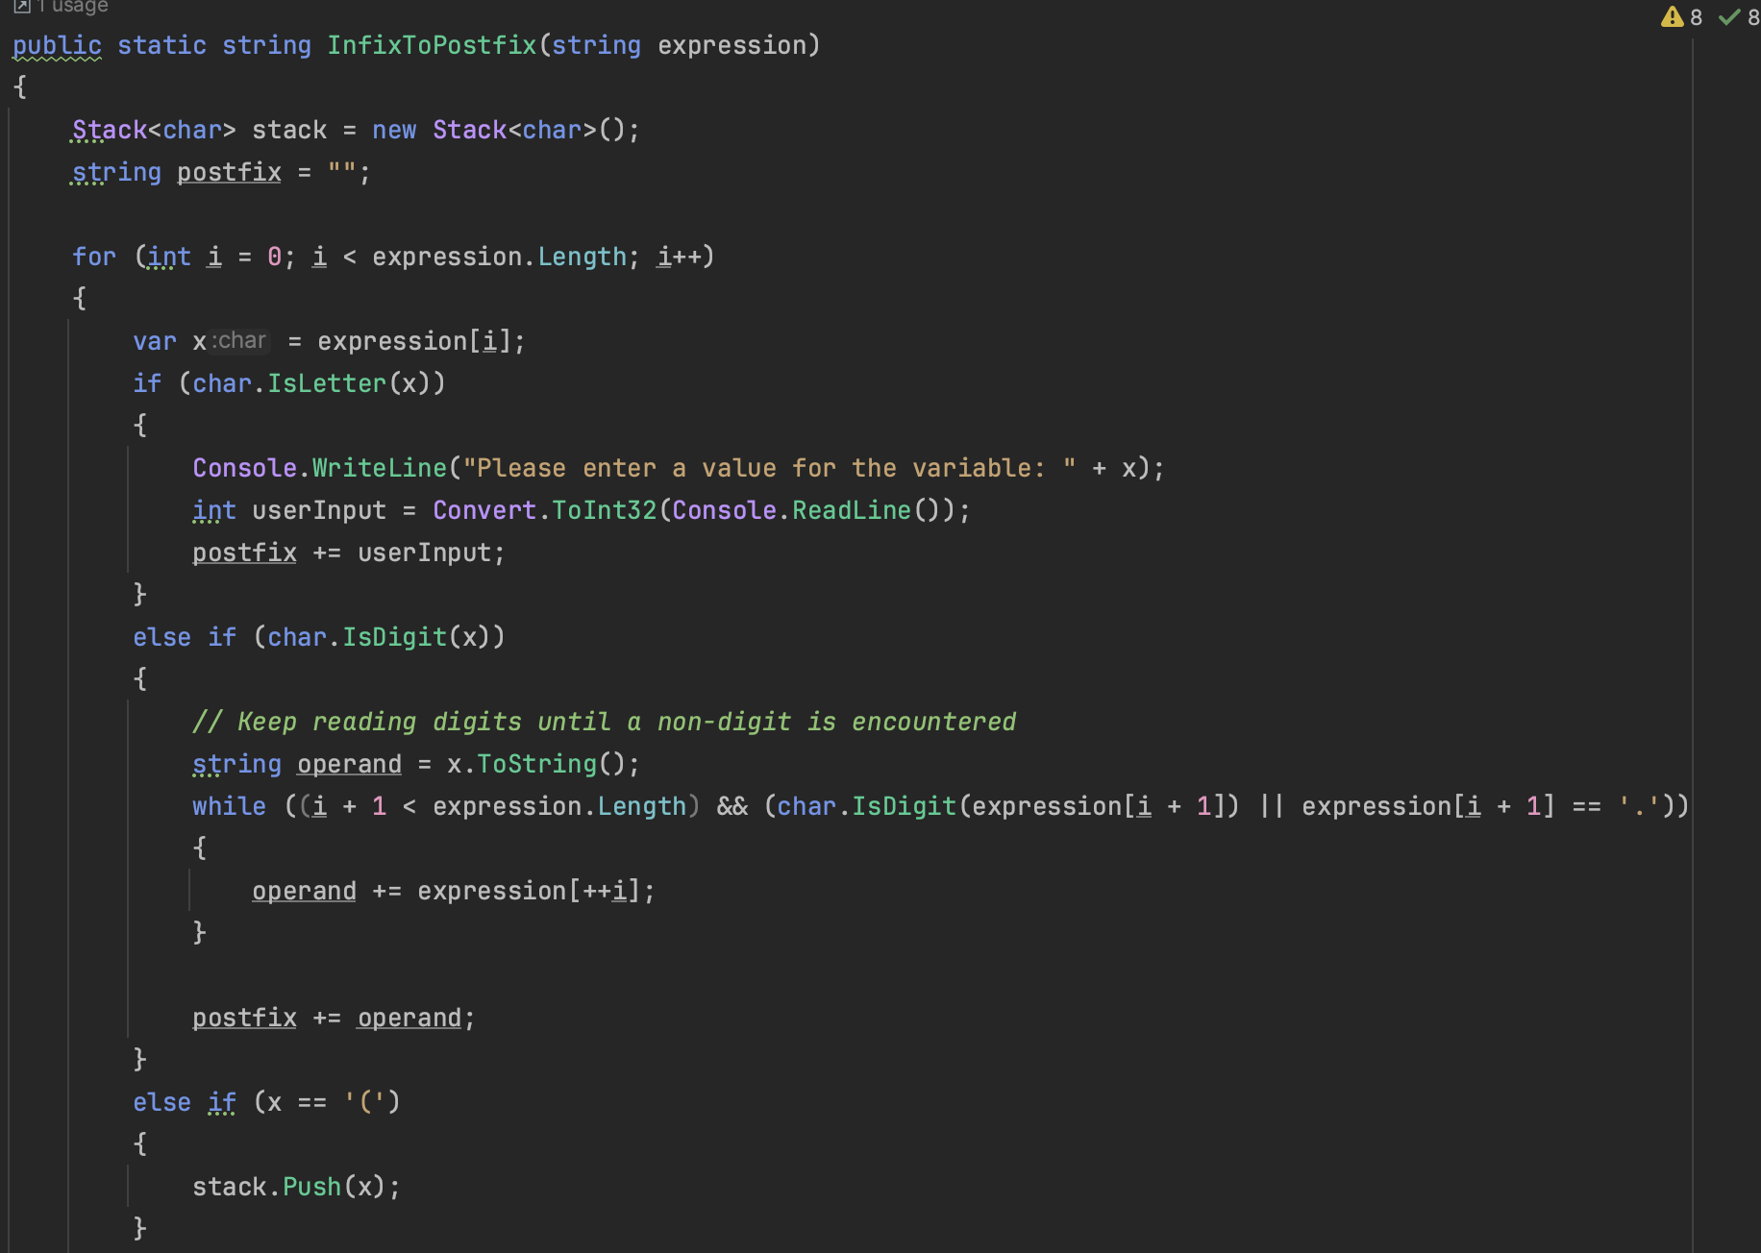

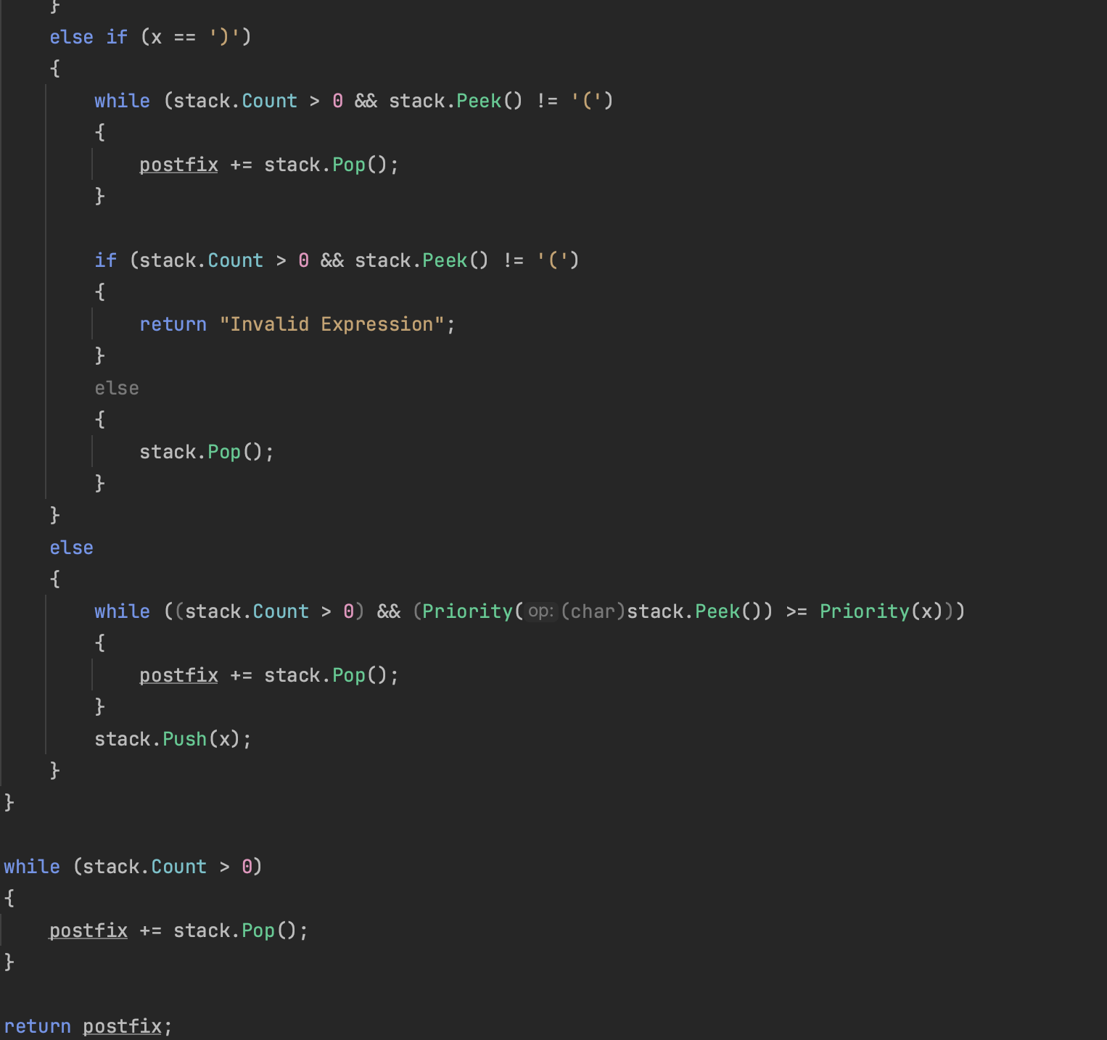

**Evaluation function**

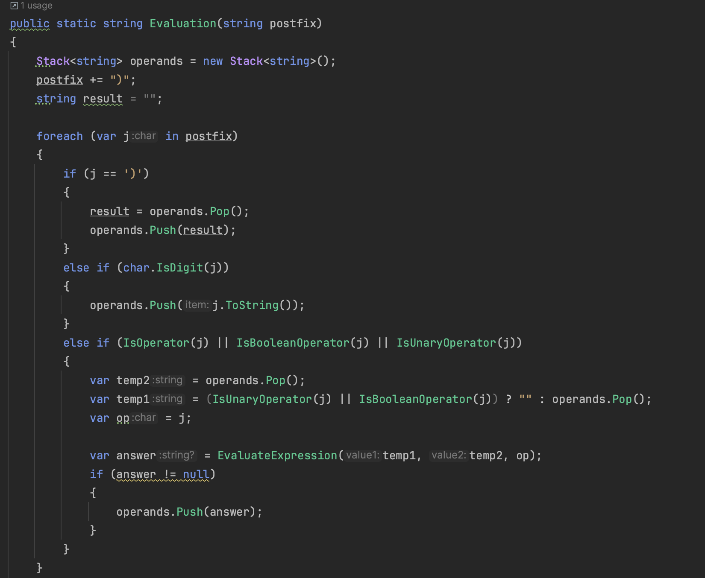

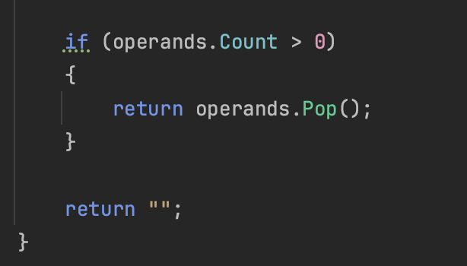

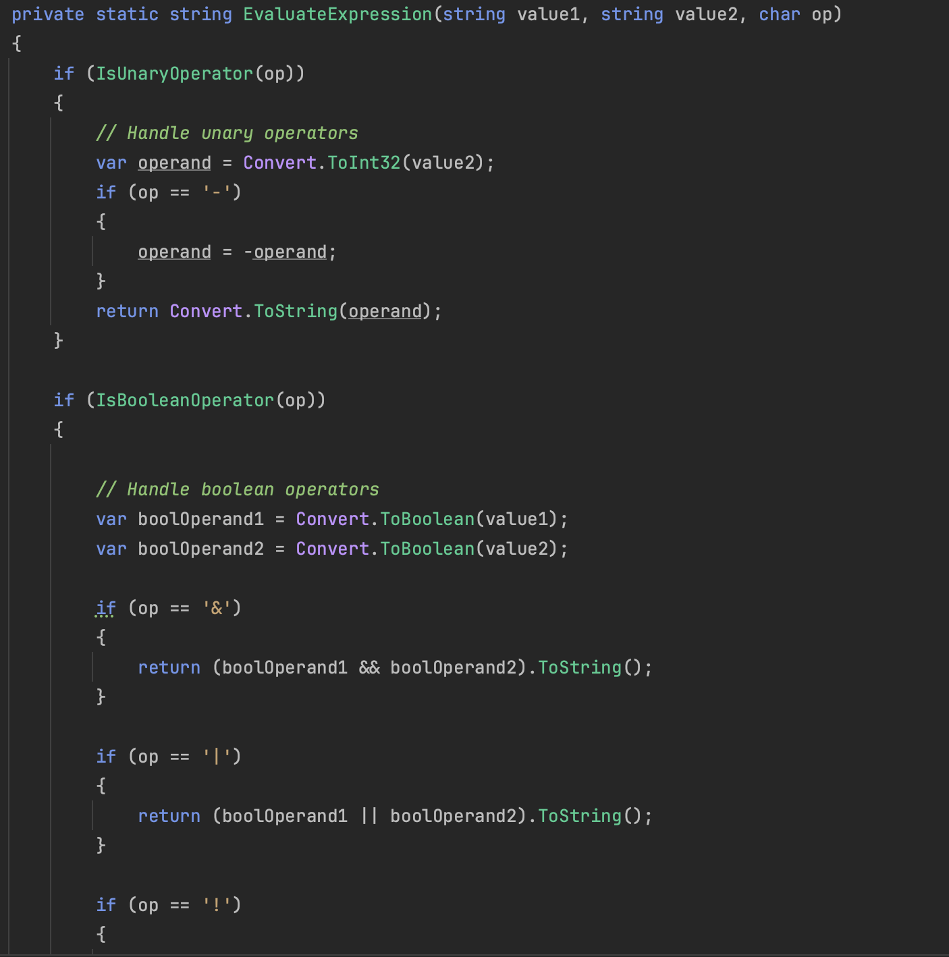

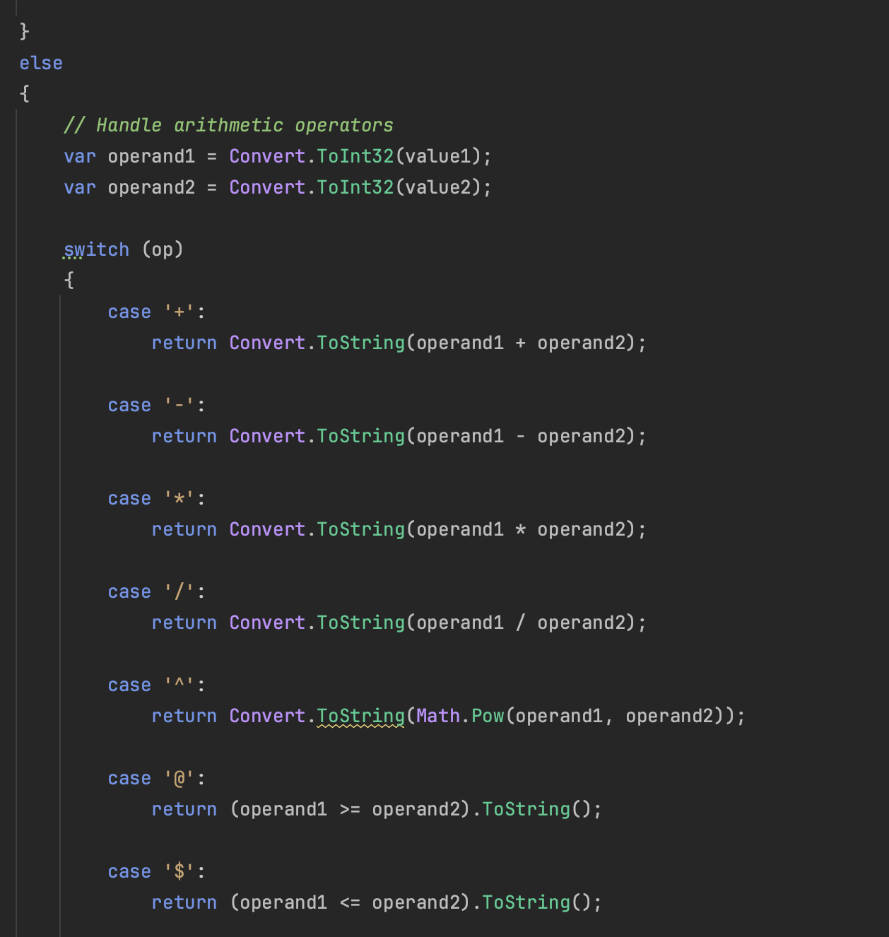

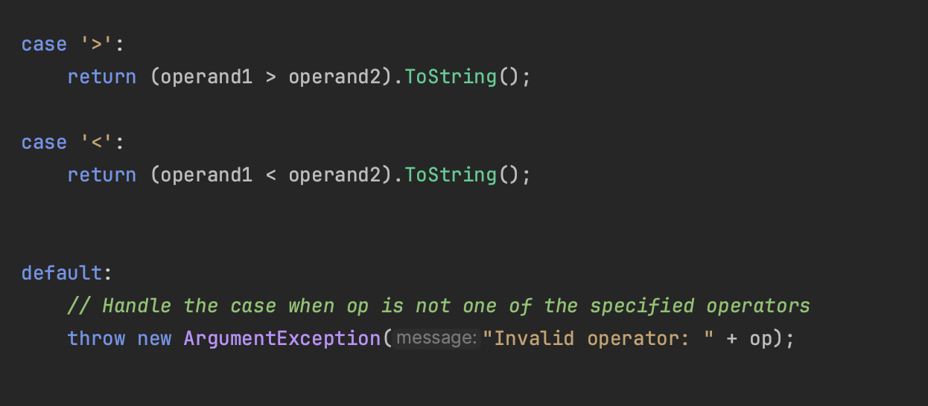

**Priority function**

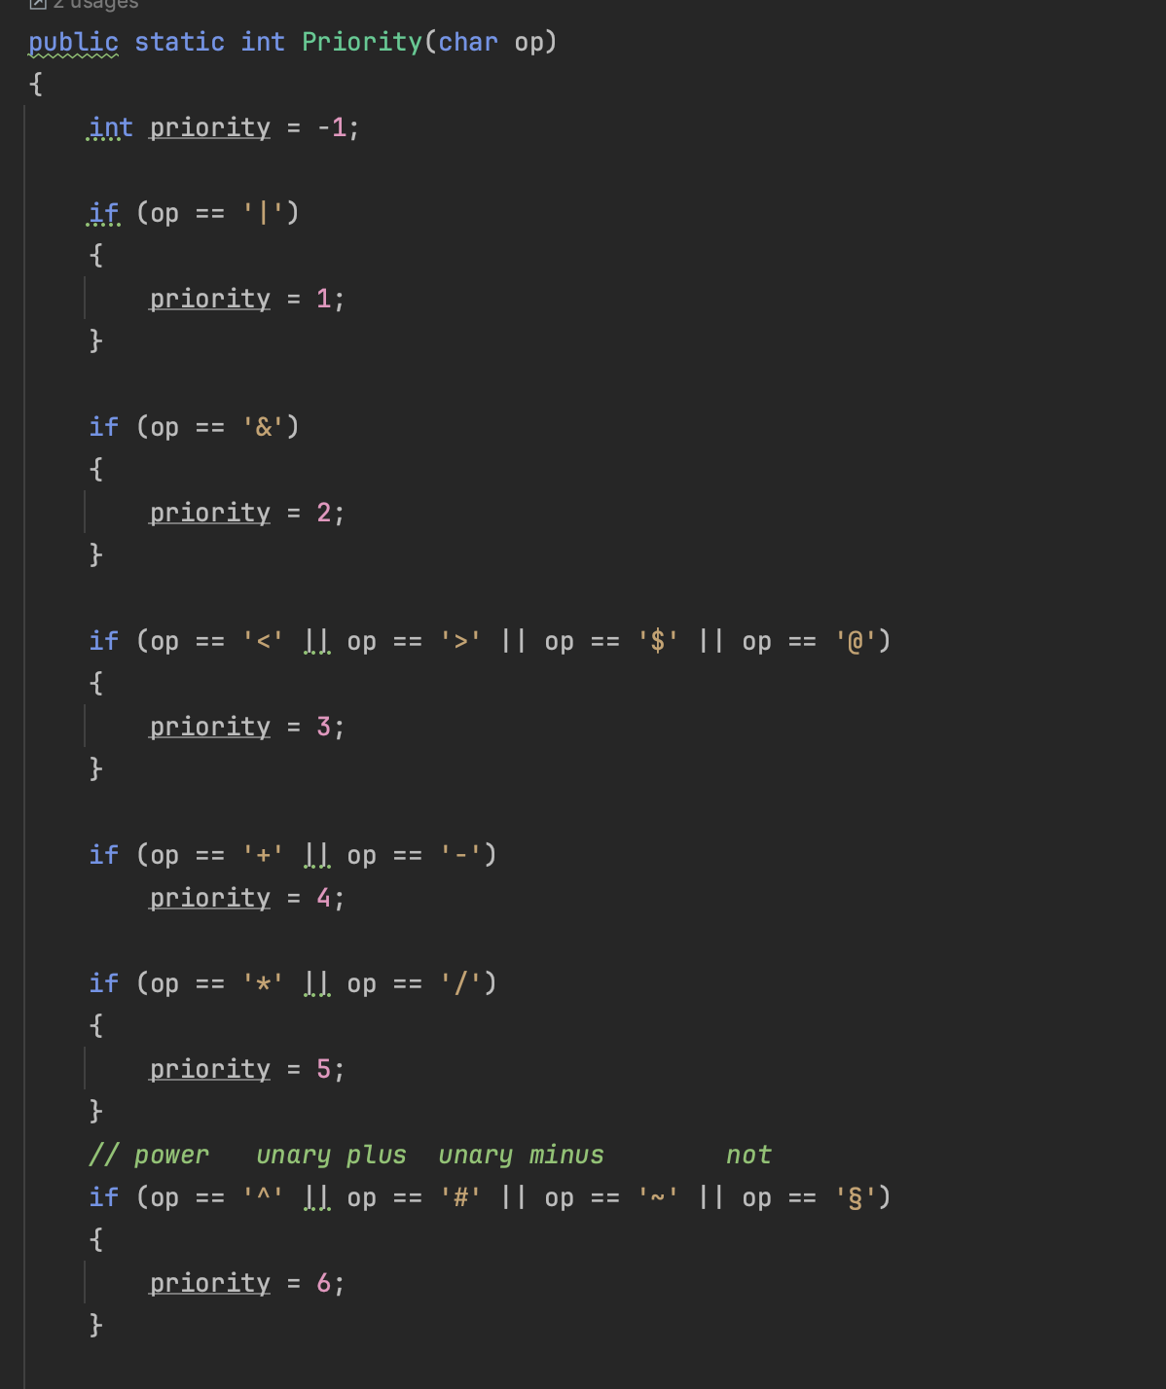

### 2.4.2 Problem-solving strategy

The biggest problems I encountered whilst developing my project would be learning how to include unary operators, Boolean values, and comparative operators as this required a bit more logic than simply checking for the basic expressions (+ - * /).

When it came to the unary operators, I toiled over what options I had available, deciding within my mind which would the most appropriate for the current problem.

However, when it came to deciding the data structures that I would need for the main aspect of the program which would be converting from infix to postfix was an easy decision to make as only one data structure seemed to make the most sense intuitively. That would be the stack data structure as it allowed for easy insertion and deletion of values from the stack, as well as also fairly representing the natural flow of the problem.

## 2.5 Incorporation of formative feedback

|  |  |  |
| --- | --- | --- |
| **Date Received** | **Feedback Received** | **Incorporation of Feedback** |
| 24/11/2023 - Mehmet | Positive feedback received regarding current components of documentation, namely the representations of algorithms in an Algorithmic Language and the justification of chosen Data Structure  Mentioned that I now need to work on detailing the transition from algorithms to actual implementation in C#. Pointed out the updated template now on Blackboard | Refined any redundant parts within my explanations and cleared up any inconsistencies.  Also investigated the new template given on Blackboard and began constructing ideas on how I will describe the transition from algorithms to my implementation in C#. |
| 16/12/2023 - Mehmet | Was told that when dealing with positive values in the evaluation and conversion, there must be a unary + in front of the value. | Took feedback into consideration but still had many other projects and parts that needed to be implemented. Was not able to implement this feature properly within the project but if I had managed my time more effectively, then I could have. |

# 3. Project 3

## 3.1 Algorithms in an Algorithmic Language, such as ADL

Algorithm: ProjectManagement

CalculateProjectDuration(ProjectGraph)

- Declare new Stack.

- Calculate the time it takes to complete the project without delay.

CalculateCriticalPath(ProjectGraph)

- Declare new Stack.

- Identify the critical path(s) in the project.

ProduceProjectManagementData(ProjectGraph)

- Declare new Stack.

- Calculate Earliest Start Time.

- Calculate Latest Start Time.

- Calculate Slack Time.

Main

- ProjectGraph = InputProjectGraph()

- CalculateProjectDuration(ProjectGraph)

- CalculateCriticalPath(ProjectGraph)

- ProduceProjectManagementData(ProjectGraph)

## 3.2 Data Structures

For this project, there is a use of a project management technique that requires mapping out key tasks that are necessary, which includes identifying the amount of time to finish each and the dependencies of each activity on others.

Additionally, there is a requirement to use a given directed and non-circular graph that represents a project. This graph contains vertices (e.g V1, V2, etc) that are used to represent the starting points of the given activity, which is then followed up by an edge or line that connect 2 or more projects, which represents the activity itself in the project.

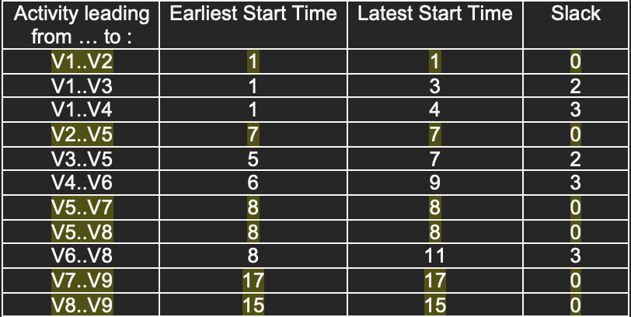

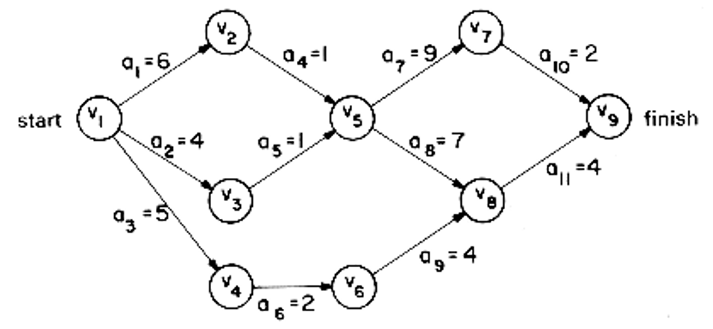

However, since a graph data structure cannot be directly implemented into C#, we need to use alternative data structures to implement the graph. The two ways we can do this would be either using an adjacency matrix or an adjacency list, and below I will go into detail about both data structures and conclude which one I believe is best for the scope of this project. Both data structures will share key values, where the vertices/nodes are the tasks and the edges between them represent dependencies and time to complete.

**Adjacency Matrix**

An adjacency matrix is a square matrix, of size V x V that is used to represent a finite graph, where V is the number of vertices within the graph. Within the matrix, the elements represent whether pairs of vertices are adjacent or not, shown by a 1 or 0 in an unweighted graph, or by the weights in a weighted graph.

To implement this within C#, arrays will be used as they allow us to correctly store the values for the scope of the problem. We can implement our adjacency matrix using a 2D array e.g adj[][], where vertices i and j would have an edge of weight w if the array equated to adj[i][j] = w.

This project has a graph that consists of 9 vertices, so we are going to create a 2D array of size 9x9 to represent our adjacency matrix.

|  |  |  |  |  |  |  |  |  |  |
| --- | --- | --- | --- | --- | --- | --- | --- | --- | --- |
| i x j | 1 | 2 | 3 | 4 | 5 | 6 | 7 | 8 | 9 |
| 1 | 0 | 6 | 4 | 5 | 0 | 0 | 0 | 0 | 0 |
| 2 | 1 | 0 | 0 | 0 | 1 | 0 | 0 | 0 | 0 |
| 3 | 0 | 0 | 0 | 0 | 1 | 0 | 0 | 0 | 0 |
| 4 | 0 | 0 | 0 | 0 | 0 | 2 | 0 | 0 | 0 |
| 5 | 0 | 0 | 0 | 0 | 0 | 0 | 9 | 7 | 0 |
| 6 | 0 | 0 | 0 | 0 | 0 | 0 | 0 | 4 | 0 |
| 7 | 0 | 0 | 0 | 0 | 0 | 0 | 0 | 0 | 2 |
| 8 | 0 | 0 | 0 | 0 | 0 | 0 | 0 | 0 | 4 |
| 9 | 0 | 0 | 0 | 0 | 0 | 0 | 0 | 0 | 0 |

Due to the nature of an adjacency matrix being a square matrix, it means that the space complexity for this data structure would be $O\left(v^{2}\right)$ where $v$ is the number of vertices. This complexity and storage space required then becomes the drawback of this adjacency matrix, since there is a lot of memory being used to store null values because the graph is directed one way. With at most two connections to a single node at a time, the graph is evidently very sparse and not many edges are being stored despite the size.

However, when addressing the access time within an adjacency matrix, it can be written as $O(1)$ time taken, since an array is being used and a simple look-up within the array can be used to check the distance between two connected nodes.

**Adjacency List**

This data structure is represented in the form of an array of size V, that holds multiple linked lists, whereby the first node of a linked list represents a vertex and the remaining lists that are connected to this initial node represent the vertices to which this node is connected.

The graph for this project has 9 vertices, so an array of size 9 is created, where each index represents a vertex.

|  |  |  |  |
| --- | --- | --- | --- |
| 1: | (2,6) | (3,4) | (4,5) |
| 2: | (5,1) |  |  |
| 3: | (5,1) |  |  |
| 4: | (6,2) |  |  |
| 5: | (7,9) | (8,7) |  |
| 6: | (8,4) |  |  |
| 7: | (9,2) |  |  |
| 8: | (9,4) |  |  |
| 9: |  |  |  |

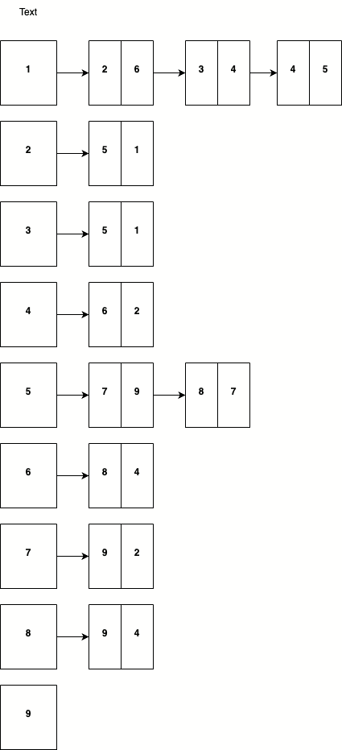

When addressing the space complexity of this data structure, the understanding of how the data structure works can be used to calculate it. Since an adjacency list is essentially an array of linked lists, where a node within the array represents a vertex, and the linked list that follows represents the vertices connected to the vertex, the complexity can start to be calculated by noting that the array itself requires $v$ amounts of memory, for each vertex. From here, the total number of edges can be labelled as some value $e$, and for this problem, there is a need to store the information about such edges. This means that alongside, the $v$-sized memory already being used to store the vertices, there is also a need for $e$ amounts of memory for the edges, which will be used as pointers in the linked lists. To conclude, the space complexity of an adjacency list can be defined as the sum of the space required for an array and the linked lists, which would be $O(v+e)$.

On the other hand, to calculate the time complexity of querying for an edge between two nodes on a given graph, there must be a check for adjacent vertices to a specific vertex. Since the worst-case scenario would be where the vertex has at most $V$ neighbours, the search would have to check for every adjacent vertex, leading to a complexity of $O(V)$.

**Conclusion**

In the context of critical path analysis for this project domain, an adjacency list would be best suited in comparison to an adjacency matrix.

The nature of critical path analysis involves a focus on dependencies and connections between tasks, and an adjacency list best represents these by efficiently storing connections between vertices without the need for excessive memory allocation and use. This is particularly highlighted with the problem at hand since the graph has little connections between vertices, and as such a list provides a much more concise representation.

Additionally, the list’s time complexity of $O(V)$, where $V$ is the number of vertices, for finding a connection between two vertices makes it a favourable option due to the need to access relevant information when identifying relationships and critical paths.

In summary, the adjacency list’s ability to represent relationships efficiently in terms of both time and space complexity makes it a superior choice for this project. The flexibility in which it is able to handle sparse graphs whilst also providing quick access to adjacent vertices aligns well with the scope of this project.

## 3.3 Software and its Presentation, including testing (and video link)

## 3.4 Descriptive Report, including artefacts.

### 3.4.1 Transitioning algorithms to implementation

### 3.4.2 Problem-solving strategy

My biggest problem when it came to this problem was the fact that I left it far too late to create a good implementation of what the project asked out of me. Whilst this is not an excuse for any problems with the program, I believe it is important that I mentioned this fact to whomever may be reviewing this portfolio.

However, when it came to deciding the major data structure that would be used to implement the graph, I had to take the time and space trade into consideration, and this is what led me to decide on implementing the graph via an adjacency list. Additionally, I had to consider how I was going to represent the tasks themselves, and the easiest way I believe would be to refer to the tasks as integers so that the graph can be indexed easily but it also makes it more legible and easier to understand the relationships between tasks.

## 3.5 Incorporation of formative feedback

|  |  |  |
| --- | --- | --- |
| **Date Received** | **Feedback Received** | **Incorporation of Feedback** |
| 16/12/2023 - Mehmet | Tests on graphs on blackboard can be done to show implementation of project. | Took feedback into consideration but was not able to test or even implement this project fairly due to poor time management. |

# 4. Project 4

## 4.1 Introduction

### 4.1.1 Bubble Sort and Quick Sort

Sorting algorithms play an incredibly important part within computer science, giving us the means to which we can sort and organise data, in a multitude of different applications. This project covers only 2 given sorting algorithms but there are many others, which all range in usefulness and efficiency.

**Bubble Sort**

*Definition:*

Bubble Sort is quite a simple implementation of a sorting algorithm, and it works by iteratively traversing through a list, comparing adjacent elements as it goes, and then proceeding to swap them if they are in the wrong order. If a list has been traversed completely but is still not in the right order, then we go back to the beginning and make another ‘pass’. This process continues and keeps going until the entire list is sorted in either ascending or descending order.

The algorithm gets its name from the way in which larger elements in the list ‘bubble’ up to the top (if sorted in ascending order).

*Example:*

Consider the example list: [5, 2, 9, 1, 5] where we want to sort it in ascending order.

1. Pass 1:
   * 1. Starting with the first pair, 5 and 2, we compare and see 2 is smaller than 5 so we swap them to get [2, 5, 9, 1, 5]
     2. Moving forward we compare our next values, 5 and 9, where there is no need for a swap, so the list remains the same.
     3. Next, we have 9 and 1, and since 1 is smaller than 9, we swap the two values, meaning our list now looks like [2, 5, 1, 9, 5]
     4. Finally, we compare the last two values, 9 and 5, and comparing them means we get a swap that results in [2, 5, 1, 5, 9]. However, looking at this list we can see that it is still not completely sorted so we need to pass through again.
2. Pass 2:
   * 1. Our list now looks like [2, 5, 1, 5, 9] so we compare 2 and 5, and there is no swap, so list remains the same.
     2. Next, we compare 5 and 1, and since 1 is much less than 5, the two are swapped around and our list now looks like [2, 1, 5, 5, 9]
     3. After that, we need to compare 5 and 5, but since these are the same then there is no need for a swap.
     4. Finally, the last elements to compare are 5 and 9 but since 9 is already greater than 9 and at the end of the list, then there is no need for a swap and our second pass is complete. This leaves us with a list [2, 1, 5, 5, 9] but again we can see that this is still not fully sorted so we must make another pass through.
3. Pass 3/Final Pass:
   * 1. On the third pass, the list looks like [2, 1, 5, 5, 9] so we start by comparing 2 and 1, and this results in a swap to make our list now look like [1, 2, 5, 5, 9] which we can now see is sorted.
     2. Even though we can see that our list is now sorted in ascending order, a basic bubble sort algorithm like the one we are using has no mechanism to stop execution once the list is sorted. This means that the algorithm must complete the full pass through and check the rest of the values in the sort, even though it was sorted after the first check.
     3. Our sorted list looks like [1, 2, 5, 5, 9] and it took a total of 3 passes through the list to sort.

*Algorithmic Complexity:*

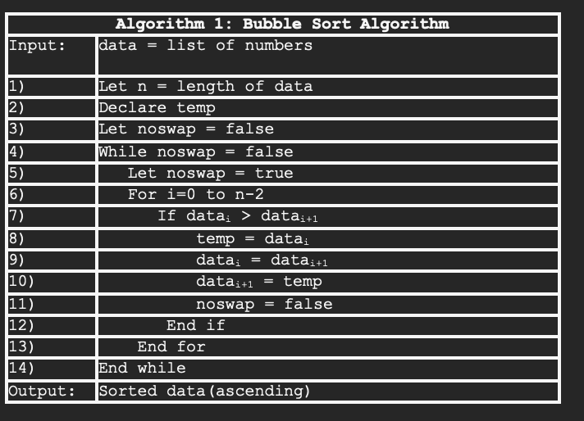

Firstly, we can work out the space complexity for this algorithm, as it is not a very complicated process. If we are including the size of the dataset input then this sorting algorithm would be considered to have a space complexity of $O(n)$, however if we exclude this input size then we would be left with a space complexity of $O(1)$ since only an additional variable ‘temp’ is created.

Next, we can start to work out the time complexity, which is the time taken for an algorithm to run based on the input size. For this problem, we can start by defining our algorithm as a function, $T(n)$ where $n$ is some measure of the size of the input problem. The output of this algorithm is the running time for an input of size $n$.

$$T\left(n\right)=runtime$$

The pseudocode above employs two different loops: an outer while loop, and an inner for loop, which from first glance suggests that we are working with quadratic time complexity i.e $O(n^{2})$ but I want to be able to prove why this is the case.

Best Case:

In the best possible scenario for the sorting algorithm, the list of elements would already be in sorted in order, and as such the algorithm would have to make one pass through to ensure the elements are in order. This means that the algorithm would have to do $n-1$ comparisons meaning:

$$T\left(n\right)=n-1$$

And since we are working out the time complexity for just the algorithm by itself, then we do not need to worry about the constants in our equation, as we are only worried about the dominant term in the expression since that will be the fastest growing term as our input $n$ increases. This leaves us with a time complexity of

$$O(n)$$

If we want to look at proving the statement from a different perspective, then we can look at showing that $n-1$ belongs to $O(n)$ using the formal definition of Big-O notation.

The formal definition for Big-O notation states that:

$f\left(n\right)=O\left(g\left(n\right)\right)$ if there exists such positive constants $c, k$ such that:

$f\left(n\right)≤cg(n)$ for all $n≥k$ where $k$ is an integer value

And where $f$ and $n$ are functions that only take integer arguments.

So, if we want to show that our expression has a complexity of $O(n)$ we must show that:

$$n-1 ≤cn$$

This is because we want to find a function g(n) that is bigger than our function f(n) So, we can rewrite our expression like this:

$$-1 ≤cn-n$$

Which can be simplified to show in terms of $n$

$$-1 ≤n\left(c-1\right)$$

From here we need to have $n$ just by itself, so we need to isolate our variables.

$$\frac{-1}{c-1} ≤n$$

Now we can begin substituting values for n and c to fulfil the expression.

|  |  |  |  |
| --- | --- | --- | --- |
| **Value of n** | **Value of c** | **Fulfilled expression** | **Is true?** |
| 0 | 0 | $$0 ≥ \frac{-1}{0-1}$$ | Technically but our formal definition is looking for positive constants and 0 is neither positive nor negative.  Additionally, it would not make sense to have 0 for our time taken. |
| 1 | 1 | $$1 ≥ \frac{-1}{1-1}$$ | This is not true as the right-hand sides evaluates to us trying to divide by 0, and since this is not mathematically possible and the scope of this module does not cover this, then we cannot use this. |
| 1 | 2 | $$1≥ \frac{-1}{2-1}$$ | This fulfils the requirements for the formal definition of Big-O notation since 1 is greater than -1. |
| 2 | 3 | $$2≥ \frac{-1}{3-1}$$ | This too fulfils the requirements for the definition of Big-O notation since 1 is greater than -0.5 |

So, we can now say that n must be greater than or equal to 1 to make our expression true.

Thus, it holds that there exists two such positive constants $c$ and $k$ such that $n-1 ≤cn$ for $n ≥k$

And because this condition holds, then we can conclude that $n-1$ is $O\left(n\right)$

Worst Case:

The worst situation for the bubble sort algorithm would be when the list's smallest element is in the last position. In this situation, the smallest element will move down one place on each pass through the list, meaning that the sort will need to make the maximum number of passes through the list, namely $n-1$ passes, where $n$ is our input size. During each pass, the algorithm compares $n-1$ pairs of elements within the list, so the total number of comparisons made can be represented as an arithmetic series.

$$\left(n-1\right)+\left(n-2\right)+…+2+1$$

Applying the sum of N natural numbers

$$\sum_{k=1}^{n}{k}=\frac{n(n+1)}{2}$$

We can derive the expression for worst-case time complexity.

$$T\left(n\right)=\frac{n(n-1)}{2}≡ \frac{n^{2}-n}{2}$$

Now looking at this new expression we can work out the time complexity from here. Since time complexity is looking at the most dominant term within an expression, we can see quite intuitively what that would be from our expression. This leaves us with a worst-case time complexity of

$$O(n^{2})$$

If we want to further prove this is the case, we must look at proving that our worst-case expression ‘belongs’ to $O\left(n^{2}\right)$ using the formal definition of Big-O.

So, if we want to show that our expression has a complexity of $O\left(n^{2}\right)$ we must show that:

$$\frac{n^{2}-n}{2} ≤cn^{2}$$

This is so that we need to show that we have a function g(n) that is greater than f(n).

First, we must start with our given expression.

$$T\left(n\right)=\frac{n^{2}-n}{2}$$

From here we can recognise that our numerator is a quadratic expression, and the fraction is a constant multiplier. In the context of Big-O notation, we want to focus on the dominant term in the expression, which is $n^{2}$.

Therefore, we need to simplify our expression to highlight the dominant term.

$$T\left(n\right)≈\frac{n^{2}}{2}$$

From here we can take our expression and begin to show that it follows the definition of Big-O notation.

$$\frac{n^{2}}{2} ≤cn^{2}$$

|  |  |  |  |
| --- | --- | --- | --- |
| **Value of n** | **Value of c** | **Fulfilled expression** | **Is true?** |
| 0 | 0 | $$\frac{0^{2}}{2} ≤0(0^{2})$$ | No since we cannot possibly divide 0 by another integer.  Additionally, the formal definition asks for a positive constant for both c and k so this would not fulfil the conditions. |
| 1 – chosen because we need to show that the statement is true for all $n ≥k$ | ½ - arbitrary choice but consistent with expression | $$\frac{1^{2}}{2} ≤\frac{1}{2}(1^{2})$$ | Yes, since both sides evaluate to $\frac{1}{2}$ meaning we have two positive constants, c and k, such that $f\left(n\right)≤cg(n)$ |
| 1 – need to show consistency | 1 | $$\frac{1^{2}}{2} ≤1(1^{2})$$ | Yes, both sides of the expression are equivalent meaning our conditions hold true |

This now shows that our condition, $n ≥k$ holds up where k = 1.

Thus, it holds that there exists two such positive constants $c$ and $k$ such that $\frac{n^{2}-n}{2} ≤cn^{2}$ for $n ≥k$

And because this condition holds, then we can conclude that $\frac{n^{2}- n}{2}$ Is $O\left(n^{2}\right)$

*Advantages/disadvantages:*

Due to the bubble sort’s very simple design and implementation, it is very easy to understand even if someone is not well versed in programming languages. Additionally, this is also the reason that it can be introduced early on to students and used in educational scenarios. Furthermore, since all elements within the list are swapped in place, there is no need for any additional memory, so the space requirement is at a minimum.

Although, bubble sort is one of the simplest sorting algorithms to introduce and implement, the fact that it has a time complexity of $O(n^{2})$ means that it becomes incredibly inefficient once dataset size increases past more than just a small list of elements. This essentially means it does not have many practical uses since other sorting algorithms are generally much more efficient and can scale much better, although this is a good introduction into what sorts are.

**Quick Sort**

*Definition:*

The quick sort algorithm is generally considered to be a very efficient and much more widely used sorting algorithm, that works by following a ‘divide-and-conquer’ strategy when dealing with the list of elements. It takes a pivot element and partitions all other elements based on their relationship to the pivot, either smaller or greater than the pivot. If an element is smaller than the pivot, then it is moved to the left-hand side and vice versa if the element is greater. From here we have sub-arrays of elements that can be sorted recursively until the list is sorted.

*Example:*

Consider the same unsorted list that was used for the bubble sort: [5, 2, 9, 1, 5] where we want to sort it in ascending order.

1. Choose 5 as our pivot element.
2. We need to partition the rest of the elements within the list, based on their relationship to the pivot.
3. Sub-arrays are created with elements that are less than, equal to, or greater than the pivot. This leads our list to now look like: [ [2,1], [5,5], [9]]
4. Since we can see that the list is still not completely sorted, we must recursively sort these sub-arrays that have been created.
5. Starting with [2, 1], we choose 2 as the pivot, and then compare the elements, leading to a swap.
6. Next, we have our sub-array of [5, 5] but as these elements are equal then no swap is performed.
7. Finally, our sub-array [9] consists of just a single element so no swap or comparison is needed to be done.
8. The final list after all recursions and sorts is [1, 2, 5, 5, 9]

*Algorithmic Complexity:*

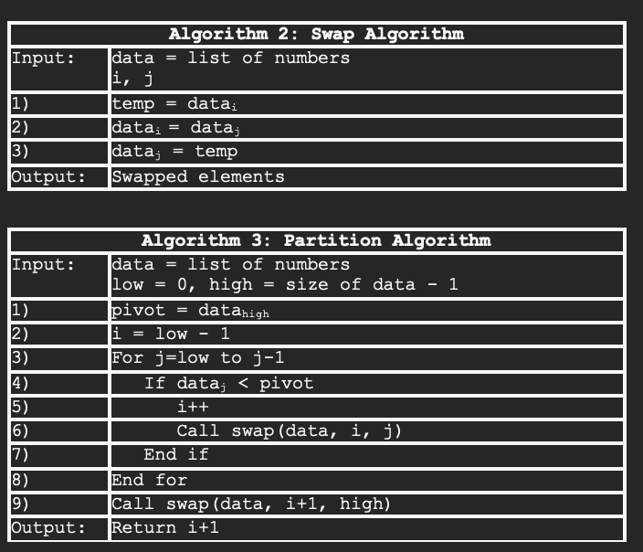

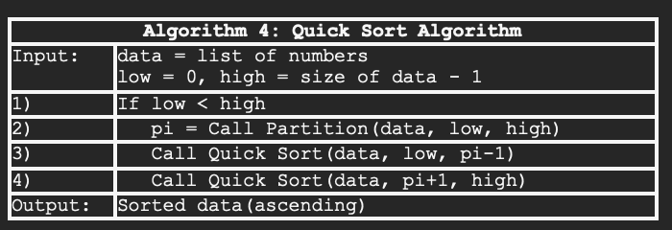

To begin with, we can work out the space complexity of the given pseudocode, and since this usually remains constant for the given algorithm, we do not have to work about best/average/worst case scenario.

The space complexity for this algorithm stems from the recursive nature of the algorithm and the partitioning of the dataset.

For this algorithm, the space required for recursion is proportional to the logarithm of the dataset size. Each recursive call involves a constant amount of additional space for storing local variables, such as indices and pivot values. Since the dataset is repeatedly partitioned into smaller segments during recursion, the maximum depth of the recursion tree determines the space complexity.

The logarithmic space complexity arises because, at each level of the recursion tree, the dataset size is halved due to the partitioning process. As a result, the maximum number of recursive calls or the depth of the recursion tree is logarithmic with respect to the dataset size. Therefore, the space complexity for the given algorithm would be:

$$O(\log{n)}$$

where $n$ is the number of elements within the dataset.

Next, we can work out the time complexity of our given algorithm. For this problem, we can state that our algorithm can be represented as a function, $T(n)$ where $n$ is some measure of the size of the input problem.

$$T\left(n\right)=runtime$$

Best case:

The best scenario for this sorting algorithm would consist of a list of elements, such that when the pivot element selected at each step is able to divide the list into two almost equal halves/sub-arrays. This means that when we recursively call our function to sort sub-arrays, it is only having to deal with a list that is roughly half the size. For best case, I will assume perfect partitioning to keep the maths simpler, and as such there will two perfect halves for each partition.

In this case, the number of times we can break it in half will be the base-2 logarithm of the number of inputs. For example, given 128 inputs, we get partition sizes of 64, 32, 16, 8, 4, 2, and 1, which equates to 7 levels of partitioning, and $\log_{2}\left(128\right)=7$.

So far:

$$T\left(n\right)=log⁡(n)$$

However, this is not all that the algorithm is doing since it needs to check each input on every level/partition, meaning it must check $n$ inputs. This now changes our complexity and leaves us with:

$$T\left(n\right)=n log n$$

From here it is simple to derive the complexity as there is no other constants or variables in our expression, leaving us with a time complexity of:

$$O(n log⁡(n))$$

Worst case:

The worst possible scenario for this sorting algorithm would be where the pivot element that is selected, is either the smallest or largest value within the dataset. This means with a dataset of N size; the first partition call takes N times to partition the dataset.

Each partition step is called recursively from the last. From here we can take the complexity of each partition call within the execution and sum the total to get the complexity for worst-case.

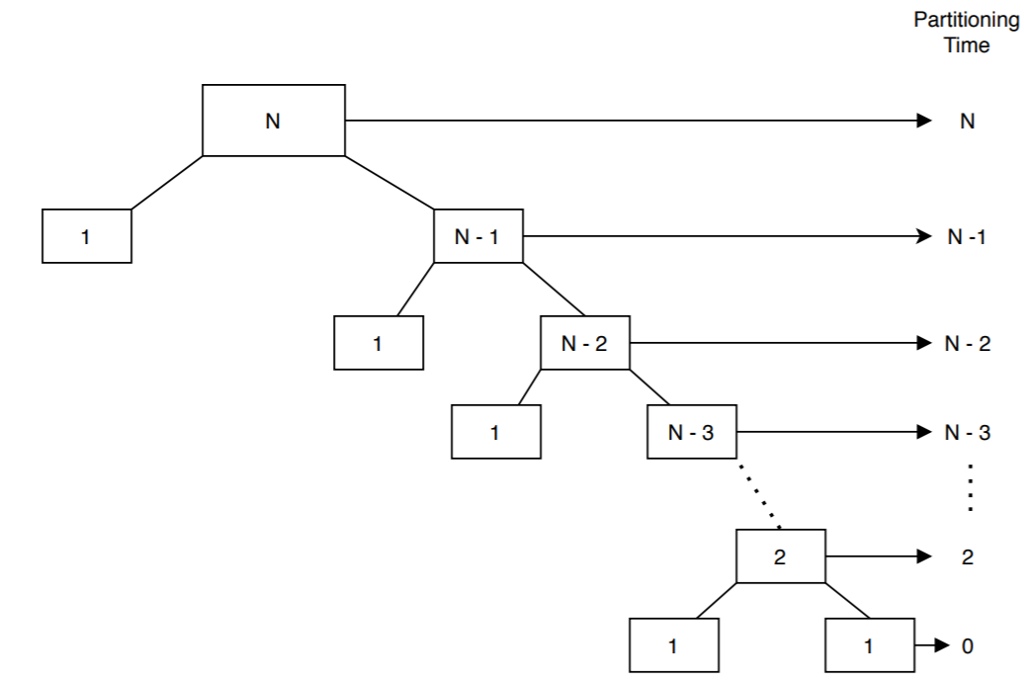

$$N+\left(N-1\right)+\left(N-2\right)+…+2$$

Applying the sum of N natural numbers:

$$\sum_{k=1}^{n}{k}=\frac{n(n+1)}{2}$$

We can derive the worst-case time complexity.

$$T\left(n\right)= \frac{n(n+1)}{2}-1$$

Since Big-O notation and working out the time complexity means we are only interested in the dominant term, we can expand the expression and highlight the dominant term to get our complexity.

$$T\left(n\right)= \frac{n^{2}+n}{2}-1$$

$$∴T\left(n\right) belongs to O(n^{2})$$

*Advantages/Disadvantage:*

Quick sort is a widely adopted sorting algorithm that boasts good efficiency, it has an average and best-case complexity of $O(n log n)$ which makes it very well suited for much larger datasets. Furthermore, since it sorts in place, there is no requirement for extra space.

However, the algorithm is quite dependent on the choice of the pivot and can be vulnerable to the worst-case scenario, in which case it performs similarly to the best/average case of other sorting algorithms.

## 4.2 Data Structures

Before detailing why certain data structures are better suited to the problems within the project, I want to note that the choice of data structure is also dependent on the specific characteristics of the data as well as the context of its application.

### 4.1.1 Bubble Sort

Since this algorithm works by swapping adjacent items, there is a need for a data structure when given a specific element, allows for us to access the element next to it in constant time.

The best possible data structure for this situation would be an array since they fulfil the requirements that we need, allowing for efficient traversal and swapping of elements. Additionally, arrays are one of the simpler data structures to understand, which aligns with the nature of the pseudocode for a bubble sort algorithm, making for a clear and easy implementation.

However, we can also consider using a linked list data structure for the scope of this problem as this uses pointers to connect each element to one another. Within this data structure, we can sequentially traverse the list which is what is required for a bubble sort. However, swapping elements within a linked list is more challenging and less efficient as it requires the swapping of pointers.

Based on the pseudocode and the desk research I have done into what data structures may be best suited, I intend to use arrays to implement the pseudocode into C# code. They will be used to store the values within the dataset, in the form of an integer array. Additonally, this dataset stored as an integer array will be used as a parameter within the sorting algorithm itself.

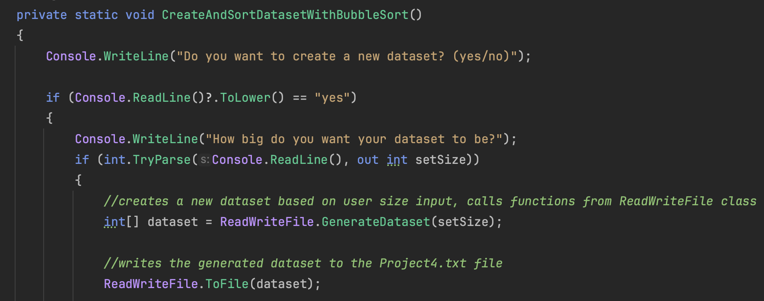

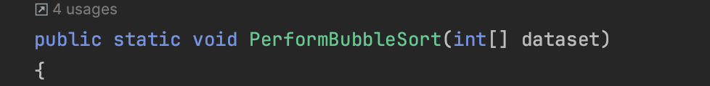

### 4.2.2 Quick Sort

This algorithm relies on partitioning elements into smaller, hopefully even, groups whereby it recursively sorts these until the whole dataset is sorted.

I believe that the best data structure for this situation would be an array since it allows for sequential traversing/accessing, and this is heavily important because of the partitioning element within our quick sort. We need to be able to access differing elements within the array as we numerous pivots, and since arrays provide constant-time random access, meaning we can access any value if we have its index. Additionally, elements in an array are stored in contiguous memory locations, so there is efficient use of memory which contributes to the overall efficiency of the quick sort algorithm.

An alternative data structure would be a linked list since this also consists of a linear collection of elements but is accessed using pointers to the next element instead of an index. Linked lists can dynamically change at runtime so this may be beneficial in a scenario where the dataset changes during execution. However, using a linked list for a quick sort would limit us on what options are available to choose for the pivot element, particularly to the front of the list since we are unable to access random elements within a linked list. This may be more vulnerable to becoming a worst-case scenario and as such efficiency will take a hit, meaning this is a less preferred data structure.

Based on the pseudocode and the desk research I have done into what data structures may be best suited, I intend to use arrays to implement the data structures into C# code. For the quick sort algorithm in place, they will be used to store the dataset of randomly generated integers, within an integer array. Additionally, this array will be used as an argument for the functions needed for the algorithm itself.

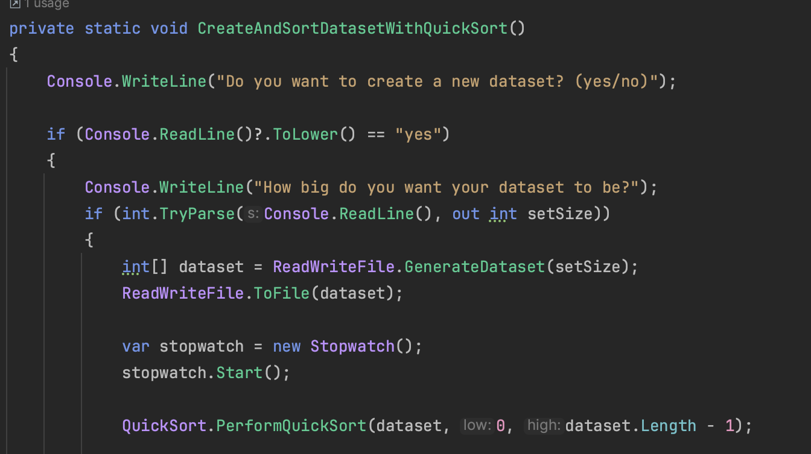



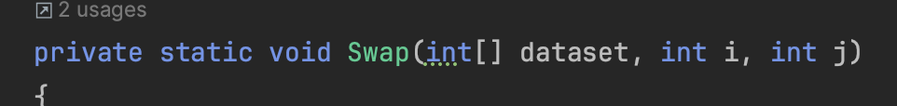



## 4.3 Implementation

The implementation of the given pseudocode into C# code was relatively easy as there not much that needed to be changed for it to work. Something minor that I did have to deal with however, was the fact that I split my functions into their respective classes/files to make the project easier to understand and traverse between, and so I had to use my knowledge of Object-Orientated Programming to implement this. I did so by giving each major subsection of the whole project its own class, and then from here I programmed the respective functions within each class.

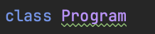

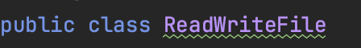

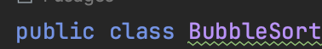

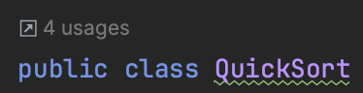

­­­­­

Whenever I needed a function from a class that was not part of the current scope, I simply accessed it using the dot syntax.

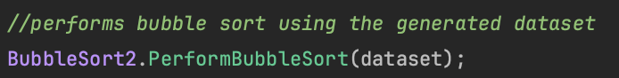

Moving on to the individual implementation, for the bubble sort pseudocode, it was easy to begin the setup process and initialise the variables that were needed. To get the dataset, then I just had it as the parameter for the function and it would be created within Program.cs dependent on if the user creates their own dataset or not. For the other variables, it was just the case of setting them to an appropriate data type to avoid any errors or mismatched data types.





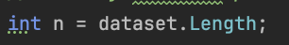

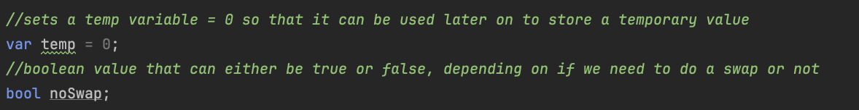

In addition to this, I implemented a little bit of error handling so that it would not perform an unnecessary sort on a dataset that is too small or on a dataset that does not exist.

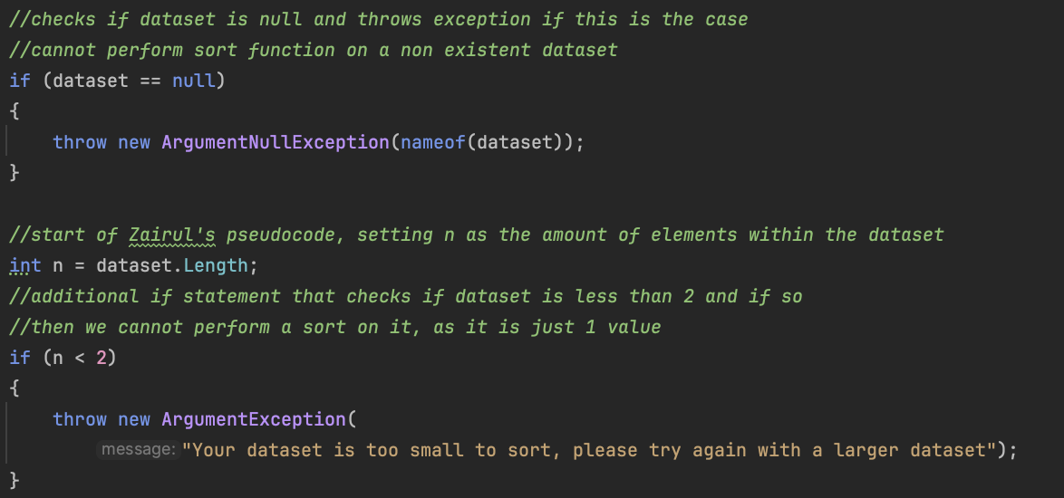

Next it was the case of implementing the while loop conditions and its subsequent code to be executed if the condition remains. The pseudocode was very well written and as such it meant it was easy for me to implement it into C#. However, an issue did arise when writing the conditions for the inner for loop, as when I set the condition to (from I = 0, to I = n-2) then I ended up with a sorted list that had not sorted the final 2 values. This required a simple change in conditions and then the code worked fine, and the sorted dataset was displayed back to the user. The rest of the lines of pseudocode required no additional changes and it meant I could follow line for line, resulting in a successful application.



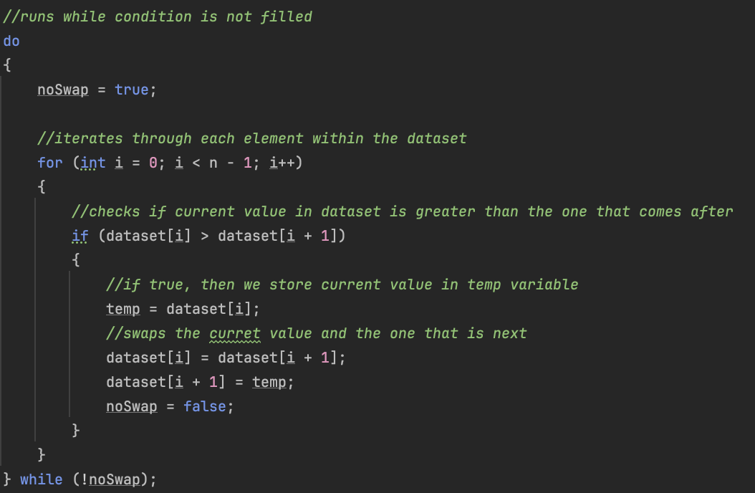

Next, I had to deal with implementing the quick sort algorithm from Zairul’s pseudocode into C# code. This required a little more effort and work arounds since it was split into multiple functions. Due to this fact, I had to work out which place was the best for me to start from and after reading through all the pseudocode and noticing that algorithm 3/4 call other functions, I decided that starting with implementing the Swap function would be best.

To start with, I looked at the inputs required and created a private static function named Swap that would not return a value but would take 3 inputs as required. These were all integers as that is the scope of the datasets for the project. From here I could start working on the implementation of the code itself, and this was a fairly easy process as it would be just a carbon copy of the pseudocode in C#. Technically I could have used a feature within C# called tuples to avoid the use of a temporary variable, but I did not see much reason in doing so since it does not change the underlying operations and it is only a small function.



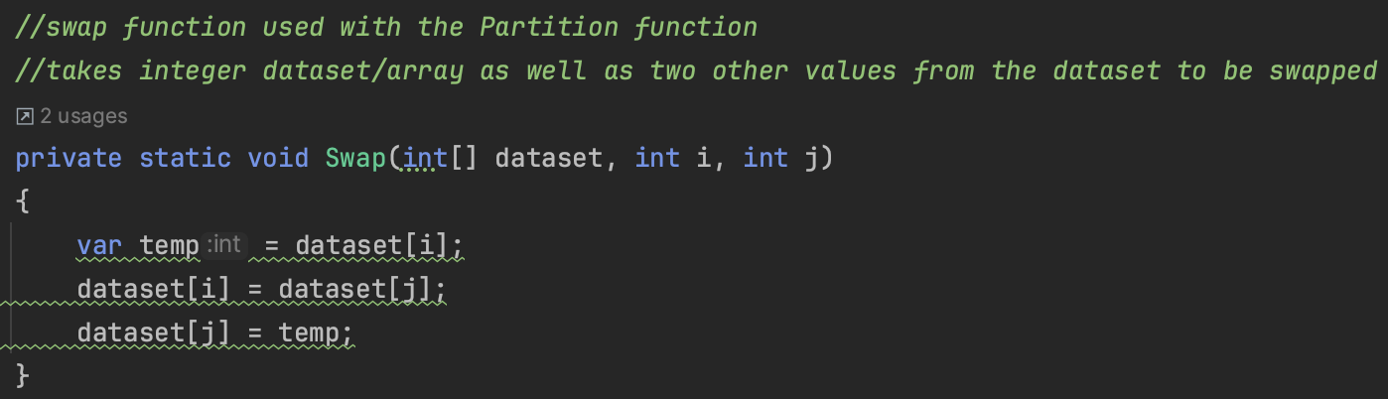

If tuples were used:

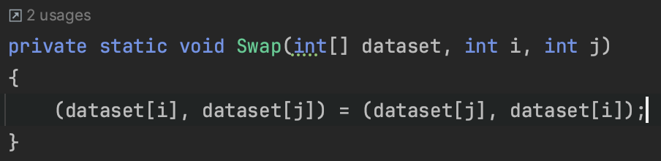

Next, I moved on to implementing the Partition algorithm, which is arguably the main concept that quick sort revolves around. Within this, the elements would be checked and swapped if the comparison proved true.



The implementation started off with initialising 2 of the variables that were a part of the algorithm, one of which determined what the pivot point was going to be for the algorithm. This was the key part in determining the overall performance of the algorithm as the complexity is reliant on the pivot point, if a bad pivot is chosen then the sort’s worst performance equates to around the same as other sort’s average/best performance. If I wanted to further optimise the algorithm, then I could have it so that a random element is selected as the pivot or possibly always choose the middle element to try to avoid the worst-case scenario.

After this, the algorithm runs a for loop that iterates from the ‘low’ variable which is one of the parameters and loops until it reaches the ‘high’ variable. Originally, when I started to implement this algorithm and used the for-loop conditions mentioned in the pseudocode, I came across issues with indexing and the algorithm did not sort the elements properly. Instead, I chose to change the condition to loop until the ‘high’ value which meant that it iterated for the entire size of the dataset and as such elements were ordered correctly.

Next, it simply checks if the value from the dataset is smaller than the pivot element, and if this is the case, we call the Swap function previously implemented to swap the values.

Finally, once the for loop has been iterated through and all checks have been done, the Swap function is called one last time and then the function returns an integer value.

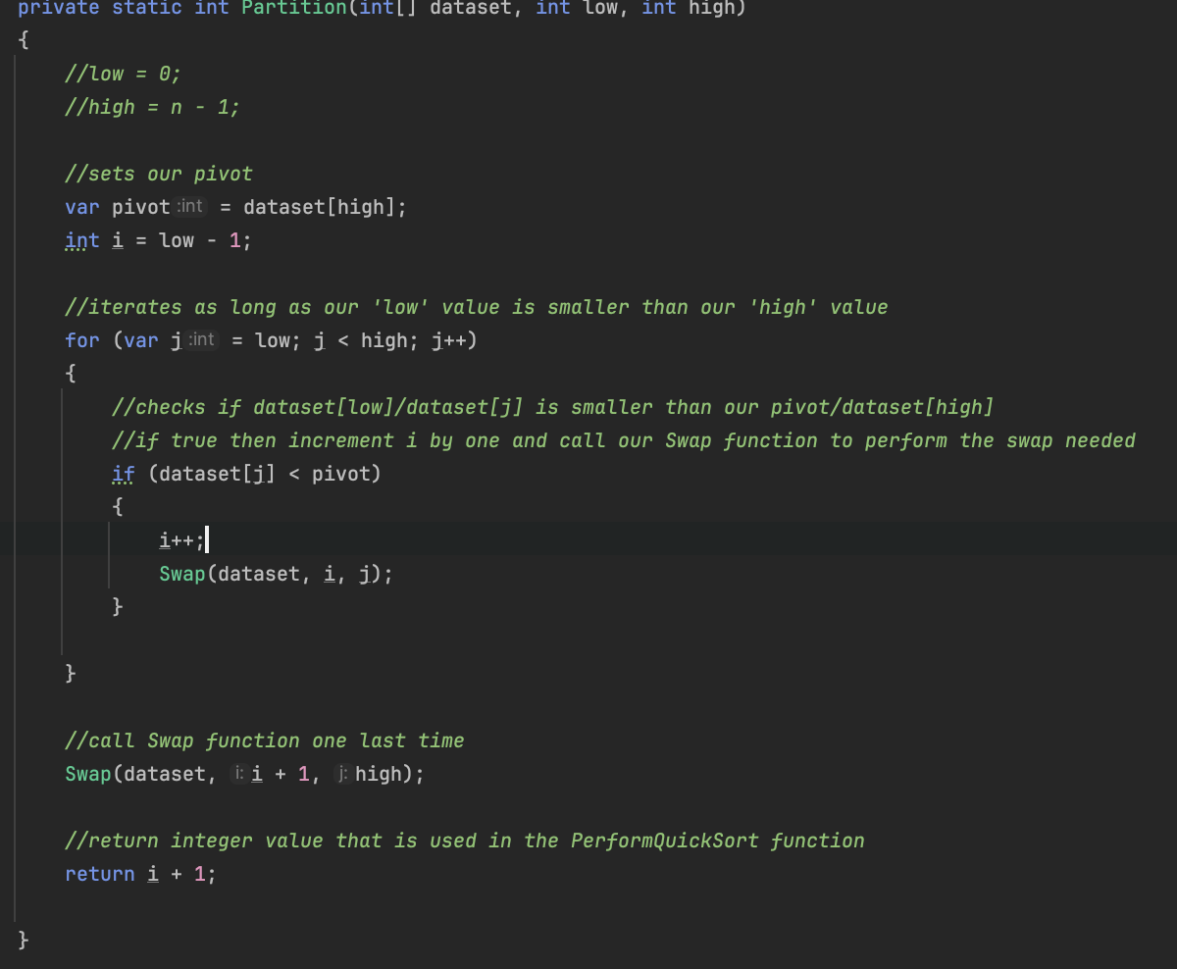

An issue that arose when implementing this function came about through a misunderstanding of the inputs required. When I first wrote the C# code for this function, I defined the low and high variables as parameters for the function but then again within the code itself. This caused a confliction of the definition since a local variable named 'high' could not be declared in the scope because it would give a different meaning to 'high', which was already used in a parent/current scope to denote something else. I did not notice this mistake for a little while and was confused on why my program was not implemented properly and did not work the way I wanted it to, but eventually I revisited the program and it was an easy mistake to fix, just by commenting out the local definition.

Finally, once the other 2 algorithms had been implemented, I had to move onto the sort function itself which is where the recursive calls (a key feature of the quick sort) began.



To start with, it was a simple function definition which took the dataset, and a set of 2 integers as parameters, like the partition function. I did make the mistake of making a local definition of the variables again, but this was quickly resolved alongside the one within the partition function.

Next, a simple if statement was implemented, that followed the conditions of the pseudocode and checked if the ‘low’ value was smaller than ‘high’. If this was true, then we set a variable ‘pi’ that would call the partition function and store it’s returned integer value.

From here, the recursive calls begin, as once we have the ‘pi’ variable, the function calls itself once where ‘pi’ is the value of ‘high’ and another where ‘pi’ is the low value. This whole process repeats as long as the conditions return true, and the dataset remains unsorted. Once the condition is no longer true then this means we have a sorted dataset, and the Program.cs uses this to display the sorted list back to the user.

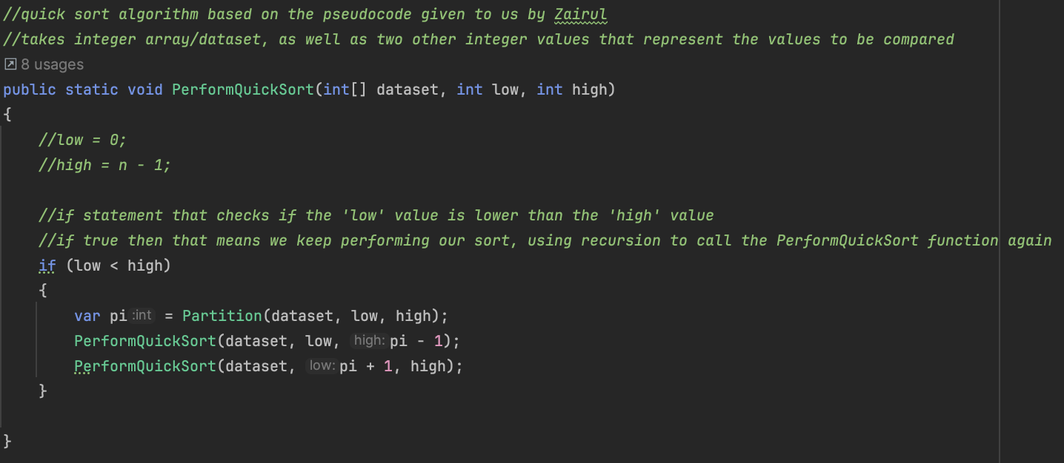

## 4.4 Results

To properly tabulate my results and get what I believe to be a fair set for each of the sorting algorithms, I have decided to go off course just a little and perform 5 sets of experiments on each dataset.

Within these experiments I intend to keep the dataset the exact same for each one, in the hopes that I will be able to get a running average once I have conducted all 5 experiments. However, a concern and potential issue of using this approach would be that the time may not be accurately consistent if I am calling the method one after another during one execution of the program. This is potentially because of numerous reasons, such as computer systems using caching to store frequently accessed data in a faster memory location. If the dataset is small enough to fit within this cache memory after the first sort performed on it, then it is very much possible that my subsequent operations may benefit if I am calling the function after itself. An additional explanation would be because .NET which is where C# is based upon, used something called JIT for compilation, whereby the first time a method is executed, it is compiled to machine code. Subsequent executions will be able to skip this compilation step and use the precompiled code, resulting in a faster execution.

I intend to hopefully counteract these issues via a couple of methods. Either by:

1. Stopping execution of my program after the sort has been executed and the result recorded. This will be the one I try at first to gather consistent results from my data, however if I am still getting inconsistent results then I will attempt to move onto my next approach.
2. Fully resetting my IDE, which in this case is Rider from JetBrains, by completely closing the application, using application manager if necessary. This would be in the hopes that the cache would be reset upon reopening, and as such should hopefully provide a more consistent environment for my testing.

Below are the results I gathered via testing:

**Bubble Sort**

1. Done one after another during a single execution, did not restart application.

[Bubble Sort Experiments](https://youtu.be/Ex8Eb5YSZc4) – this is **not** necessary viewing, I simply wanted to showcase all the bubble sort experiments done in one video. I understand that this too comes with its own drawbacks since I did all 5 experiments for each dataset size so this may not entirely be fair.

|  |  |  |  |  |  |  |
| --- | --- | --- | --- | --- | --- | --- |
| **Bubble Sort**  Time taken, in milliseconds | | | | | | |
| **Data size** | **Experiment 1** | **Experiment 2** | **Experiment 3** | **Experiment 4** | **Experiment 5** | **Average Time** |
| **500** | 1.5113 | 2.3566 | 3.1366 | 2.8887 | 3.6951 | 2.7177 |
| **1000** | 5.9085 | 11.0235 | 8.9309 | 9.1273 | 8.9802 | 8.79408 |
| **2000** | 22.3953 | 27.7831 | 40.2416 | 23.6082 | 22.8324 | 27.3721 |
| **5000** | 145.8914 | 168.8778 | 177.5301 | 159.1932 | 152.1707 | 160.7326 |
| **10000** | 639.8216 | 945.0922 | 729.7438 | 650.8467 | 681.2028 | 729.3414 |

From here, I can see that most of the datasets tend to peak during the 2nd or 3rd experiment for some reason. These can arguably be considered outliers within the experiments as in some instances cause a dramatic change for the overall average time performed. I believe that the cause could be attributed to all the sorting and dataset generation being done within a single execution, as previously stated before the experiments.

1. Stop execution after each sort is done, perform on same dataset for each data size.

[Bubble Sort with separate executions](https://youtu.be/2ik1Zm3BdF8) – once more this is **not compulsory** viewing and is not a fair representation of the whole program. It is merely to showcase how I obtained my results for this test.

|  |  |  |  |  |  |  |
| --- | --- | --- | --- | --- | --- | --- |
| **Bubble Sort**  Time taken, in milliseconds | | | | | | |
| **Data size** | **Experiment 1** | **Experiment 2** | **Experiment 3** | **Experiment 4** | **Experiment 5** | **Average Time** |
| **500** | 1.9447 | 5.5716 | 2.9777 | 2.9035 | 3.0937 | 3.29824 |
| **1000** | 7.8857 | 7.1183 | 36.755 | 6.8334 | 8.1188 | 13.34224 |
| **2000** | 28.8677 | 55.0039 | 36.3918 | 25.714 | 27.7977 | 34.75502 |
| **5000** | 155.5932 | 154.144 | 162.5965 | 156.2767 | 161.8288 | 158.08784 |
| **10000** | 636.8607 | 657.1519 | 655.6947 | 718.5515 | 649.49 | 663.54976 |

In comparison with the bubble sort that did all its experiments during one program execution, I can see that the former performed slightly faster for the first 3 datasets but for the much larger datasets (5000 and 10000), the one with separate executions seemed to perform better. However, both sets of results seem to have values that are significant outliers within the experiments so this could possibly warrant further testing, but I believe that will go outside the scope of this project.

In terms of which one is possibly best for the most accurate results, then it is a little hard to give a set answer since it depends on the context. If the situation calls for entirely independent results where the experiments should have little influence on each other then I believe it is best to perform the sorts separate from each other. However, if speed is the main concern and you are having to perform multiple sorts within a program then it may be best to not worry about halting execution. Additionally, from both sets of these results, we can see that as the dataset size increases, the time taken to perform the full sort grows rapidly, which is in line with the examination of the algorithm’s complexity, so, it is best to try and use a different sorting algorithm if you are intending to use larger dataset sizes.

**Quick Sort**

1. Done one after another during a single execution, did not restart application.

[Quick Sort Experiments](https://youtu.be/n3XLdtkuUBo) – again this is **not** compulsory viewing and does not represent my final showcase of the full project.

|  |  |  |  |  |  |  |
| --- | --- | --- | --- | --- | --- | --- |
| Quick Sort  Time taken, in milliseconds | | | | | | |
| **Data size** | **Experiment 1** | **Experiment 2** | **Experiment 3** | **Experiment 4** | **Experiment 5** | **Average Time** |
| **500** | 0.6476 | 0.6366 | 1.5976 | 0.9075 | 1.4898 | 1.0588 |
| **1000** | 0.2835 | 2.9227 | 2.0679 | 1.705 | 2.0522 | 1.80626 |
| **2000** | 0.4495 | 3.8361 | 4.4822 | 3.0788 | 2.352 | 2.83972 |
| **5000** | 1.551 | 9.9443 | 7.6939 | 16.3022 | 5.8995 | 8.27818 |
| **10000** | 2.969 | 23.5127 | 14.5732 | 133.8887 | 16.6889 | 38.3265 |

Like the bubble sort, there are multiple instances across all dataset sizes where there is a bit of a peak on the graph. Again, this might be because all experiments for all datasets were done in one single execution of my program and as such, it may have contributed to the performance of the sorting algorithm.

1. Stop execution after each sort is done, perform on same dataset for each data size.

[Quick sort with separate executions](https://youtu.be/1-MlR5iXrck) – **non-compulsory** viewing that showcases all experiments where program is halted after each execution.

|  |  |  |  |  |  |  |
| --- | --- | --- | --- | --- | --- | --- |
| Quick Sort  Time taken, in milliseconds | | | | | | |
| **Data size** | **Experiment 1** | **Experiment 2** | **Experiment 3** | **Experiment 4** | **Experiment 5** | **Average Time** |
| **500** | 0.6807 | 1.6775 | 1.8707 | 1.366 | 1.3617 | 1.39132 |
| **1000** | 0.8996 | 2.0648 | 1.7665 | 2.5482 | 6.8293 | 2.82168 |
| **2000** | 0.6333 | 4.1149 | 4.3928 | 3.6351 | 4.1567 | 3.38656 |
| **5000** | 1.2417 | 7.5479 | 6.5313 | 8.1938 | 14.0991 | 7.52276 |
| **10000** | 3.5254 | 16.6738 | 18.304 | 143.8065 | 15.2336 | 39.50866 |

In comparison to the quick sort that did all its experiments during a single execution, we can see that there is a marginal increase in the time taken for the sort on the dataset to complete but it is likely not significant enough to warrant a major decision. The small difference in time taken should not increase drastically, even with much bigger datasets and as such there is no real advantage to using either one of the two approaches in my opinion. The only potential bias I may have would be towards the sort that conducted all its experiments in separate executions since this makes the output much less likely to have been influenced by previous calls of the function, and as such may be a bit more suited if the purpose of program is to sort a single dataset at a time.

**Summary:**

In conclusion, the findings gathered from my numerous experiments allow me to present a fair summary and discussion around the two sorting algorithms. To begin with, it was expected from the start that the bubble sort would be much less efficient than the quick sort and this was then further proved correct when you compare the values gained from the results. For example, the slowest average time within the quick sort experiments was around 39.50866 milliseconds but for the bubble sort, the slowest average time was 729.3414. this totals to a difference of 689.83274 milliseconds or, almost an 18.5 times difference between the former and the latter.

Whilst these findings are not the best representation and further experiments could have been done to ensure the validity of these results, it remains a strong comparison and showcase of the differences between the two sorting algorithms. The quick sort practically outshines the bubble sort in every way, other than its space complexity but this difference is marginal even when datasets grow larger, and as such is the choice for many applications/implementations of a sorting algorithm.

Next time, I would have both sorting algorithms operate on the dataset at the same time since the .txt file is not edited, as I believe this would showcase a good comparison of both sorts being done precisely at the same time and on the exact same dataset. Hopefully, this would improve the validity and reliability of my final set of results.

## 4.5 Testing

Before the project gets further, I would like to acknowledge the use of ChatGPT to generate materials that have been included within this project. It was mainly used to get ideas regarding what tests should be conducted, and I gave it the prompt ‘what unit tests can be done on a bubble sort/quick sort?’. From here I was given multiple test ideas as well as how to perform unit testing, the exact output is below:



Additionally, I used it throughout this project it to check the validity of my dataset, whereby I asked it ‘are these values in ascending order?’ before providing the values of my dataset. The exact output of this prompt is attached later in the testing section.

Moving on, for this section, I had to do numerous tests during the process of implementing the pseudocode into actual C# code. This mainly consisted of numerous iterations of my programs upon one another.

For example, I ended up with 3 different main programs that would consist of the menus as well as dealing with user input and presenting them with the correct response. The first one was relatively simple and was built upon just performing the bubble sort to begin with.

**Program.cs**

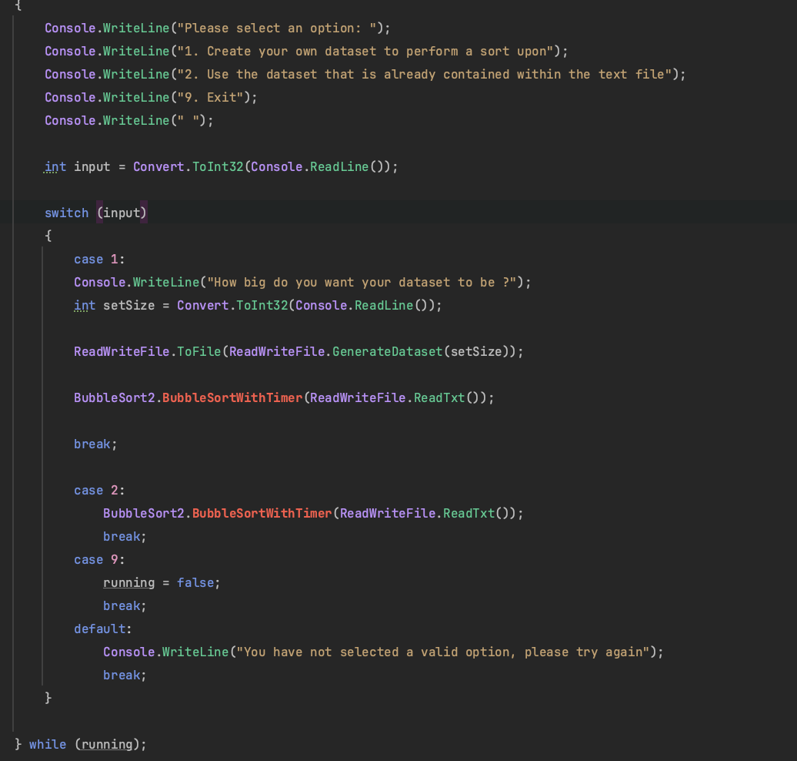

Here the user is presented with a menu and then told to select an option. If they choose 1 then they are prompted with another question where they must choose the size of the dataset that they want, from which the sorting algorithm is performed. The same goes for option 2, where it just uses the existing dataset from Project4.txt. I wanted to just start with a simple iteration at first, and just get the overall idea across so that I could further improve it and adjust where needed.

**Program2.cs**

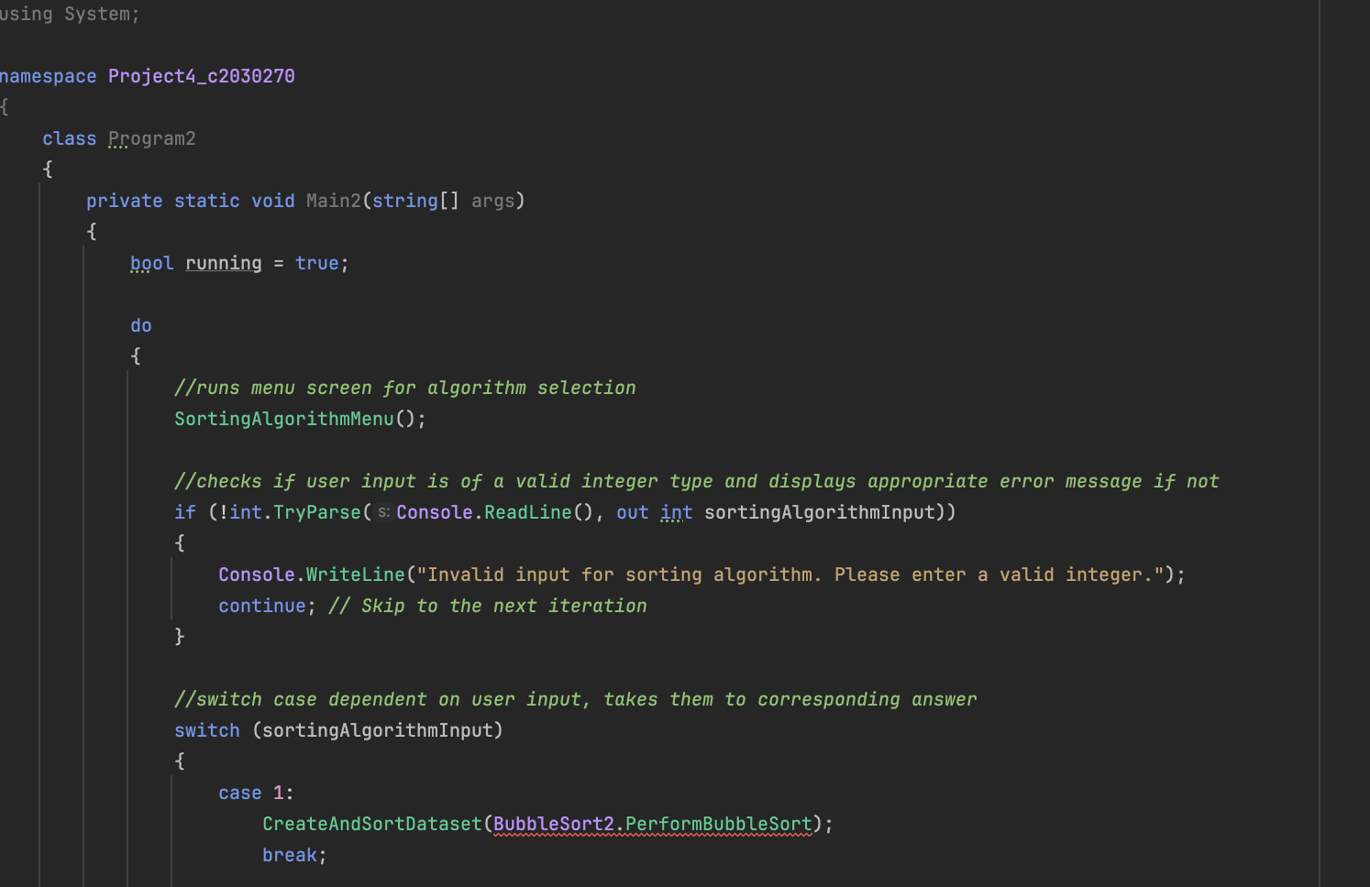

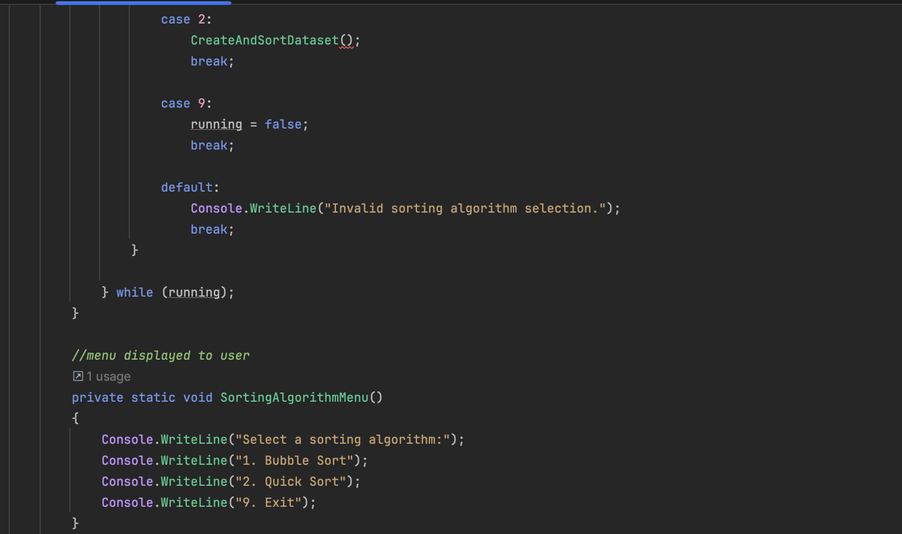

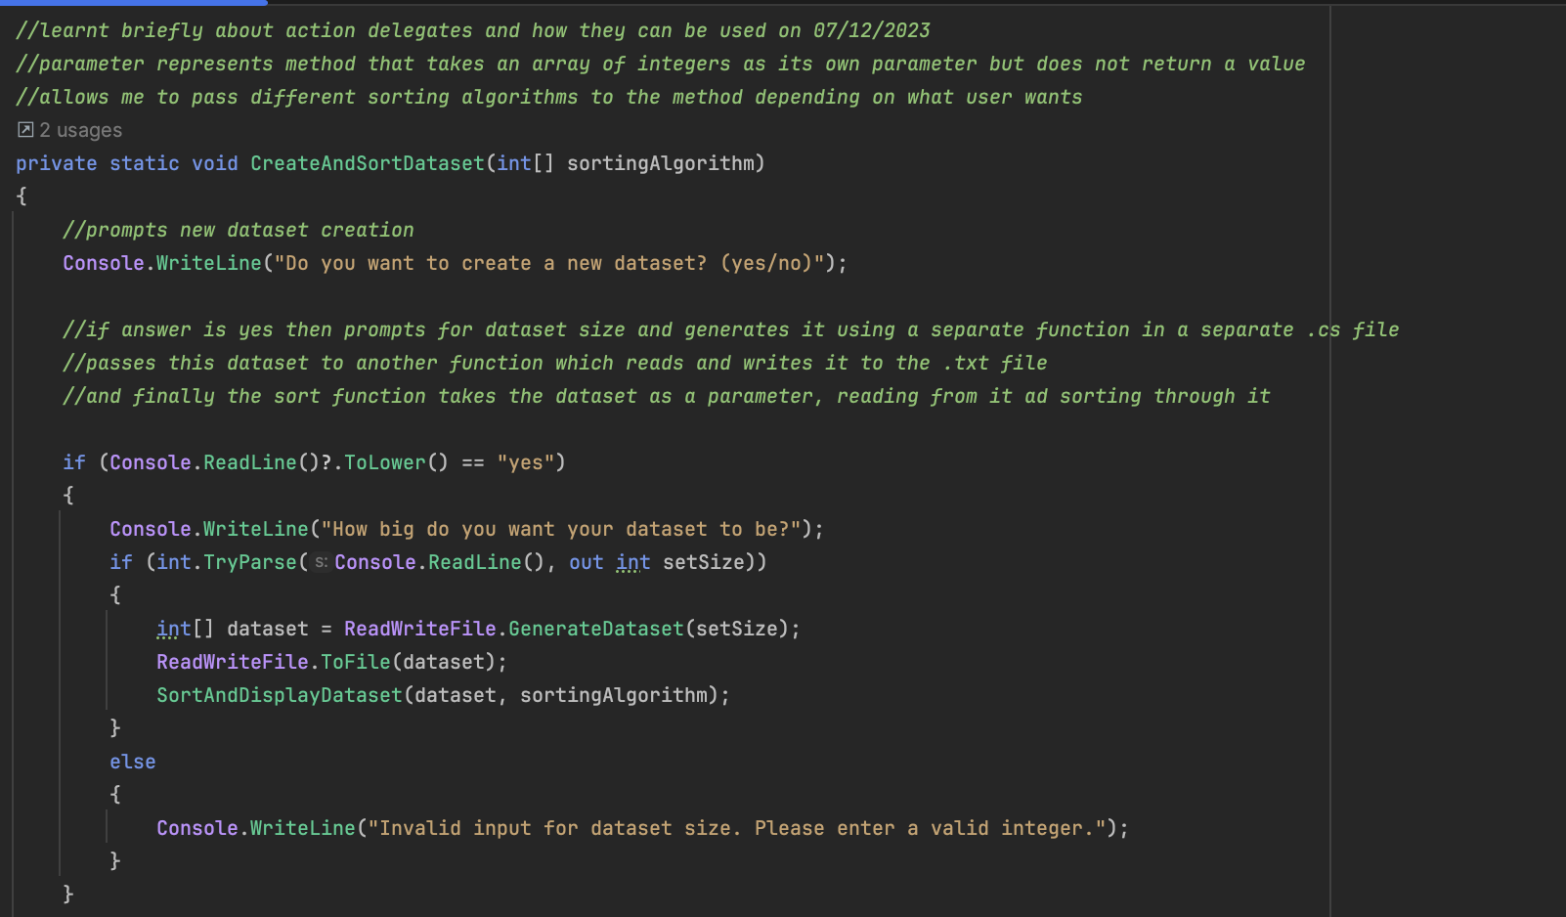

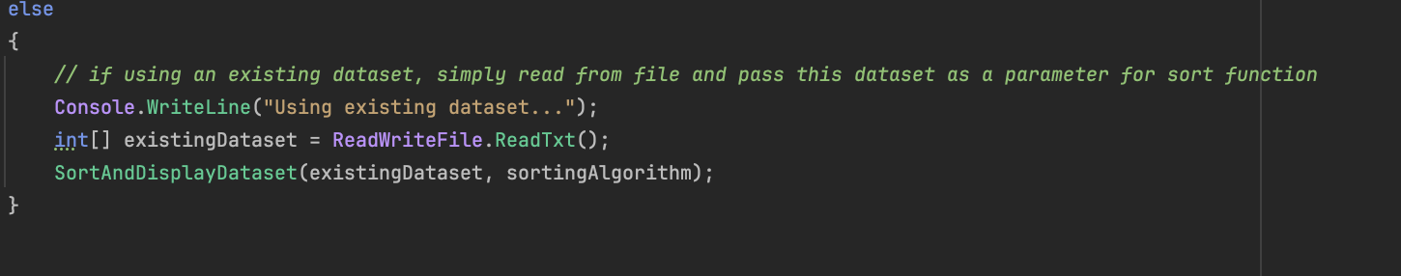

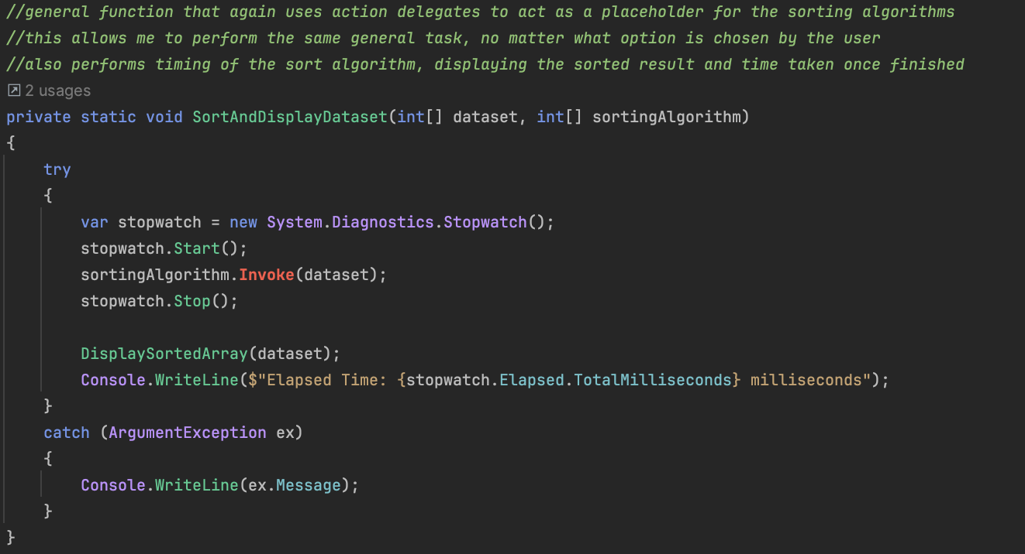

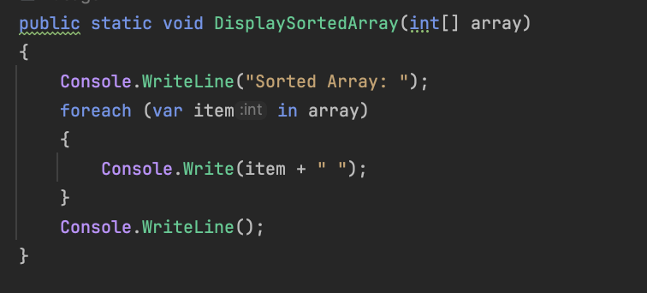

This was the next iteration of my main program file, and I intended to improve upon the first in numerous ways. Firstly, I broke down my problem into many more functions, making my code more modular and easier to understand e.g a menu function, display array function, perform sort function etc

The majority of this was easy enough to implement, as it required breaking down my first iteration into separate components whilst also adding extra details to each such as error handling or data type handling. However, I came upon a big problem when I decided to try and implement a general function that would be able to handle both sorting algorithms. I learnt very briefly about action delegates, which is a type that represents references to methods with a particular parameter list but does not return a value. I intended to have a function that took an action delegate of the sorting algorithm as a parameter and then the function would be able to perform the respective sort using this information. This worked well when I wanted to use the bubble sort algorithm as that only required one parameter, which was the dataset, but when I tried using it on my quick sort algorithm, problems arose. Namely, I was unable to perform the sort since the quick sort algorithm had 3 parameters instead of just the 1, and as such the function I had intended to deal with both was unable to function properly and returned error messages whenever I wanted to try and perform a quick sort. After multiple attempts at trying to make this solution work, I realised that it would not be possible and as such decided I need to iterate once more.

**Program3.cs –** I understand that these are not the best naming conventions, but I wanted to have it so that I could move interchangeably between them.

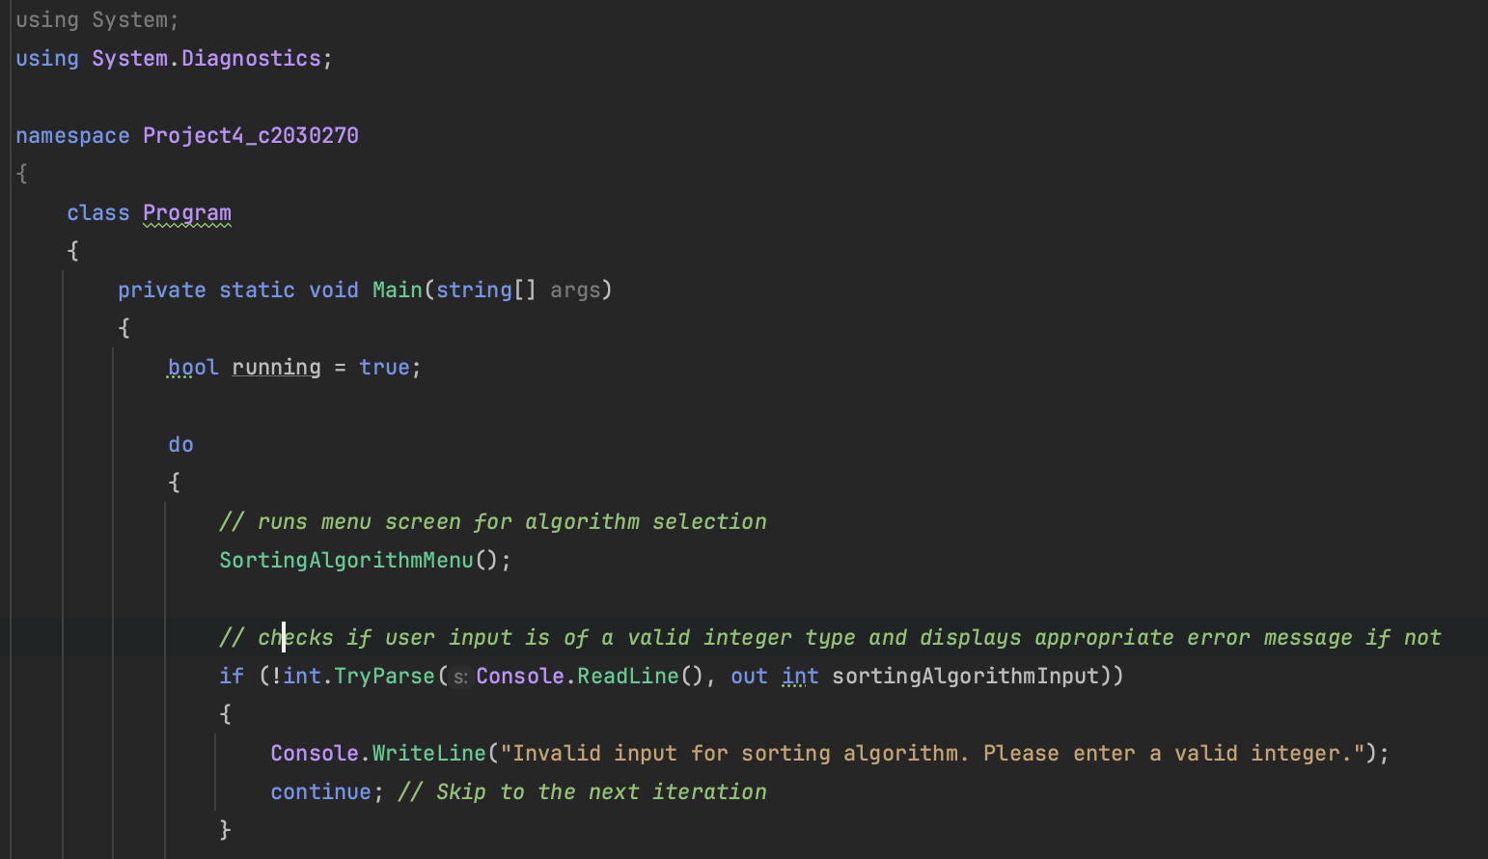

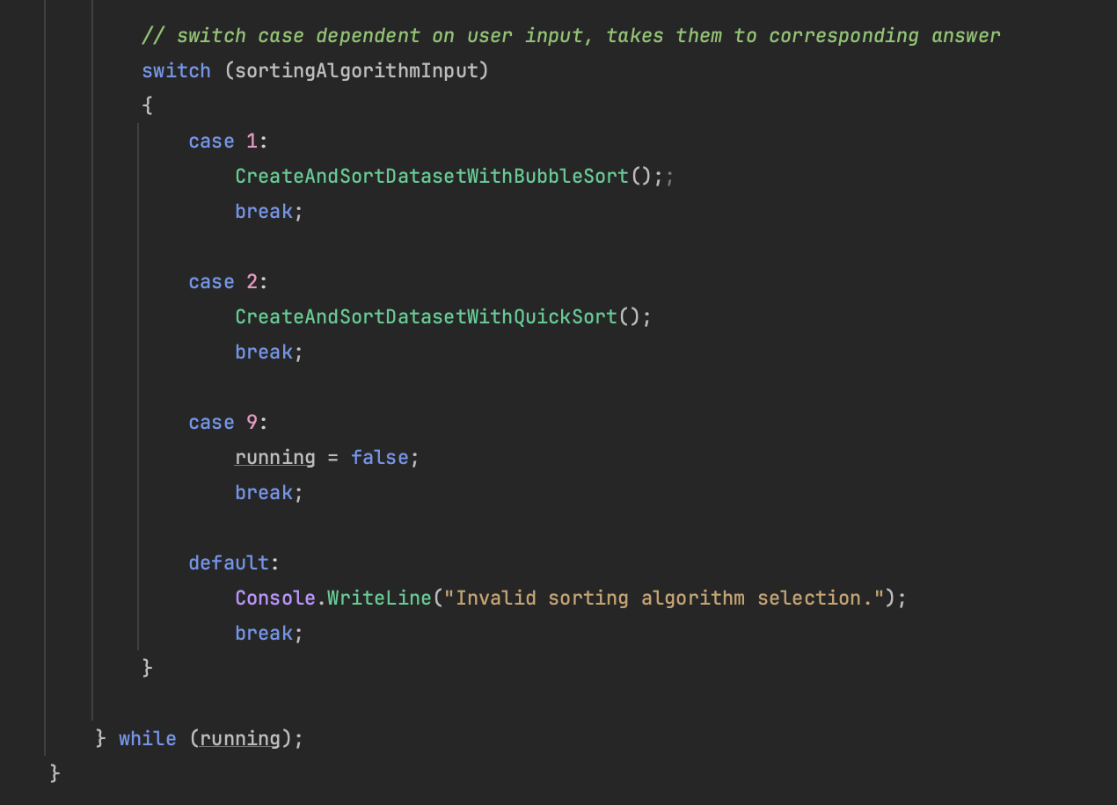

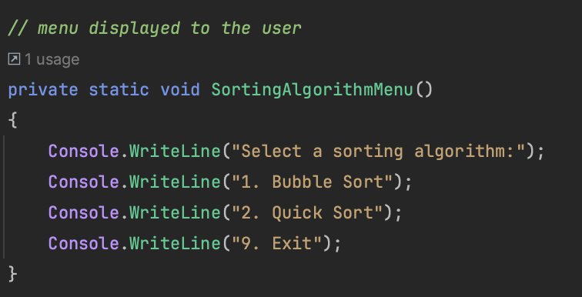

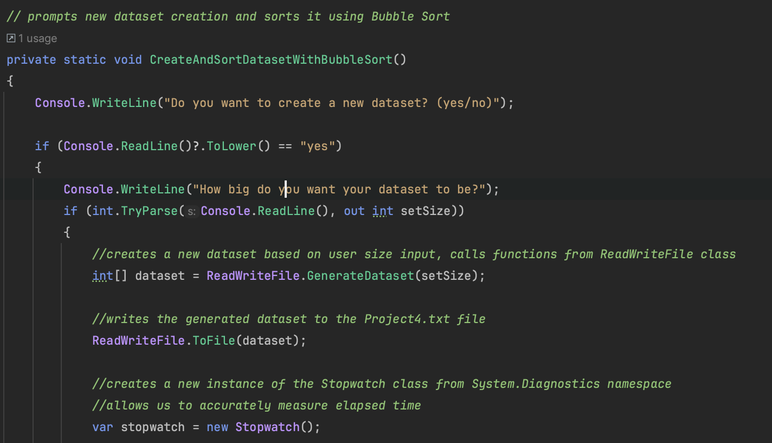

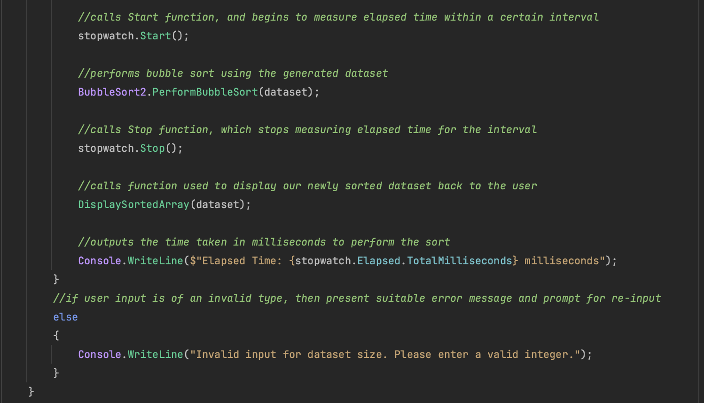

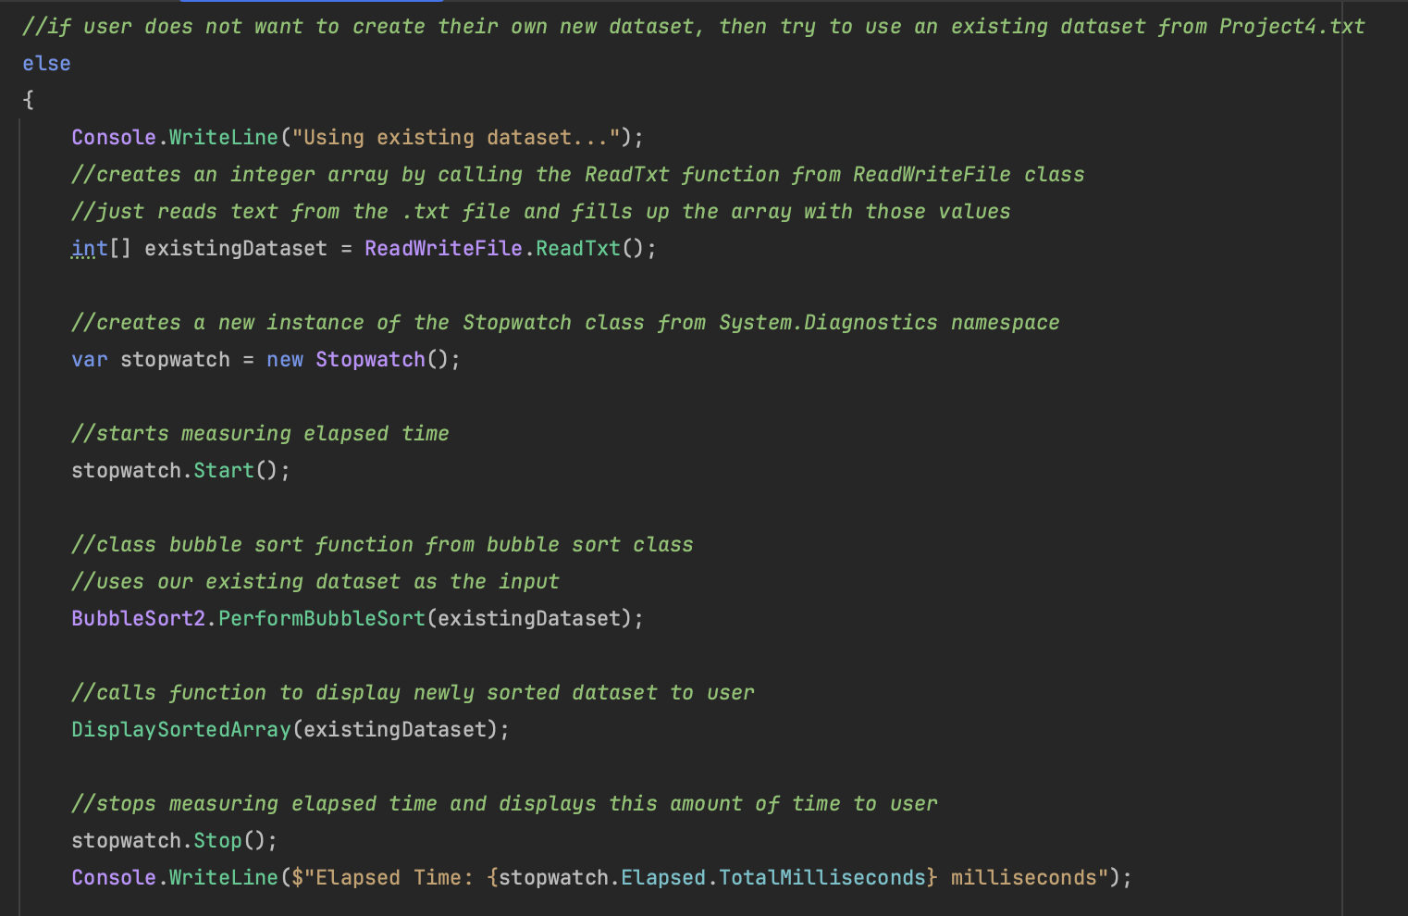

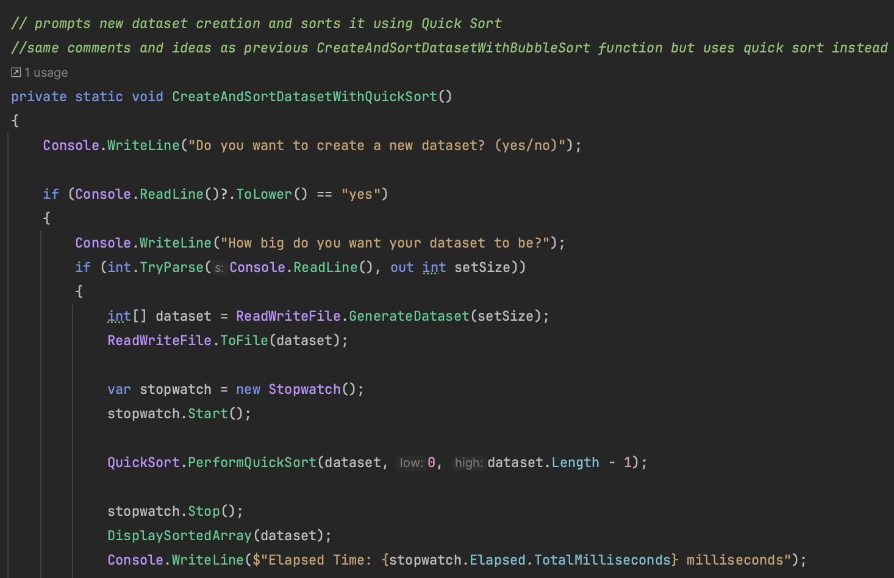

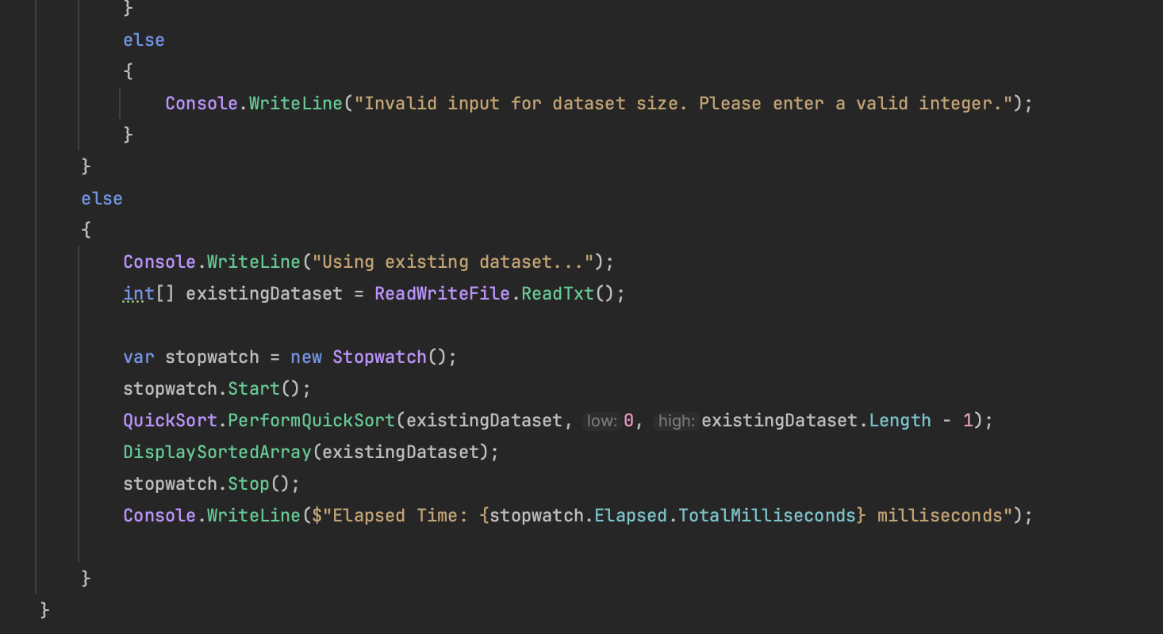

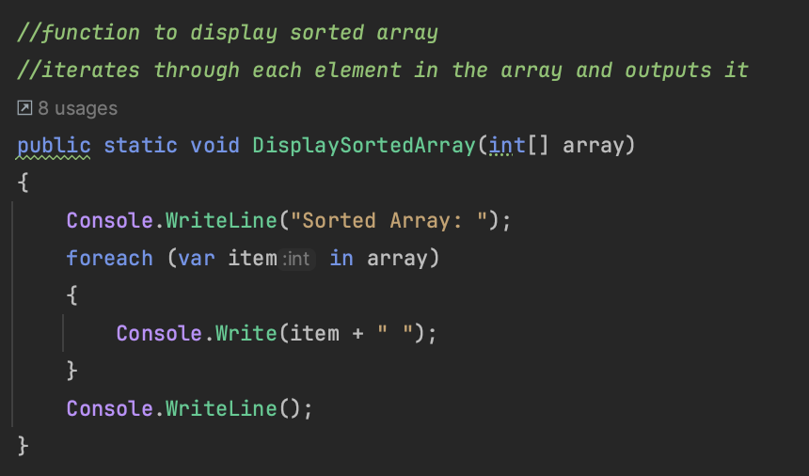

Here the main improvement that I made was splitting the create and sort dataset function into separate functions for the two sorting algorithms. Whilst making my code much bulkier, it allowed me to avoid the problems that arose when trying to deal with delegates and I could call the separate functions dependent on the user choice. This is the iteration that I ultimately ended up choosing as the correct one for the scope of the problem, since when I tested all its functions (creating a dataset to sort from, sorting from a pre-existing dataset, entering a null or small dataset etc) it provided me with all the outputs that I expected. All that was left for me was to individually test the functions and begin timing them which resulted in the answers stated previously.

However, this version did not deal with datasets that were too small or did not exist at all, and as such this was something I realised I needed to improve upon. Here is an example of me testing the bubble sort algorithm using both a dataset of size 1 and 0.

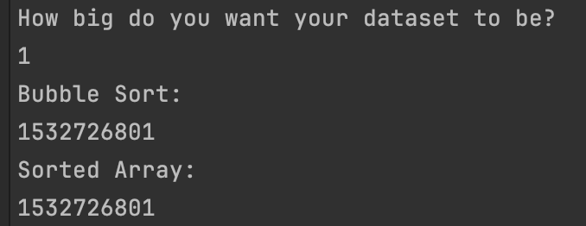

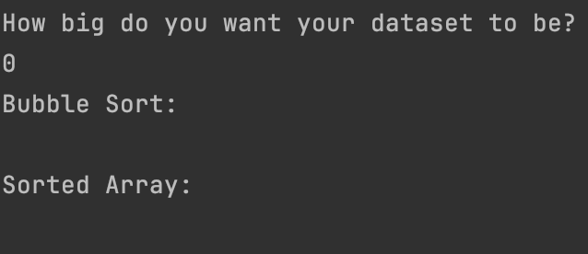

To improve upon this, I added a do while loop that would check the dataset size and would return an error message to the user if their value was less than 2, before prompting them to reinput a value.

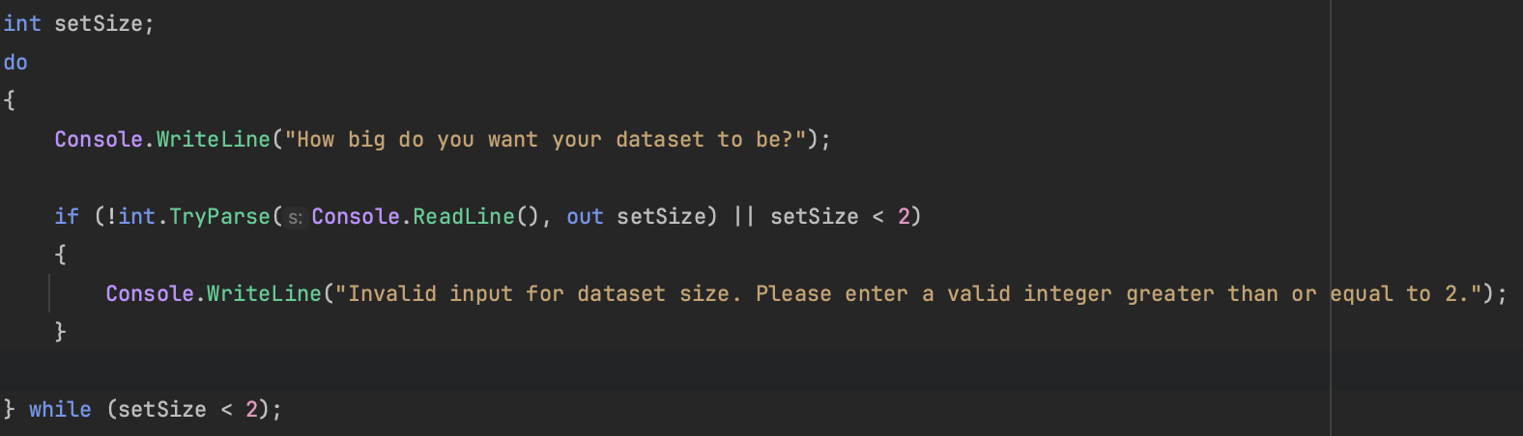

**BubbleSort.cs**

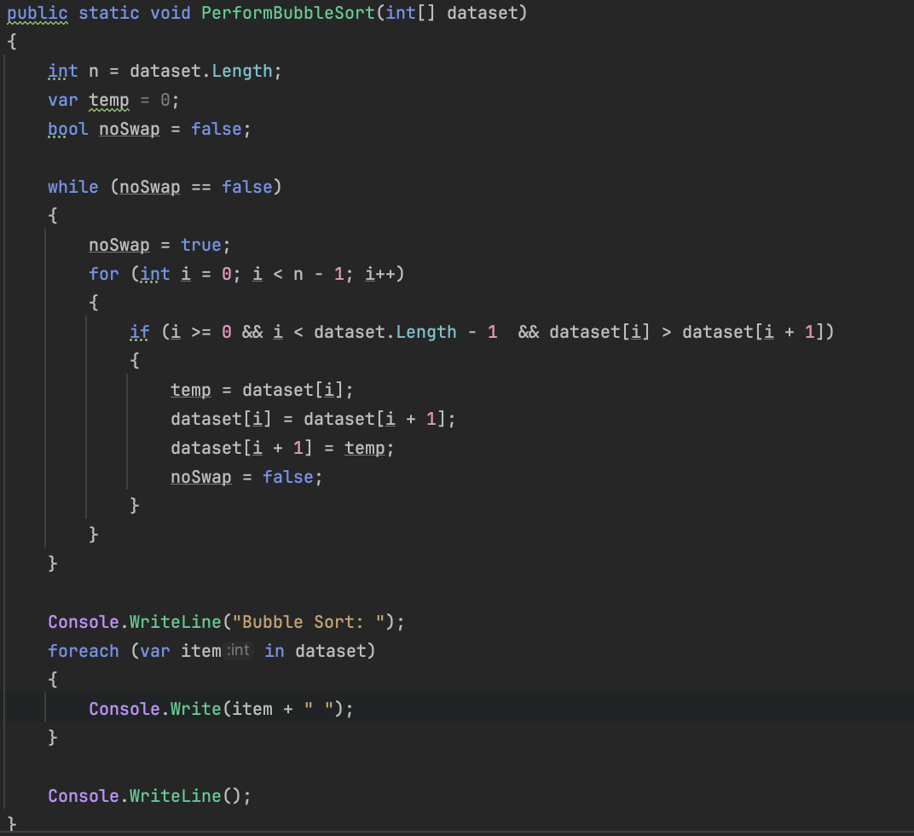

This was the implementation of my bubble sort algorithm, which took the pseudocode provided by Zairul and implemented it into C# code. Since the algorithm is just a single function that did not require much alteration from the pseudocode, it was easy to test and implement. I started by testing with small datasets (10, 20, 50 etc) and then would plug those values into ChatGPT to ensure they were in the correct order.

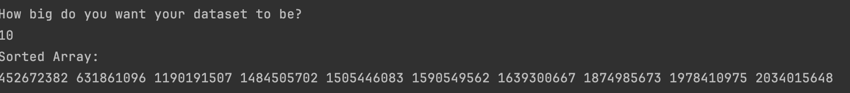

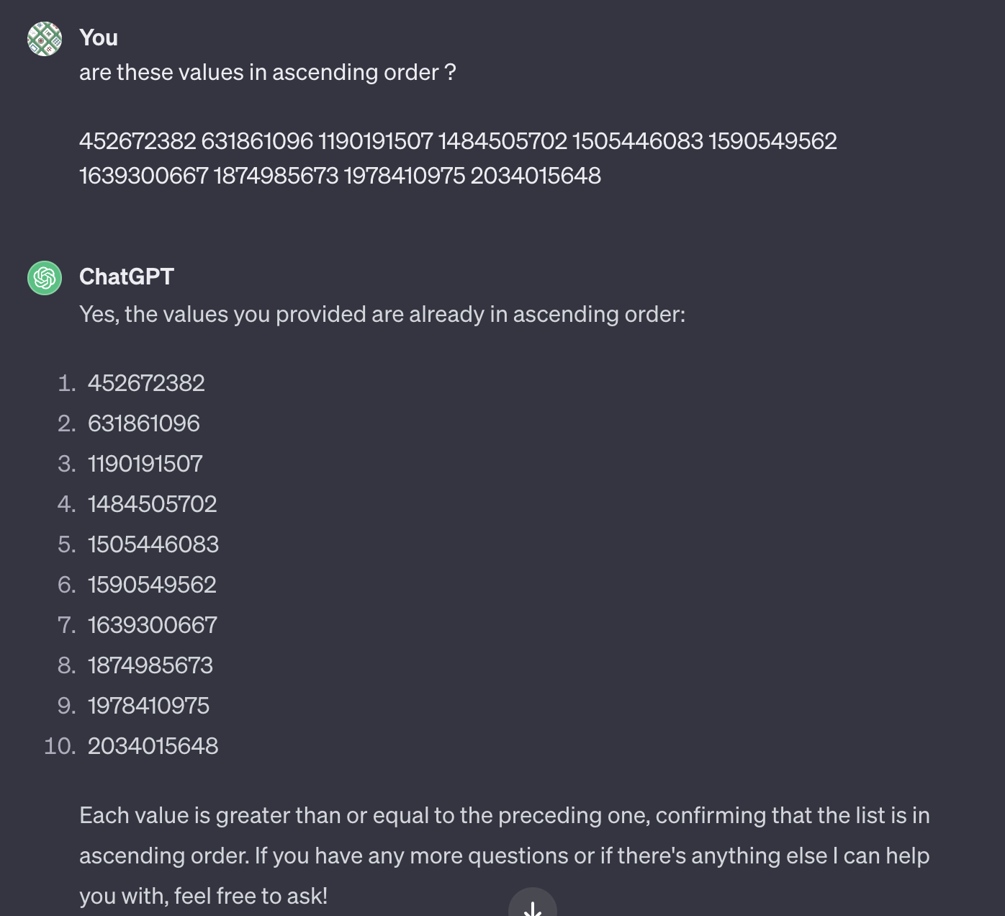

From here, I felt confident enough to test my program on much larger datasets and the experiments turned out valid.

Additionally, within a separate project/solution, I implemented some basic unit testing. My IDE of choice is Rider by JetBrains, and I used the NUnit testing framework as recommended on the official website.

* The first test checks if the sorting algorithm correctly sorts an array in ascending order.
* The second test checks if the method can handle an empty array without throwing an exception.
* The third test checks if the sorting algorithm correctly sorts the array in descending order.
* The fourth test checks if the sorting algorithm functions properly even with duplicate values in the dataset.
* The final test checks if the sorting algorithm performs the sort even if the dataset is already sorted.

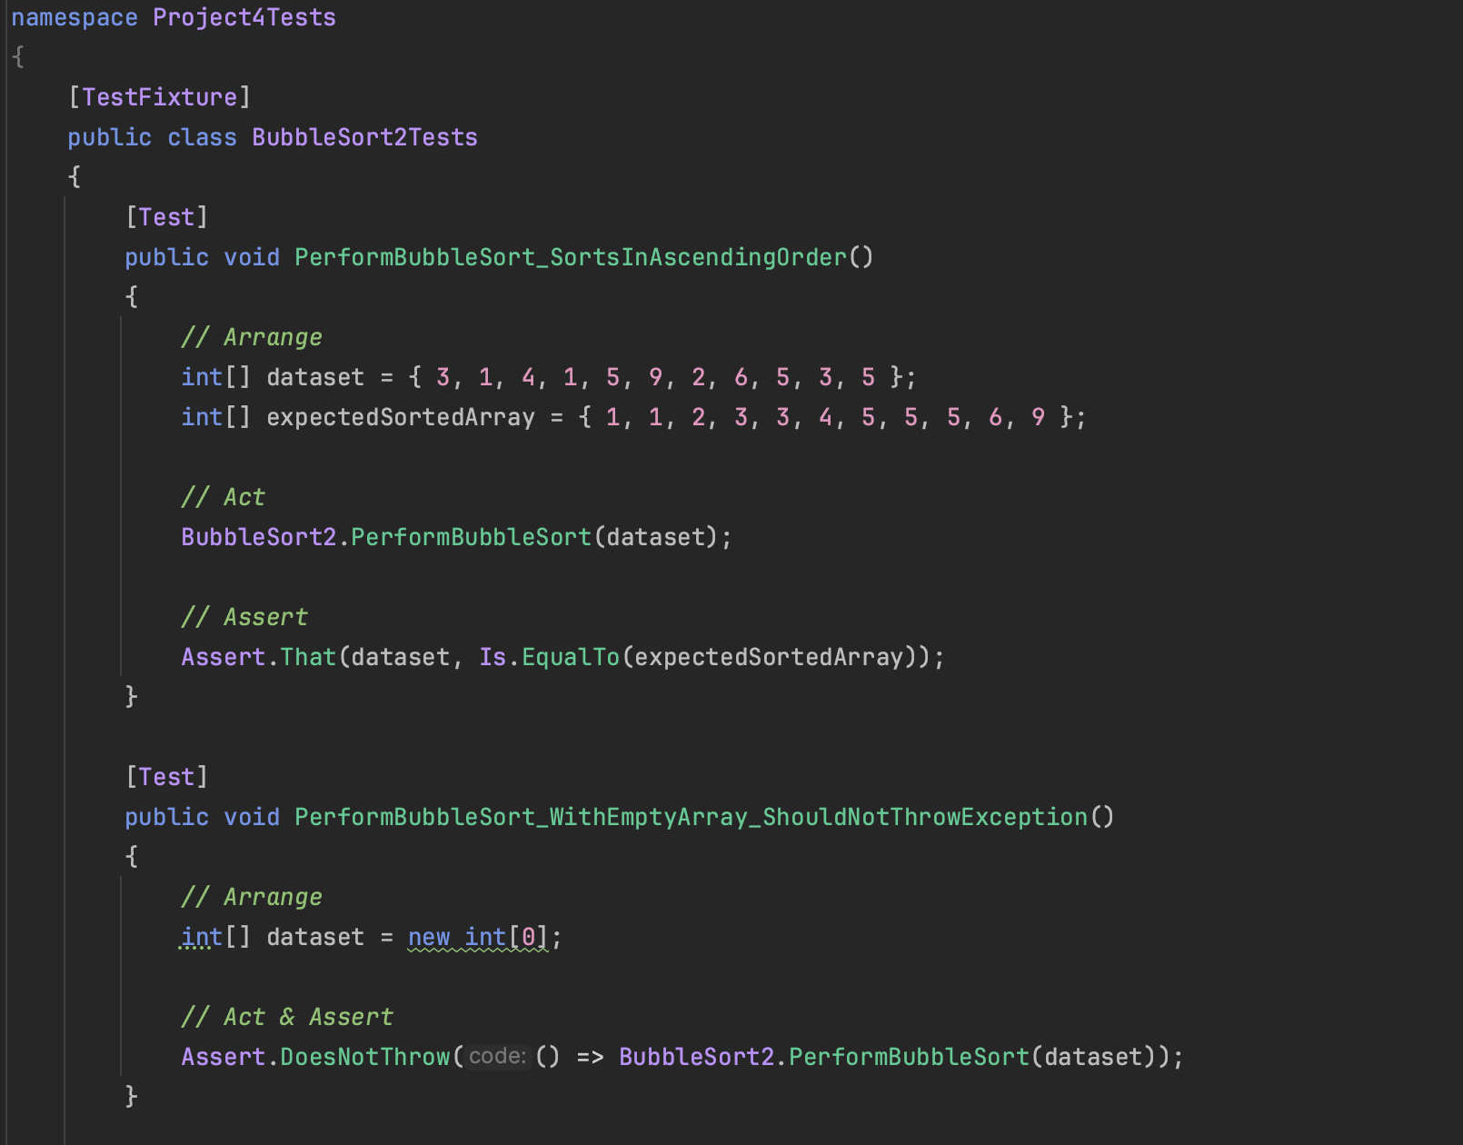

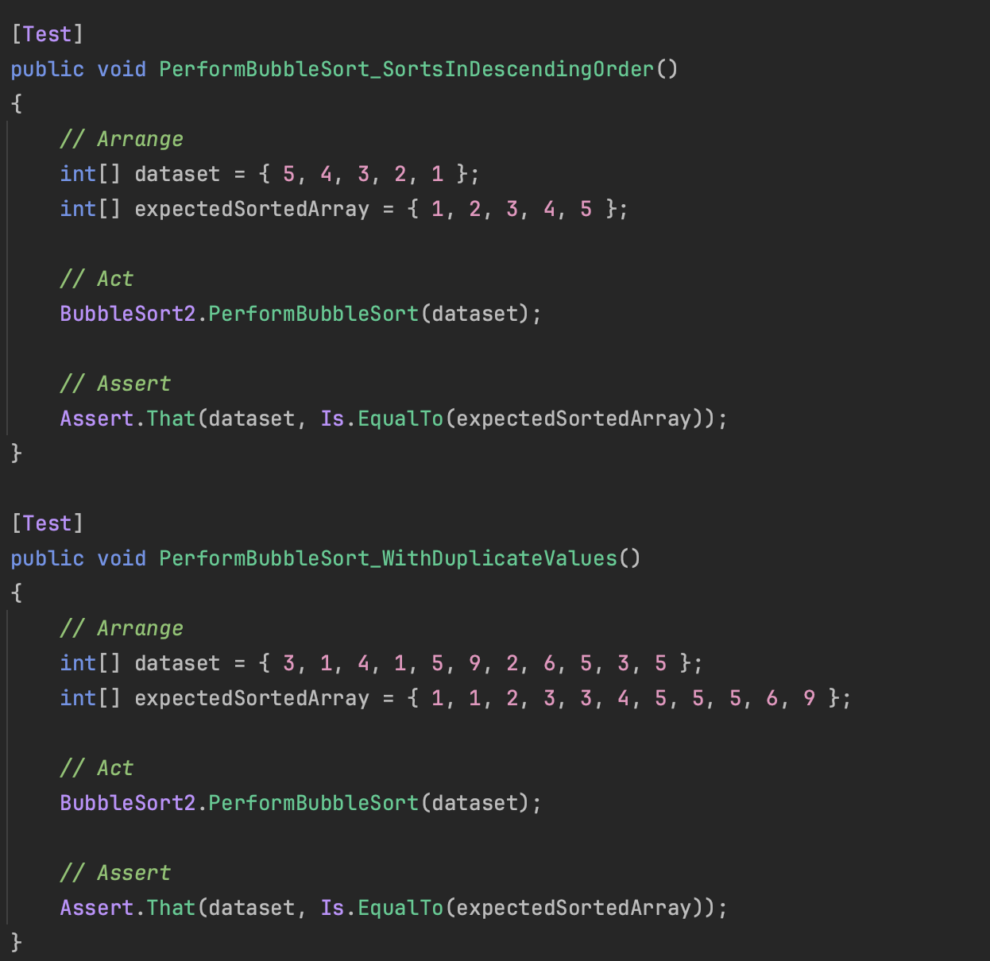

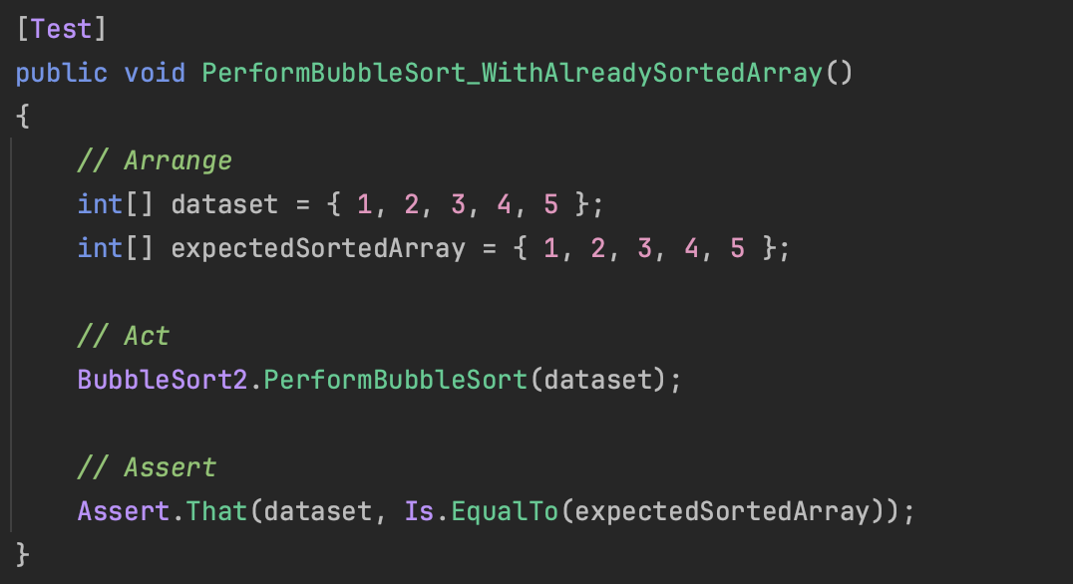

And here are the results:

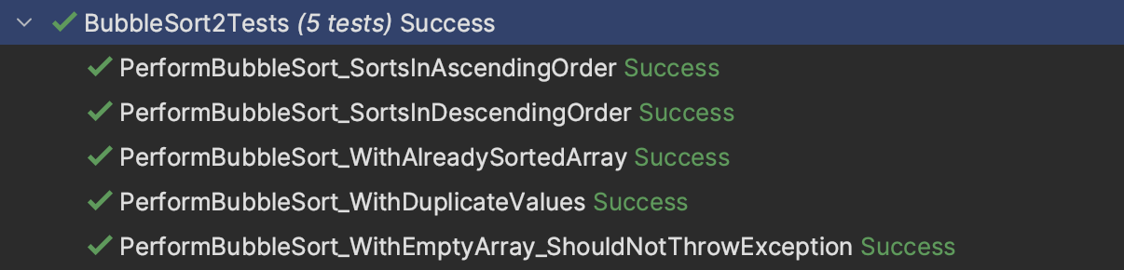

**QuickSort.cs**

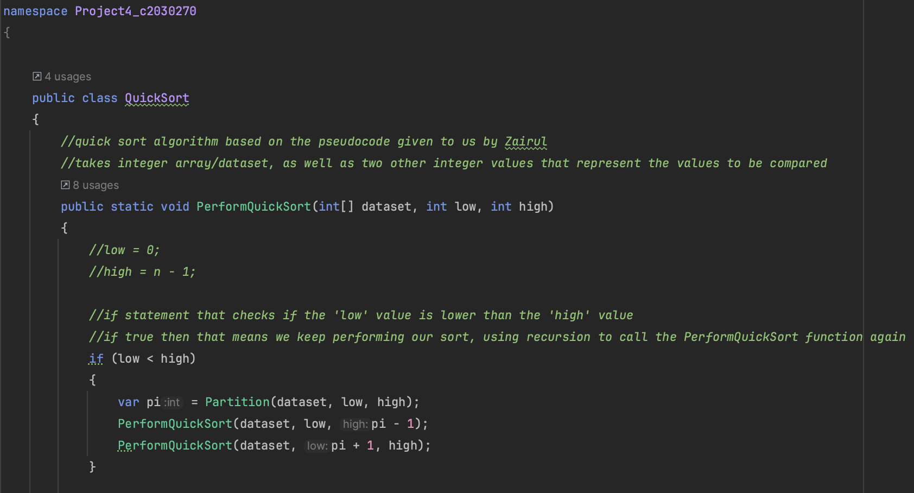

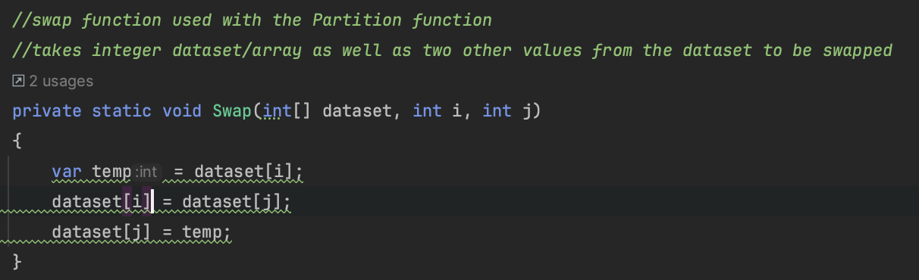

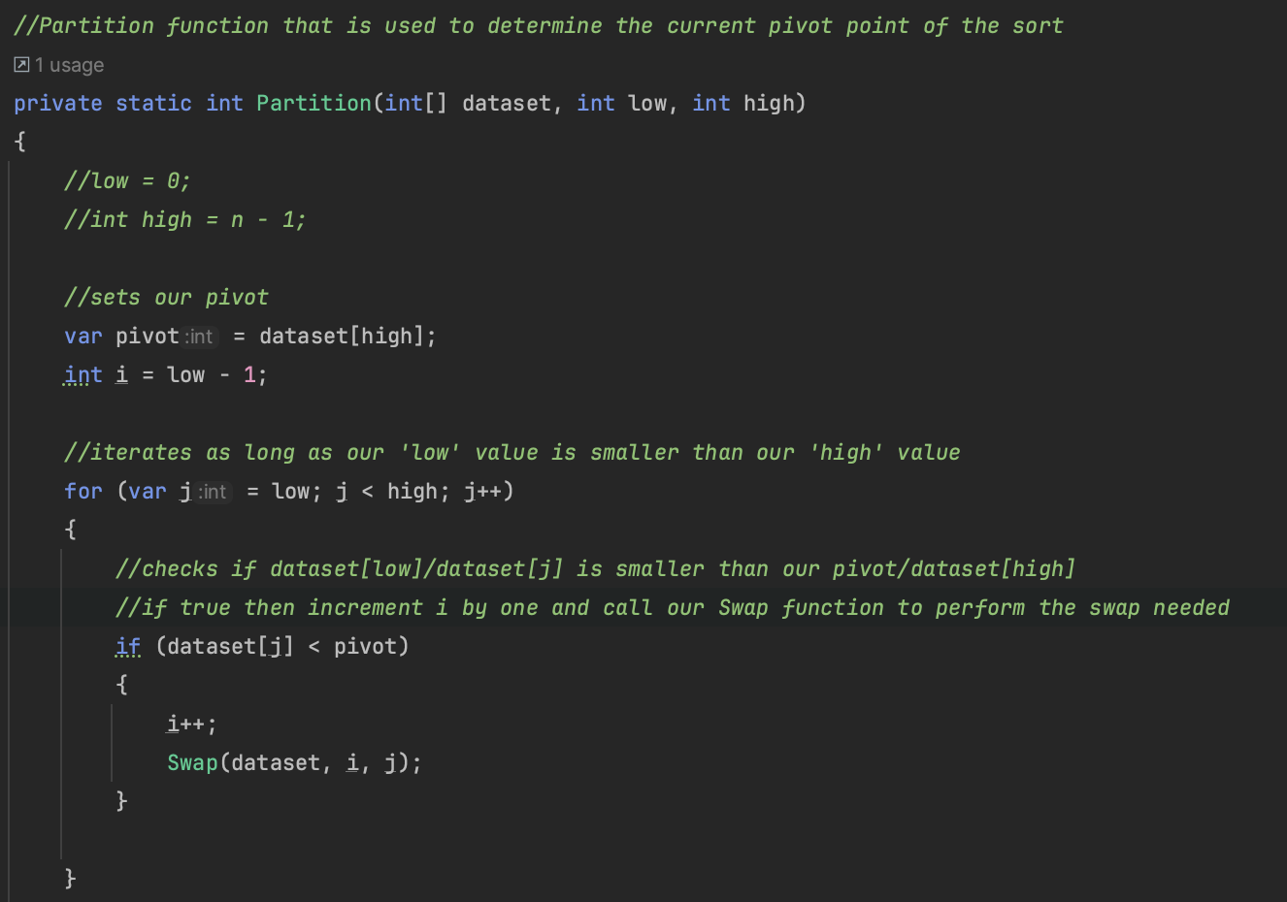

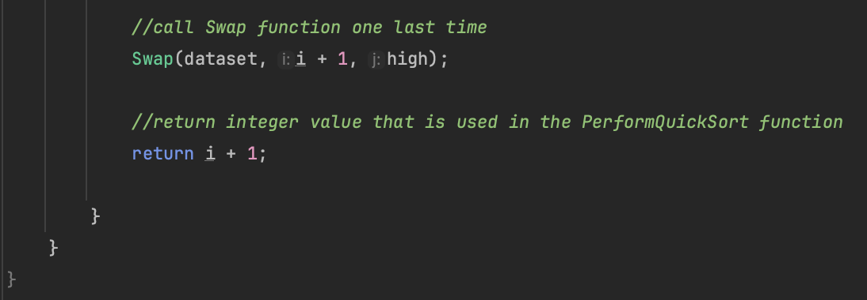

This was the implementation of my quick sort algorithm, which took the pseudocode provided by Zairul and implemented it into C# code. The only issues were the ones mentioned within the implementation section of this project, whereby my initial for loop conditions for the partition function made it so that the dataset was not sorted correctly.

Additionally, I did some unit testing to further showcase that my implementation works. Again, I used the NUnit testing framework as recommended on the JetBrains website.

* The first test checks the sorting algorithm outputs the sorted dataset in ascending order.
* The second test checks the sorting algorithm does not throw an exception for an empty array.
* The third test checks to see if the sorting algorithm works when there are duplicate values within the dataset.
* The fourth test checks to see if the sorting algorithm works when the provided dataset is already sorted.

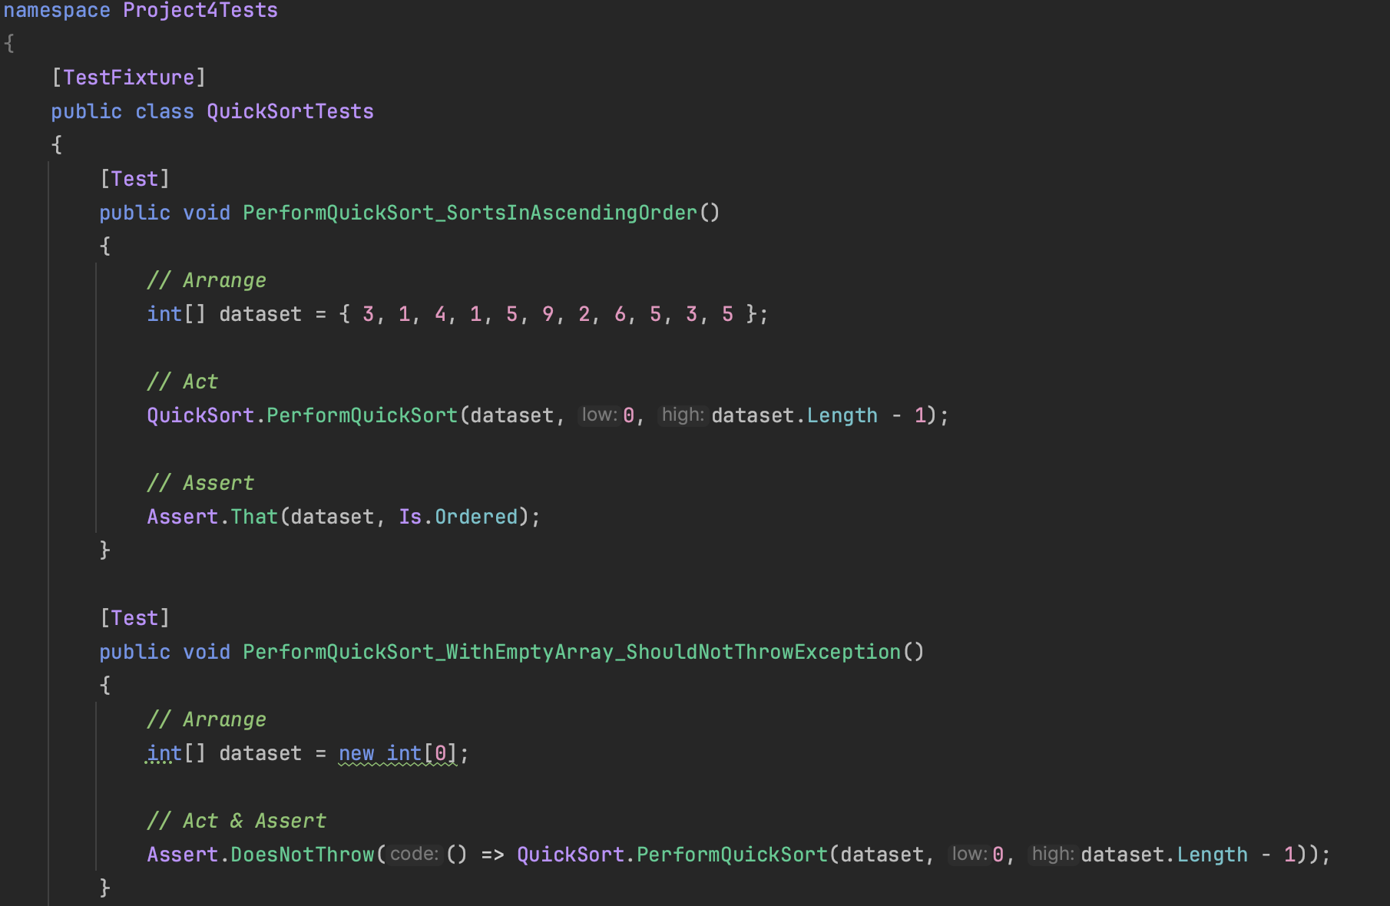

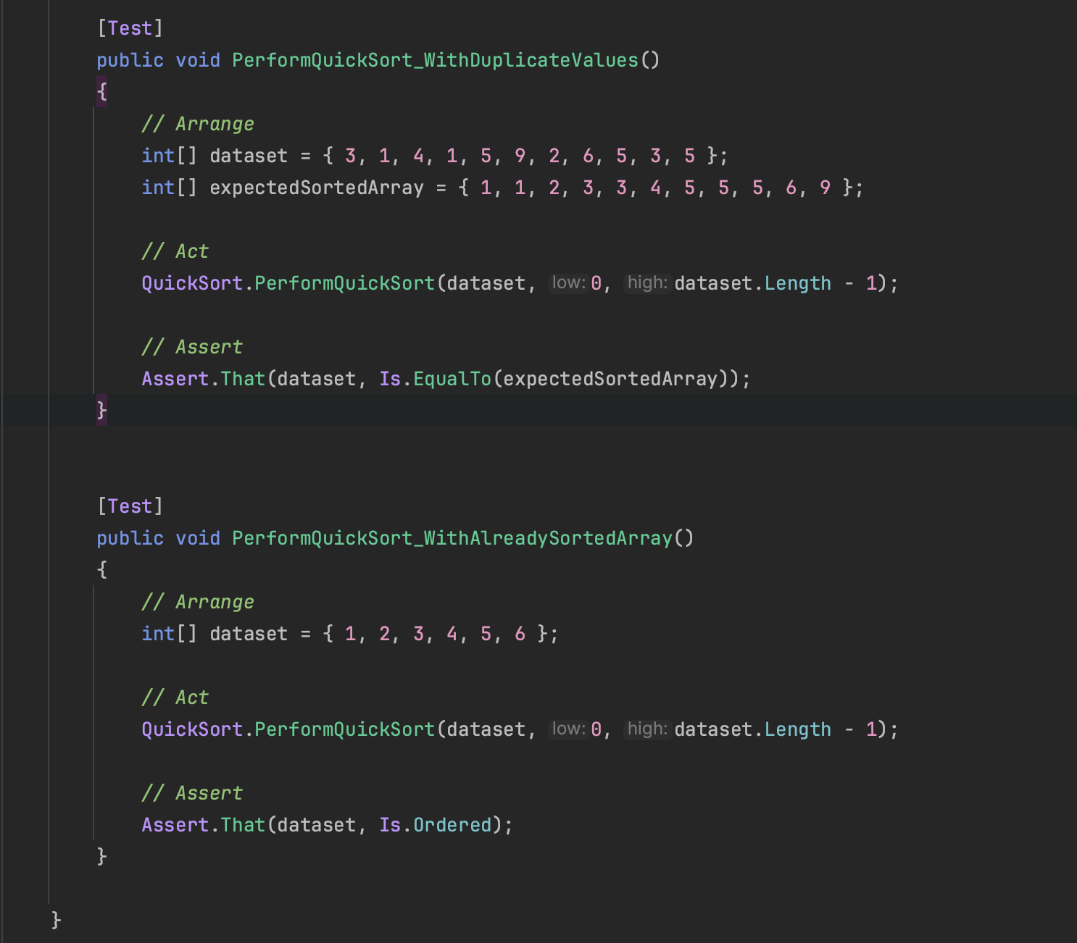

And here is the result:

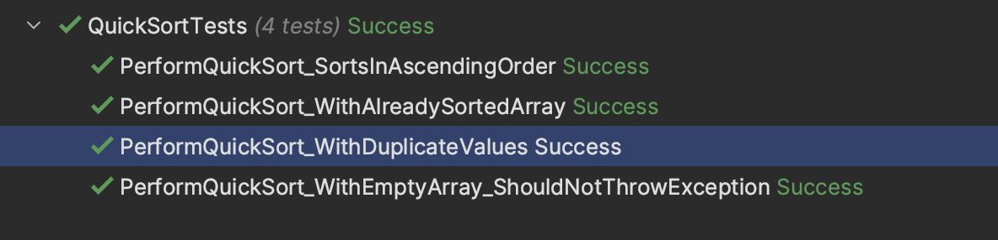

I believe that the tests I have conducted showcase my program’s main functions which is the sorting algorithm themselves, and as such are appropriate representations. However, if I wanted to further test my functions further then I could showcase tests done within other files such as Program3.cs where I could test that the menu is displayed correctly, or keeps looping whilst input is incorrect, among other ideas.

**Acceptance tests**

|  |  |  |  |  |  |
| --- | --- | --- | --- | --- | --- |
| **Number** | **Scenario** | **Value/Input** | **Expected Result** | **Actual Result** | **Pass/Fail** |
| **1** | User is prompted to select a sorting algorithm | 1 or 2, for corresponding sorting algorithm | Program continues onto the next step in the execution, prompting for dataset | Execution continues and user is prompted about the size of the dataset they wish to use | Pass |

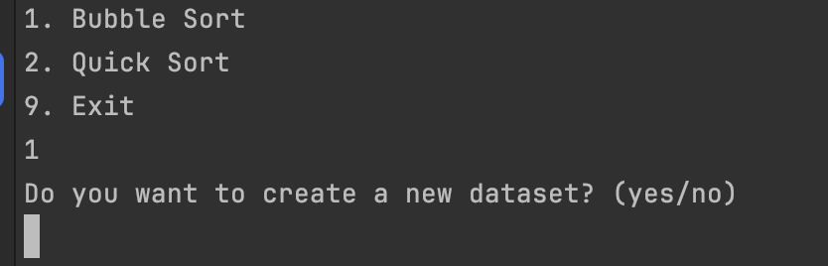

|  |  |  |  |  |  |
| --- | --- | --- | --- | --- | --- |
| **2** | User prompted to enter a value between 1, 2, or 9 to select sorting algorithm | 5 | Program repeats until a correct value is entered | A message is displayed and loops until criteria is met | Pass |

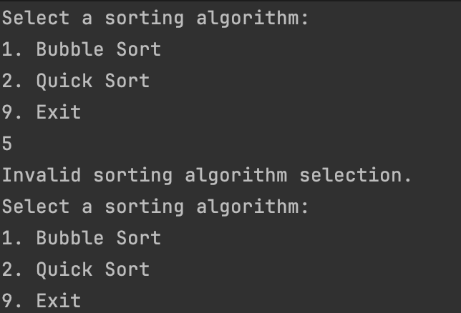

|  |  |  |  |  |  |
| --- | --- | --- | --- | --- | --- |
| **3** | User prompted to enter a size for the dataset | 1, 0, -1 | Error message is displayed, telling user that dataset size is invalid and cannot be sorted | Error message displayed to user; program repeats until valid input | Pass |

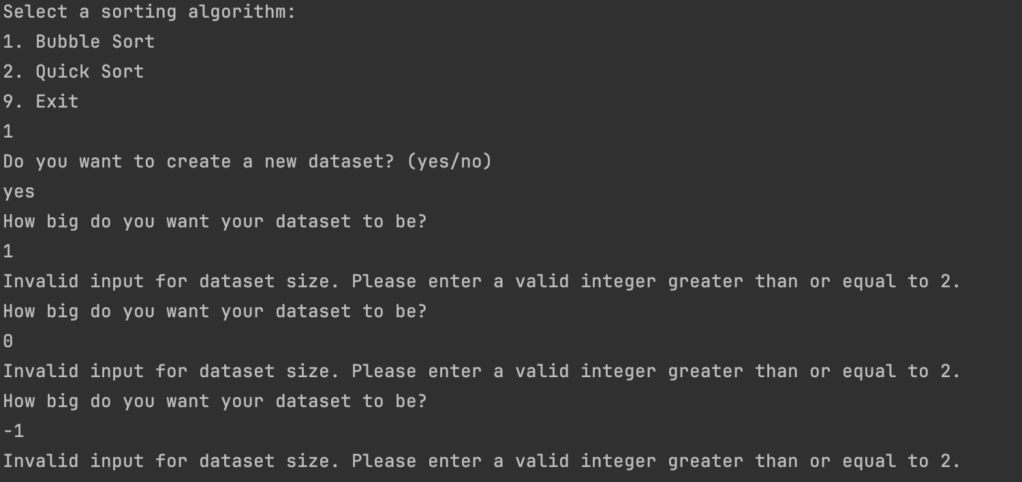

|  |  |  |  |  |  |
| --- | --- | --- | --- | --- | --- |
| **4** | User prompted to enter a size for the dataset | 50 | Dataset is created of the inputted size and is filled with randomly generated integer values.  Chosen sorting algorithm is performed on the newly created dataset | Dataset is created and filled with values.  Sorting algorithm is performed, time taken and sorted dataset is displayed | Pass |

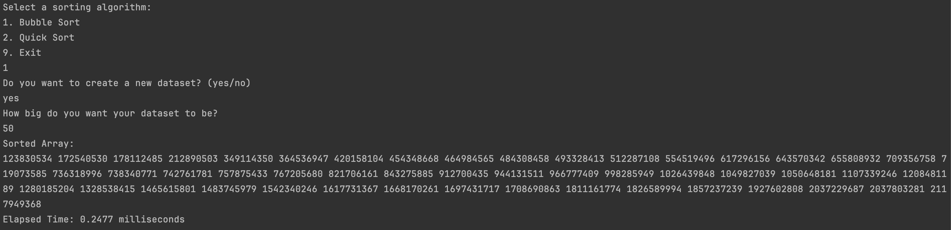

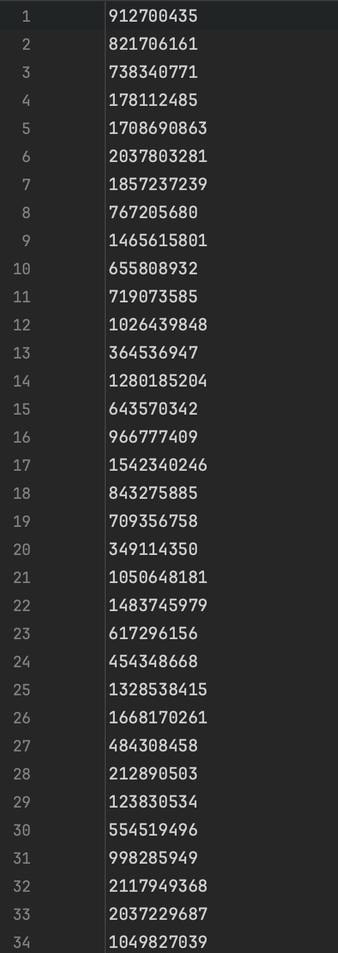

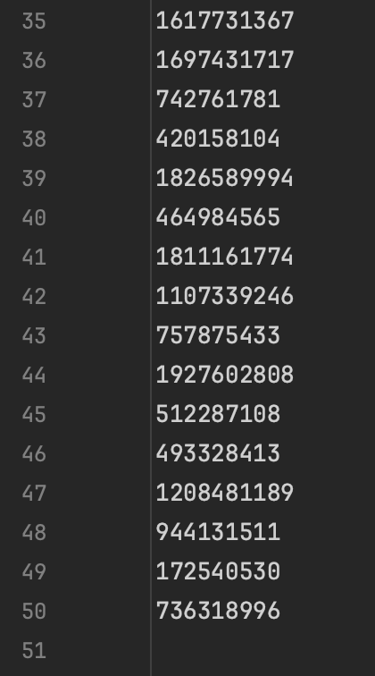

|  |  |  |  |  |  |
| --- | --- | --- | --- | --- | --- |
| **5** | User wants to use a pre-existing dataset | Dataset is already filled with string values, instead of integer values. | Corresponding error message is displayed, and user is prompted to revaluate their dataset. | Program attempts to use existing dataset but since it is of incorrect type; an exception is thrown, and error message generated.  Program execution halts. | Fail |

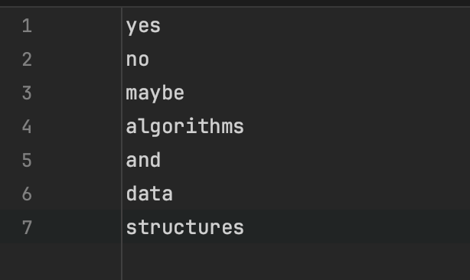

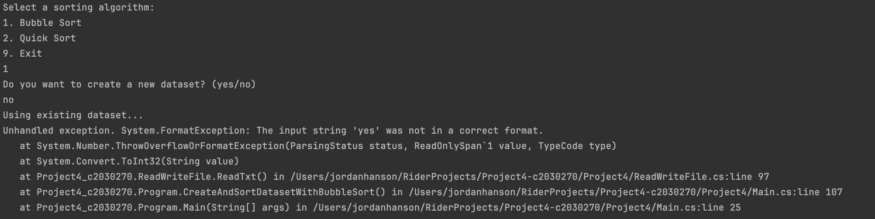

|  |  |  |  |  |  |
| --- | --- | --- | --- | --- | --- |
| **6** | Bubble sort function | Valid dataset | Sorting algorithm reads the dataset from .txt file and performs the bubble sort on the values |  |  |

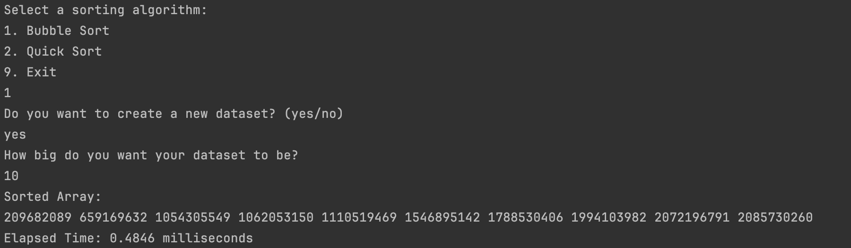

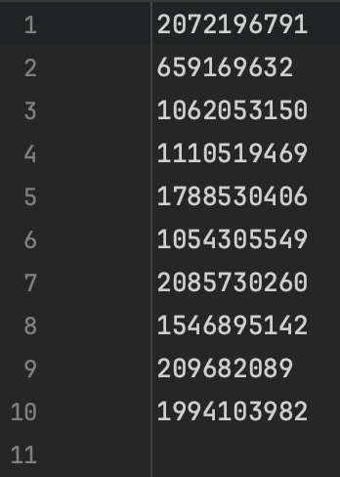

Here I am going to use ChatGPT to check if these values are correctly sorted. I am going to give it the prompt ‘Are these values all the ascending order?’ alongside the values themselves. Here is the output:

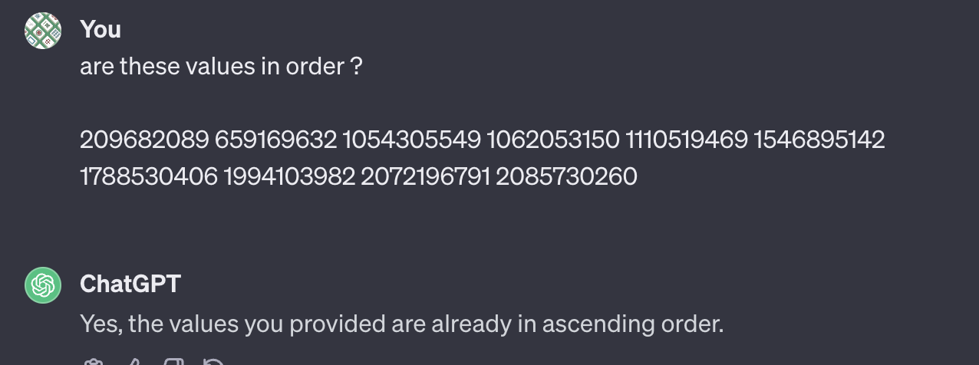

## 4.6 Software and its Presentation, including testing (and video link)

[Project 4 Video Recording](https://youtu.be/CM430VGTvko)

## 4.7 Incorporation of formative feedback

|  |  |  |
| --- | --- | --- |
| **Date Received** | **Feedback Received** | **Incorporation of Feedback** |
| 10/12/2023 – Mehmet | Emailed about concerns regarding word count and if any penalty would be incurred if I went over by too much, however Mehmet reassured me that there would be no penalty. | Did not have to adjust written work to accommodate for word count. |



# 5. Project 5

## 5.1 Introduction to the Problem

For this project, we have a problem that involves efficiently distributing resources among multiple entities, and this idea can be applied to numerous real-life applications. For example, within a warehouse management context, items need to be allocated between trucks appropriately, despite their varying sizes and weights, so that delivery times are optimised, and each truck appropriately loaded. Similarly, we can also look at how this is relevant within the context of task distribution for a team. It is important that tasks are distributed evenly and fairly between all members to ensure a balanced workload, as well as to maintain overall project efficiency.

Whilst keeping these examples in mind, the scope of this problem involves 3 separate lorries (A, B and C) as well as 20 separate piles of bricks with varying weights between the piles. For the sake of applying the provided heuristics and for proper representation, we must assume that there is no maximum load for any of the lorries. The task for this project is that we want to distribute the bricks in such a way that they are divided equally, or as equally as possible.

The objective within this project is to minimise the load difference between all three lorries.

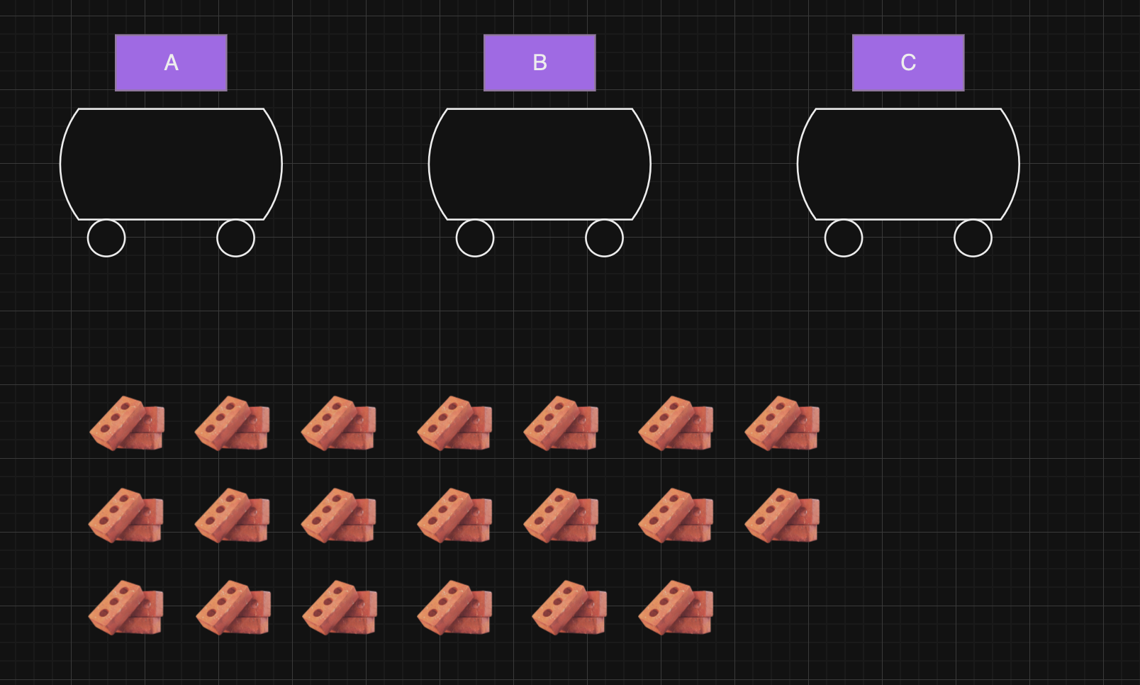

## 5.2 Solution Representation and Data Structures

5.2.1 Solution Representation and Fitness Function

For this problem, we have 20 separate piles of bricks and only 3 lorries and we need a way to be able to represent a potential solution.

The dataset

Potential solution

|  |  |  |  |  |  |  |  |  |  |
| --- | --- | --- | --- | --- | --- | --- | --- | --- | --- |
| **Lorry A** | **Lorry C** | **Lorry A** | **Lorry B** | **Lorry C** | **Lorry B** | **Lorry B** | **Lorry A** | **Lorry C** | **Lorry A** |
| Pile 1 | Pile 2 | Pile 3 | Pile 4 | Pile 5 | Pile 6 | Pile 7 | Pile 8 | Pile 9 | Pile 10 |
| **Lorry A** | **Lorry B** | **Lorry C** | **Lorry C** | **Lorry B** | **Lorry A** | **Lorry B** | **Lorry C** | **Lorry A** | **Lorry B** |
| Pile 11 | Pile 12 | Pile 13 | Pile 14 | Pile 15 | Pile 16 | Pile 17 | Pile 18 | Pile 19 | Pile 20 |

Or it could look something like this:

Potential solution

|  |  |  |  |  |  |  |  |  |  |  |  |  |  |  |  |  |  |  |  |  |  |  |  |  |  |
| --- | --- | --- | --- | --- | --- | --- | --- | --- | --- | --- | --- | --- | --- | --- | --- | --- | --- | --- | --- | --- | --- | --- | --- | --- | --- |
| |  | | --- | | **Lorry A** | | Pile 1 | | Pile 4 | | Pile 7 | | Pile 11 | | Pile 14 | | Pile 18 | | Pile 20 | | |  | | --- | | **Lorry B** | | Pile 2 | | Pile 3 | | Pile 9 | | Pile 10 | | Pile 16 | | Pile 19 | | |  | | --- | | **Lorry C** | | Pile 5 | | Pile 6 | | Pile 8 | | Pile 12 | | Pile 13 | | Pile 15 | | Pile 17 | |

The dataset

Next, there is a need for designing a given fitness function to suit the optimisation problem we have at hand, because it will allow us to evaluate how close a potential solution is to the optimal solution.

In the context of this problem, we want the function to capture the idea that a lower load difference between the lorries is more desirable. To work out this load difference we can calculate the difference between the maximum and minimum loads, whereby the maximum is the lorry with the heaviest load, and the minimum is the lorry with the lightest load.

$$Load Difference=Max\left(A, B, C\right)-Min(A, B, C)$$

A potential fitness function can be derived now that there is a formula for the load difference between lorries, and because we want a minimal value, there is need for a function that increases when the load difference decreases.

To achieve this, we can establish an inverse relationship between the load difference and the fitness values of the function. As the load differences gets smaller, which represents a fairer distribution of weight between the lorries, we want the fitness value to increase. To do this, we can use the reciprocal/multiplicative inverse of the load difference to create this function.

$$Fitness=\frac{1}{Load Difference+1}$$

This use of the reciprocal ensures that smaller distributions of weight between lorries results in higher fitness values and as such, this represents a solution that ‘fits’ better. Furthermore, adding 1 to the denominator, ensure we will deal with strictly positive values and are able to deal with extreme cases where the load difference is 0.

To demonstrate this, we can use an example solution to the problem to get a corresponding fitness value from the equation.

Let’s say we have a dataset that looks like this:

|  |  |  |  |  |  |  |
| --- | --- | --- | --- | --- | --- | --- |
| **Lorry** | A | B | C | B | C | A |
| **Data value** | 3kg | 1kg | 6kg | 4kg | 5kg | 5kg |

And this is the first solution produced randomly by the search.

Using the fitness function that was designed, the fitness value can be worked out for this solution.

$${Total}_{A}=3+5$$

$${Total}_{A}= 8kg$$

$${Total}_{B}=1+4$$

$${Total}_{B}=5kg$$

$${Total}_{C}=6+5$$

$${Total}_{C}=11kg$$

$$Load Difference=Max\left(A, B, C\right)-Min(A, B, C)$$

$$Load Difference=11kg-5kg$$

$$=6kg$$

$$Fitness= \frac{1}{6+1}$$

$$= \frac{1}{7}$$

From here, we can perform small change on the first solution to generate a new solution.

5.2.2 Data Structure

This problem has the need to be able to access/store the distribution of all the piles of bricks between the lorries, but also the weight for each individual pile of bricks, and the index/current pile number. Additionally, it needs to be able to store solutions as well as a list of the best ones to compare against one another.

For storing the solutions to the hill climbing algorithm, I believe that using a list data structure would be the best option as it correctly represents the problem at hand. Each solution would be its own list and within it, the lorry distribution for all the piles of bricks are stored.

For the distribution of the bricks between all 3 lorries, I believe that a one-dimensional array would be best suited for this problem since it allows for sequential constant-time access if the index is provided. Additionally, the requirement is only simple and iterating over values within an array is generally more efficient that for other data structures, especially when the array is this small.

It could potentially look like this:



Furthermore, when it comes to storing the pile numbers and their weights, we could potentially use a dictionary data structure to store all this information. Within this, the keys would be the pile numbers, and the values are their respective weights.

Within C#, it could potentially look this:

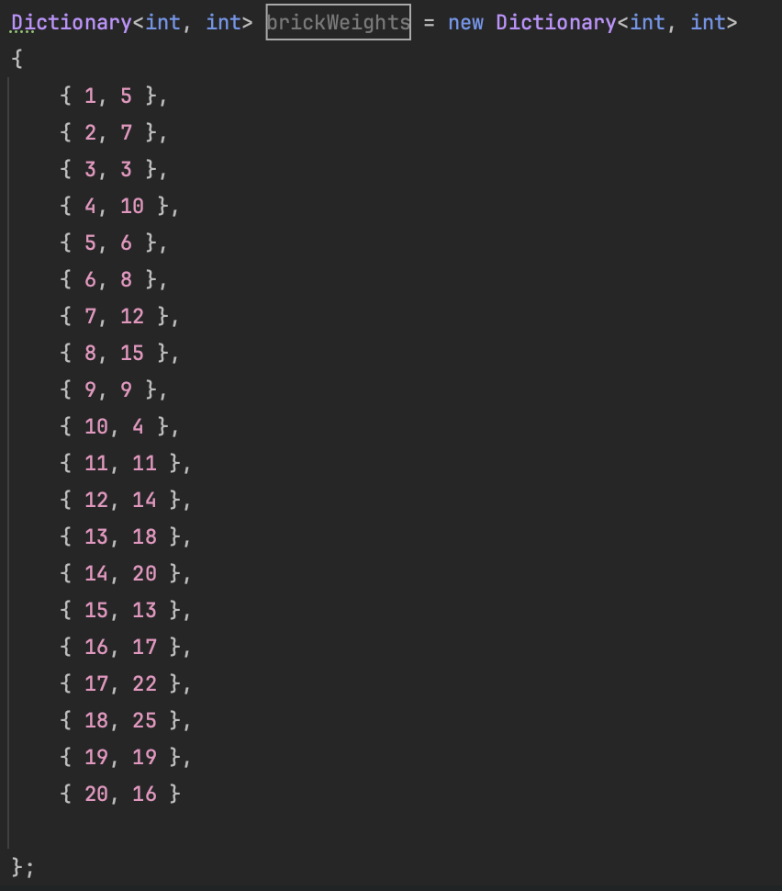

Or it could just be as simple as a List, where the index corresponds to the pile number.

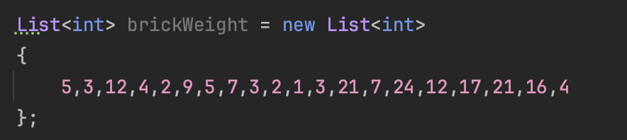

## 5.3 Heuristic Search

### 5.3.1 Random Restart Hill Climbing

Random restart hill climbing is a heuristic search algorithm that is used for optimisation problems. It is an iterative search method that combines the principles of hill climbing, namely starting with an arbitrary solution, as well as the use of random restarts to iterate.

The algorithm starts with the initial solution and intends to explore the search space by making incremental changes to the current solution. The algorithm’s distinctive feature is the use of random restarts, whereby the process of hill climbing is restarted from different starting solutions, and this allows it to search past the local optima and explore a broader solution space.

The reason random restart hill climbing differs from random mutation hill climbing is because of the way in which it explores the solution space. Whilst they are both classified as hill climbing algorithms, RMHC uses a different method of iterating and moving between solutions, as it repeats the process of randomly selecting a neighbour of the current best solution and accepts the neighbour if it is better than or equal to it. This form of the algorithm is best used when the state space is discrete, and the given neighbour list is finite.

Using the pseudocode below, we can also create a flowchart to give another representation for the flow of the algorithm.

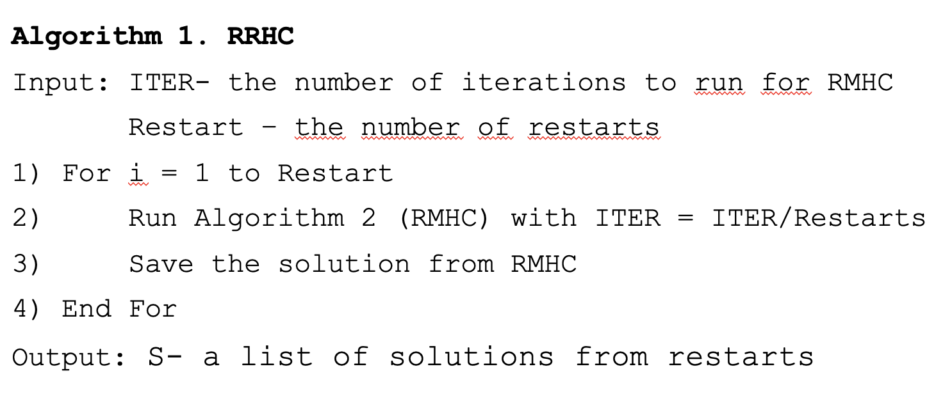

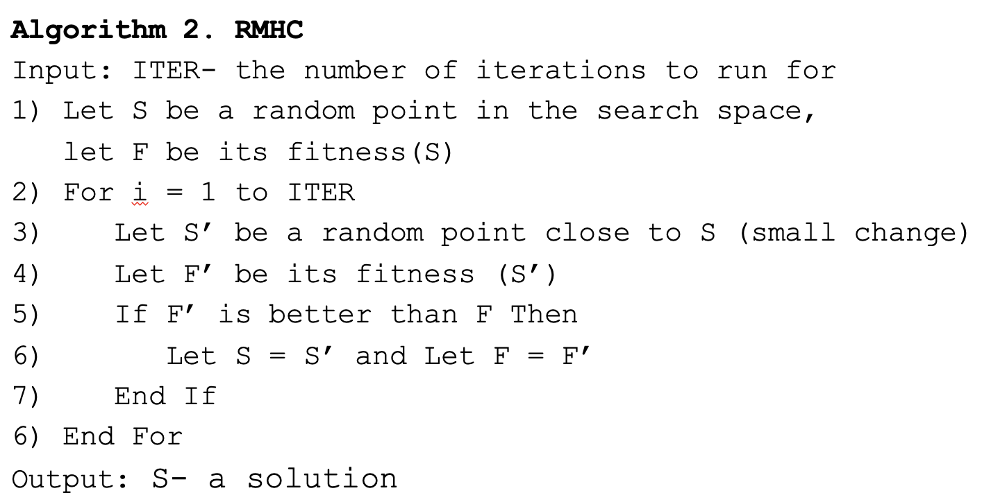

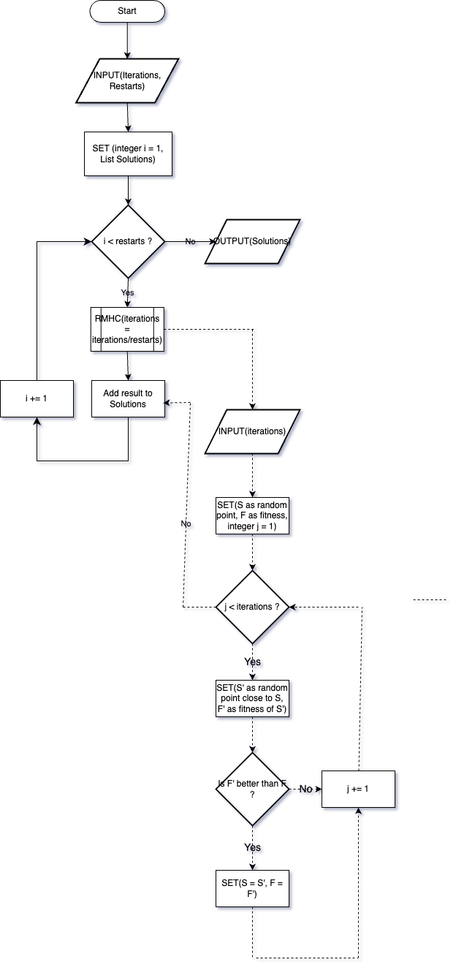

### 5.3.2 Small Change Strategy

Before I can talk about how I intend to implement a small change strategy within my algorithm, I must first discuss what It means in the context of heuristic searches and optimisation algorithms.

For the current problem, the term ‘small change’ refers to a minor, controlled change or perturbation that is applied to the current solution $S$ to generate a new solution $S’$. The purpose of making these small changes between solutions is to introduce randomness and variability in the search process, which may help the algorithm to discover better solutions.

For example, there are multiple options, among many that I do not discuss, I could go with when introducing a kind of small change within my own hill climbing algorithm.

1. Swap bricks between the lorries

I could select two out of the three lorries, and swap randomly chosen brick(s) from one lorry with other randomly chosen brick(s) from the other lorry. This option would allow me to explore nearby solutions much easier, potentially addressing load imbalances. However, this may not result in substantial improvements.

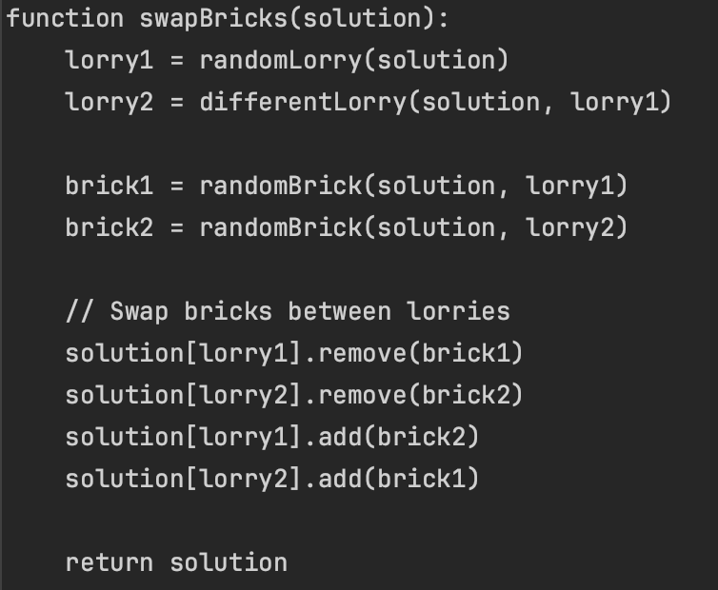

1. Random redistribution

For this approach at a small change, I could randomly swap n number of bricks between all 3 lorries, which would introduce randomness and diversity to the solution space. This then allows the algorithm to explore a wider range of solutions, especially ones that are not immediately apparent through deterministic methods. However, the changes that will be introduced are less predictable and the effectiveness of this approach would depend on how able the algorithm can explore the solution space.

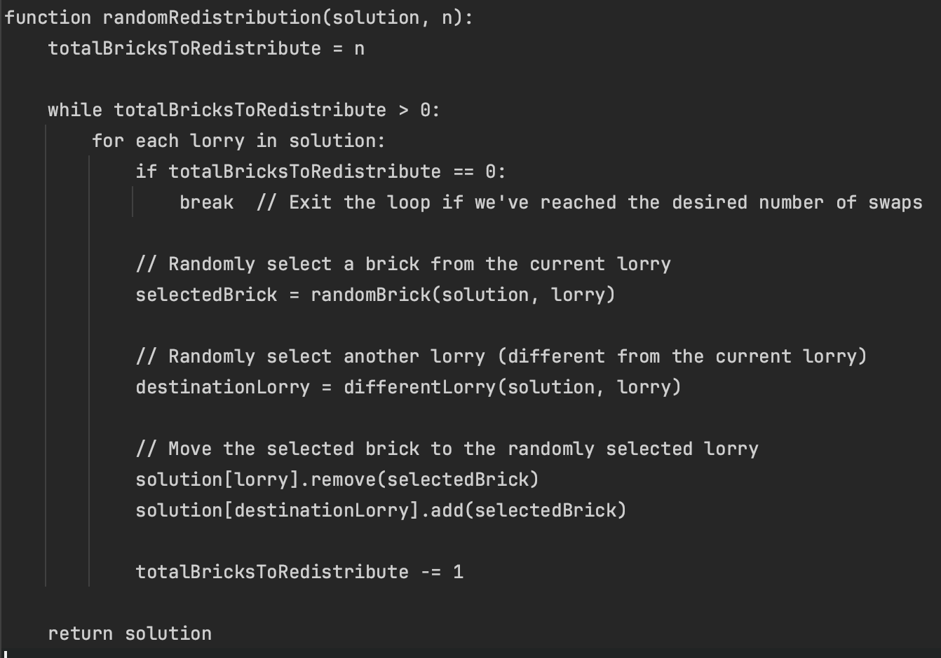

1. Swapping a singular brick between two lorries.

This strategy would entail selecting a singular brick from one lorry and moving it to another, different lorry. This would provide very straightforward means of adjusting individual elements within each solution, which would allow me to fine-tune my adjustments and therefore address specific load imbalances. However, whilst it will be suitable for smaller adjustments between the lorries, it will most likely not be able to handle larger load differences.

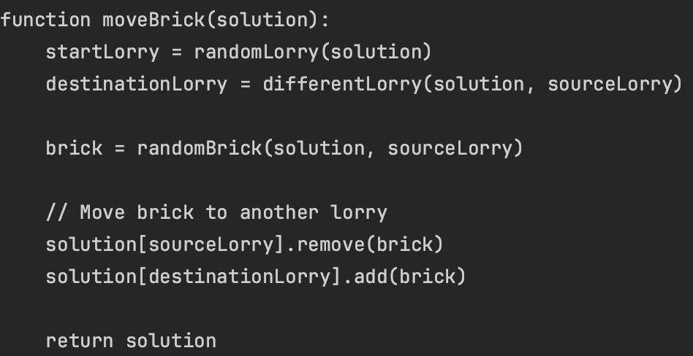

## 5.4 Incorporation of formative feedback

|  |  |  |
| --- | --- | --- |
| **Date Received** | **Feedback Received** | **Incorporation of Feedback** |
| 03/01/2024 - Zairul | I emailed Zairul about a couple of concerns I had for this project. Within the mark scheme on the assessment brief, it mentioned that Project 5 would contain an assessment of my ability to work out the complexity of an algorithm. See below.  Additionally, I also asked a question regarding the fitness function that I designed for this project since I was unsure on whether I was taking the right approach or not.  From here, Zairul addressed both of my concerns in a simple way, giving me clear and concise advice. I was reassured that working out the complexity of the algorithm would not be required, as well as also giving a suggestion on how to improve the section of my portfolio that regards my fitness function and its design. | For the concern regarding the complexity, I did not need to make much of an adjustment or plan of what to do next since the feedback I received assured me that this was not needed. As such, I was able to move on without worries and put all my focus on the remaining elements of this project.  Regarding the feedback received about my fitness function, I made plans to revisit the section that addressed this and began devising ideas on alternatives I could provide to showcase which function I believe was best suited for the scope of the problem. |

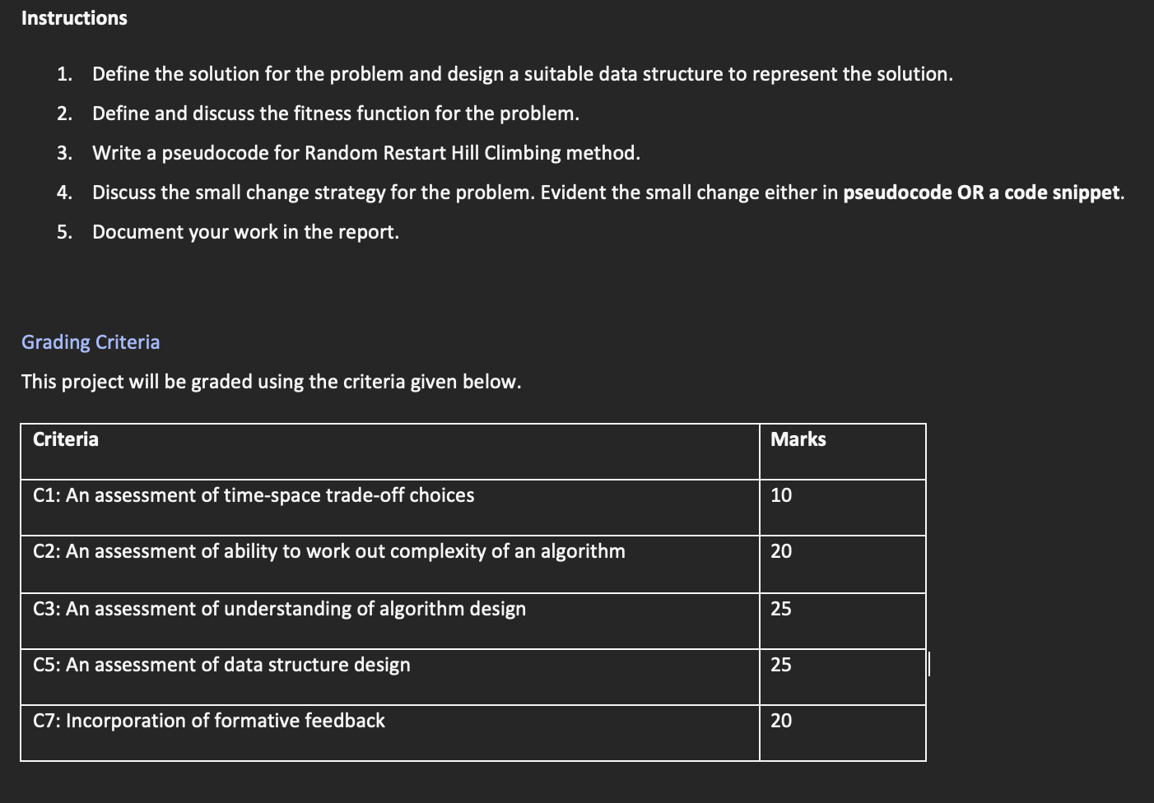



# 6. Project 6

## 6.1 Experiment Results

| **Experiment Number** | **Final Fitness Value** | **Solution** |
| --- | --- | --- |
| 1 | 0.20112630732099757 | [1, 1, 3, 1, 1, 1, 1, 1, 3, 1, 1, 3, 1, 1, 1, 1, 2, 2, 1, 1, 3, 1, 3, 1, 1, 1, 1, 1, 1, 1] |
| 2 | 0.06768647624204684 | [1, 3, 1, 1, 2, 1, 1, 2, 1, 1, 1, 1, 1, 1, 1, 1, 1, 3, 1, 3, 1, 1, 3, 1, 1, 3, 3, 1, 1, 1] |
| 3 | 0.06768647624204684 | [1, 2, 1, 1, 1, 3, 1, 2, 1, 1, 1, 3, 1, 1, 3, 1, 1, 1, 1, 1, 1, 1, 3, 1, 1, 1, 3, 1, 1, 3], |
| 4 | 0.20112630732099757 | [1, 1, 1, 1, 1, 3, 1, 1, 1, 1, 1, 3, 1, 2, 3, 1, 1, 1, 1, 1, 1, 1, 1, 1, 1, 1, 3, 1, 2, 3], |
| 5 | 0.20112630732099757 | [1, 1, 2, 1, 1, 3, 1, 1, 1, 1, 1, 3, 1, 1, 3, 1, 3, 1, 1, 1, 1, 1, 2, 1, 1, 1, 1, 1, 1, 3] |
| 6 | 0.20112630732099757 | [1, 2, 1, 1, 1, 2, 1, 1, 1, 1, 1, 3, 1, 1, 3, 1, 1, 3, 1, 1, 3, 1, 1, 1, 1, 1, 3, 1, 1, 1] |
| 7 | 0.20112630732099757 | [1, 2, 3, 1, 2, 1, 1, 1, 1, 1, 1, 3, 1, 1, 1, 1, 1, 3, 1, 1, 3, 1, 1, 3, 1, 1, 1, 1, 1, 1], |
| 8 | 0.20112630732099757 | [1, 3, 1, 1, 1, 2, 1, 1, 1, 1, 1, 1, 1, 3, 1, 1, 1, 1, 1, 3, 3, 1, 2, 1, 1, 1, 3, 1, 1, 1] |
| 9 | 0.20112630732099757 | [1, 1, 1, 1, 1, 1, 1, 1, 3, 1, 2, 1, 1, 3, 3, 1, 1, 3, 1, 1, 3, 1, 1, 1, 1, 1, 2, 1, 1, 1] |
| 10 | 0.20112630732099757 | [1, 1, 1, 1, 1, 3, 1, 1, 2, 1, 1, 3, 1, 1, 1, 1, 1, 3, 1, 1, 1, 1, 2, 3, 1, 1, 3, 1, 1, 1] |

## 6.2 Discussion

The results provided from my set of experiments are not a good representation of how the algorithm should be performed as in my results it showcases a clear discrepancy towards lorry 1. This should not be the case as the loads are supposed to be balanced fairly and ideally, have the total weight divided by 3 on each individual lorry. My implementation of the heuristic search does not showcase this.

Below I have attached information on some tests I did with differing total iterations as well as different small change ideas that are used with the RMHC function. This was done in attempt to try and escape a local optimum and broaden the solution search space.

For RandomNeighbour small change:

1000 iterations when not divided by 10 resulted in same fitness values, means that program is not escaping local optimum since there is not enough iterations. Have to increase iterations or decrease restarts. Even after increasing iterations to 10000, the fitness value did not change.

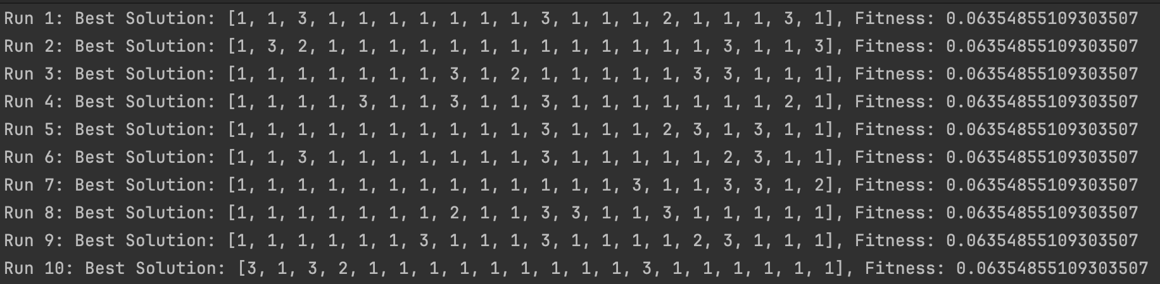

RandomNeighbourSwap – 10 restarts

100 total iterations

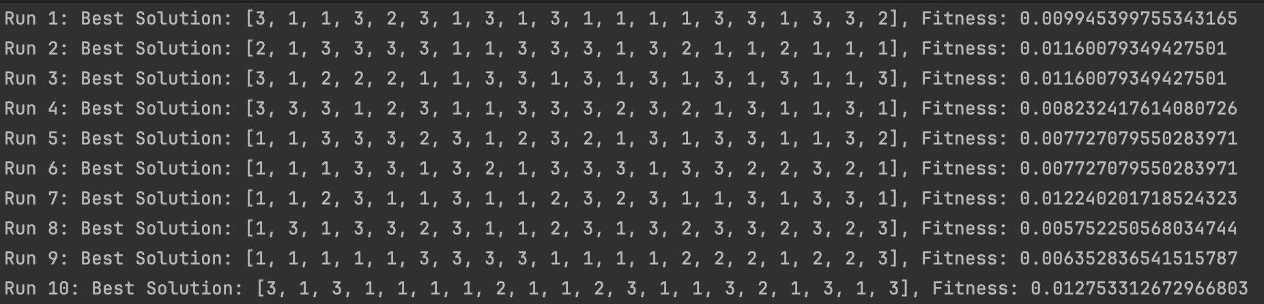

1000 total iterations

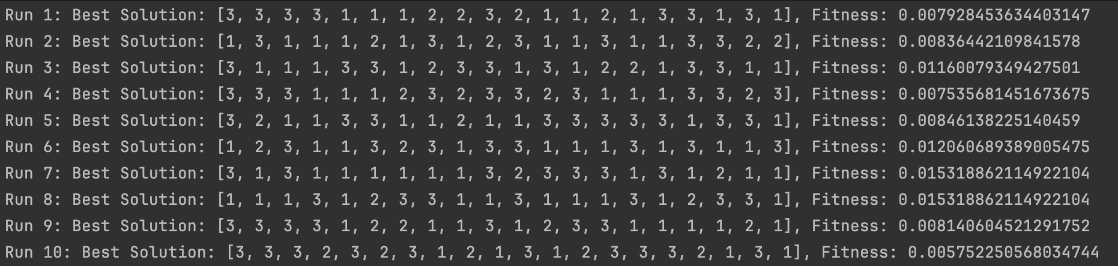

10000 total iterations

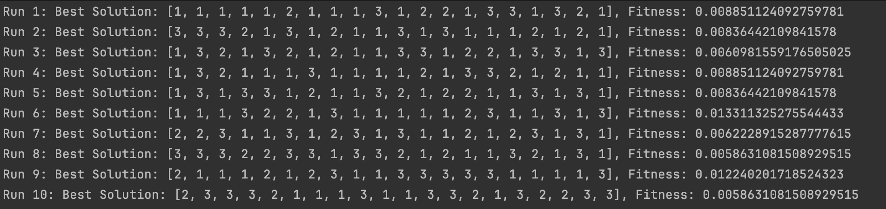

RandomNeighbourMultiple – 10 restarts

100 total iterations

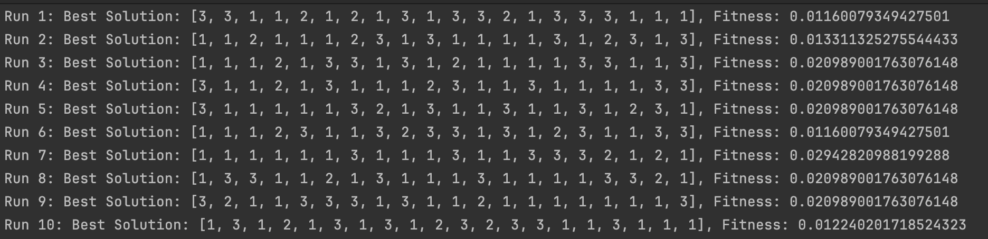

1000 total iterations

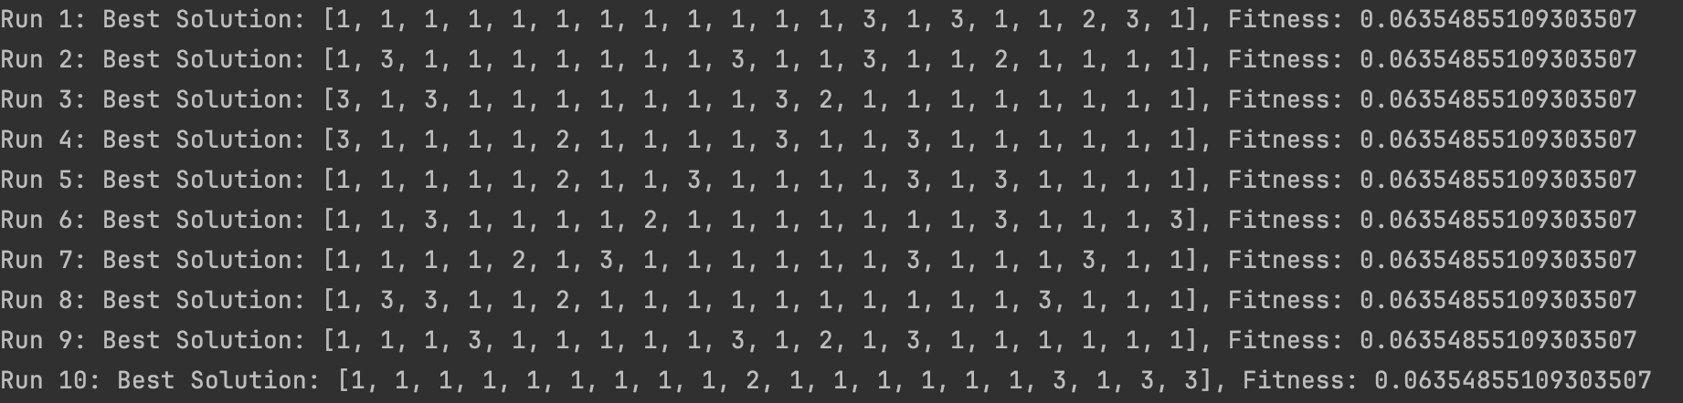

10000 total iterations

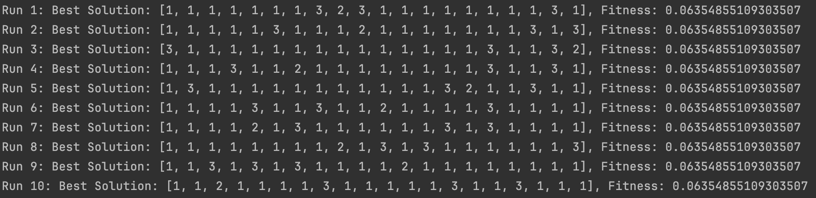

RandomLorryReassignment – 10 restarts

100 total iterations

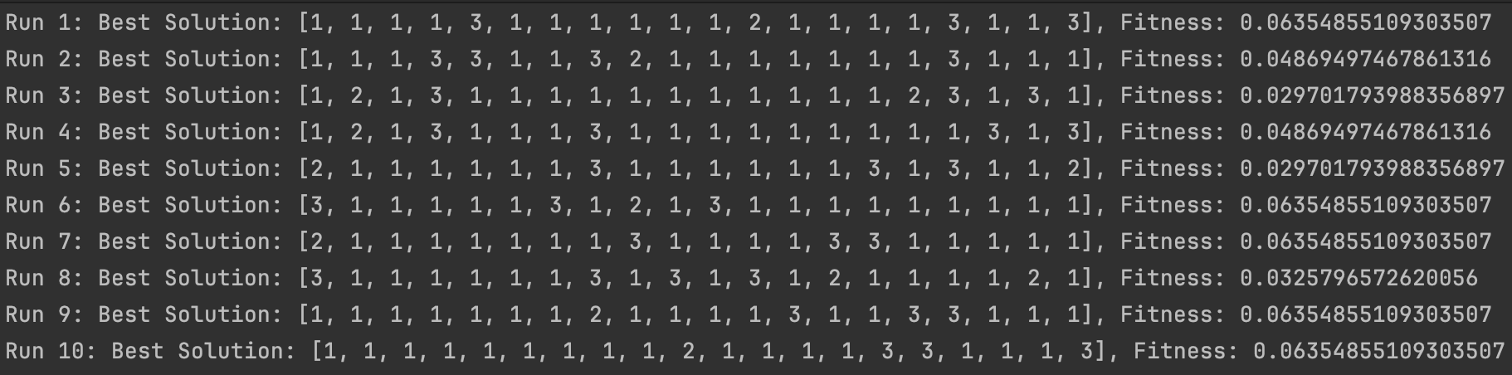

1000 total iterations

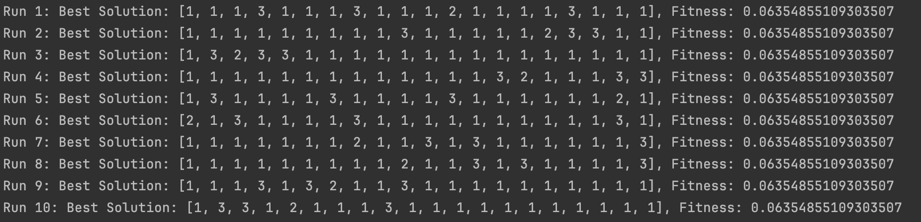

10000 total iterations

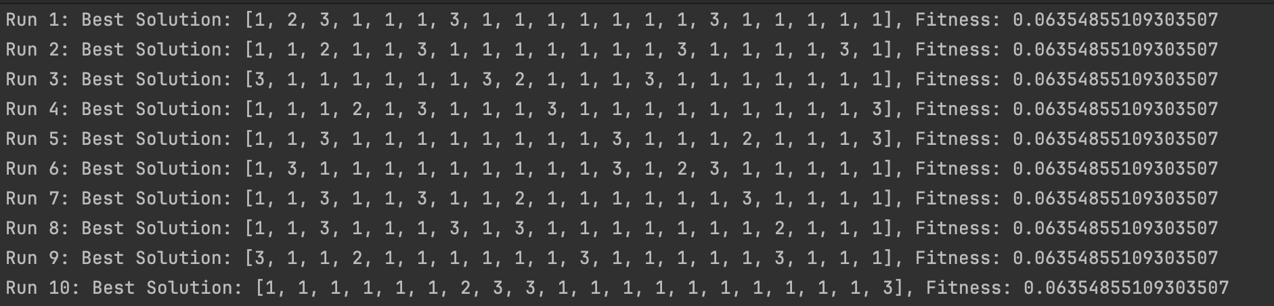

Attempt to introduce cylical assignments for weights to lorries. This creates a pattern where lorries are assigned in a repetetive pattern. Is a deterministic approach that aims to introduce structured diversity in the initial assignments. Hopefully will help to explore broader search space, so that it hopefully avoids converging on local optimum

Random neighbour – 10 restarts

100 total iterations

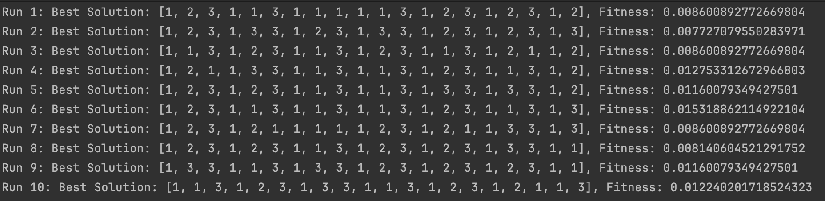

1000 total iterations

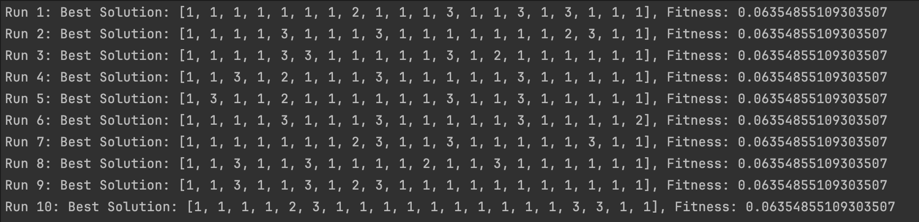

10000 total iterations

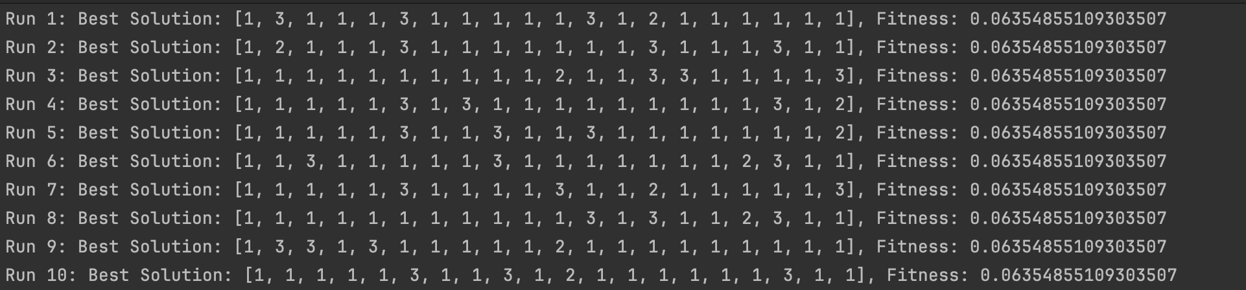

RandomNeighbourSwap – 10 restarts

100 total iterations

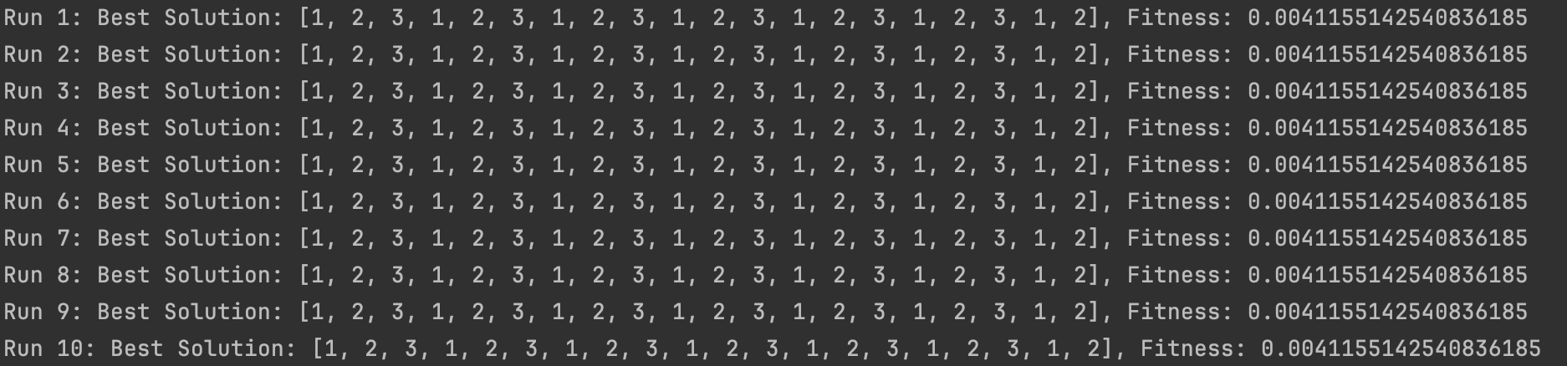

1000 total iterations

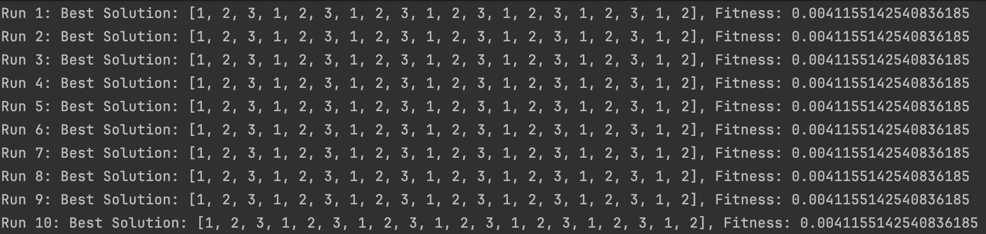

10000 total iterations

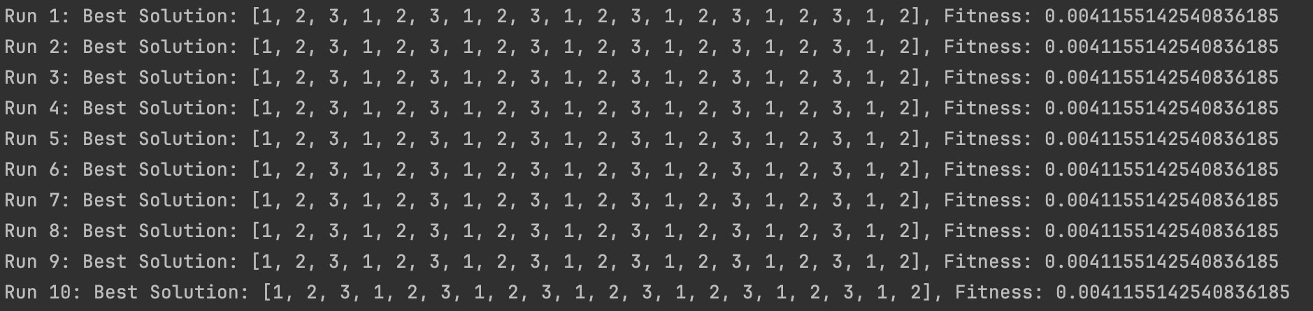

RandomNeighbourMultiple– 10 restarts

100 total iterations

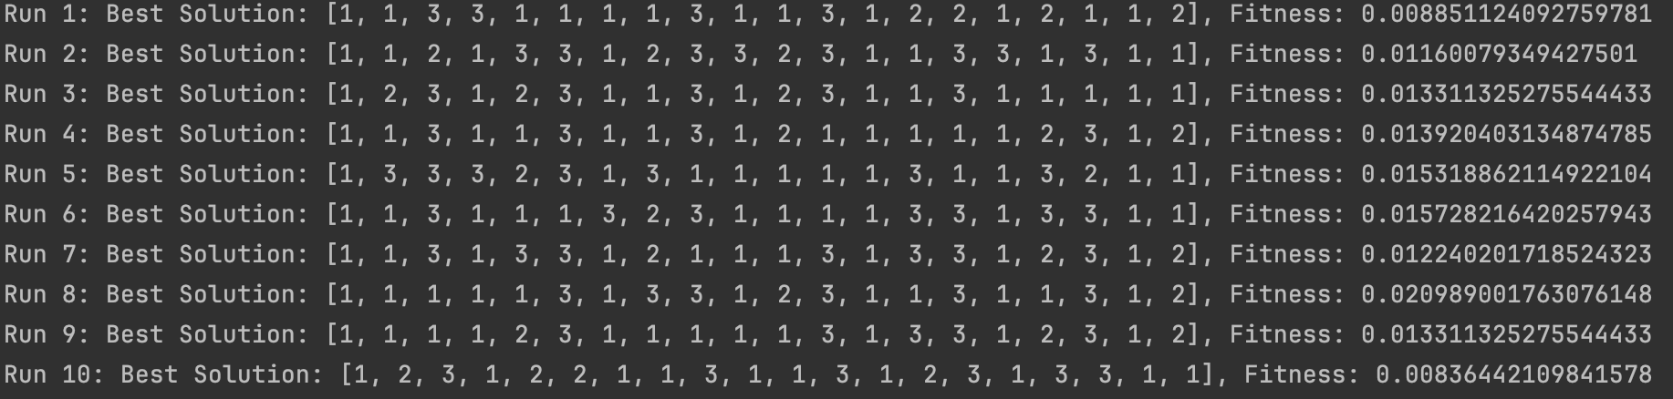

1000 total iterations

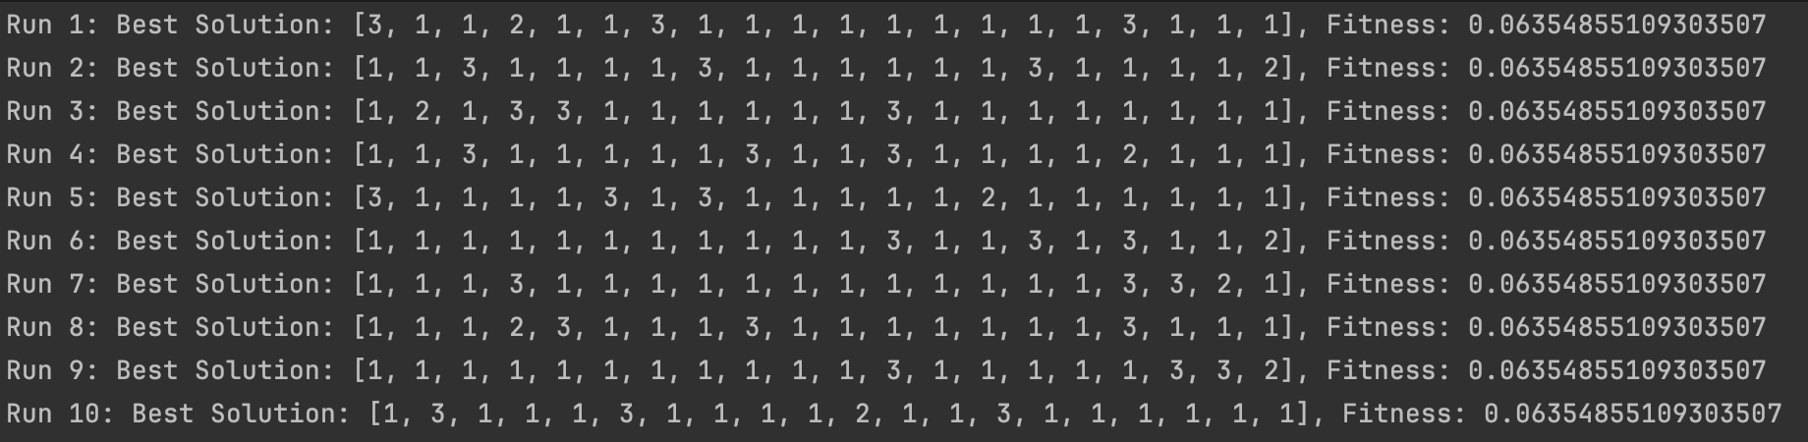

10000 total iterations

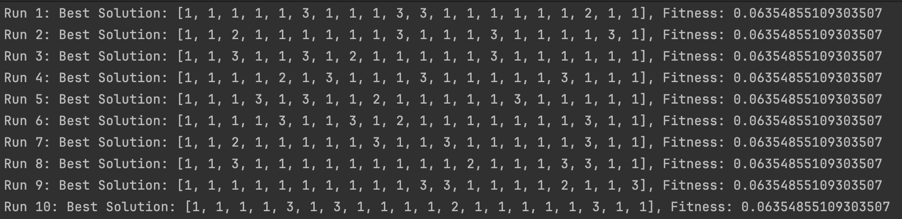

RandomLorryReassignment– 10 restarts

100 total iterations

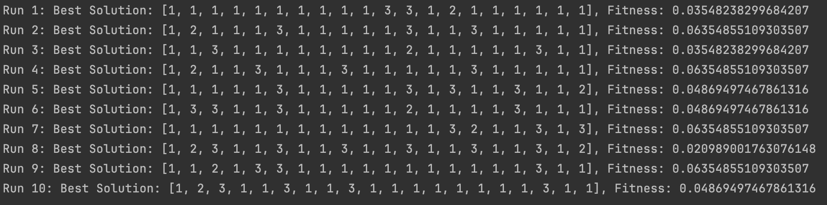

1000 total iterations

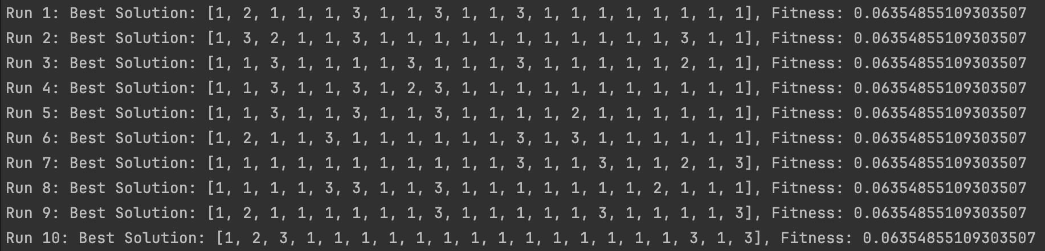

10000 total iterations

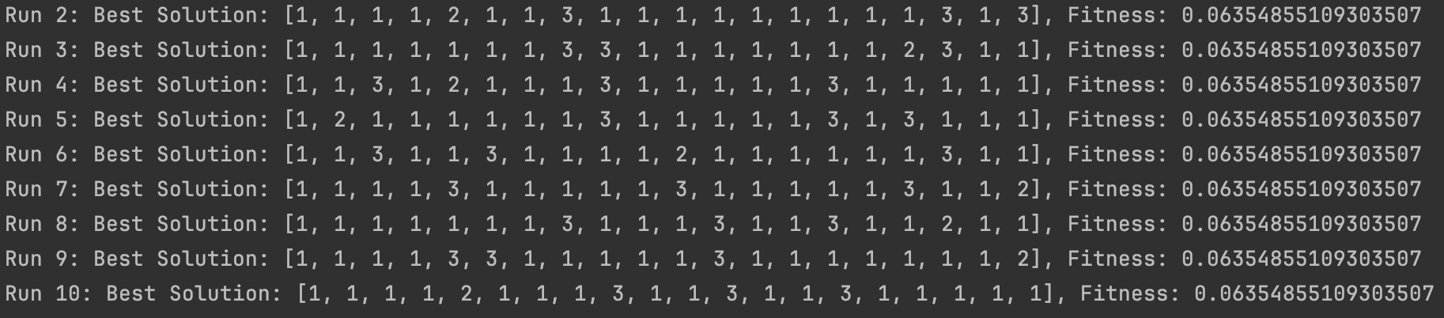

SwapFromEach – 10 restarts

100 total iterations

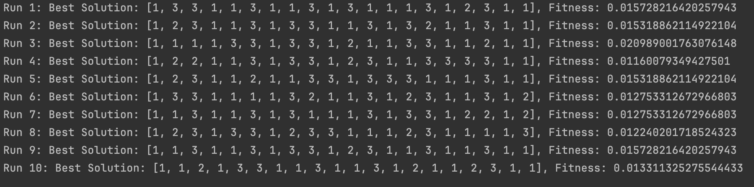

1000 total iterations

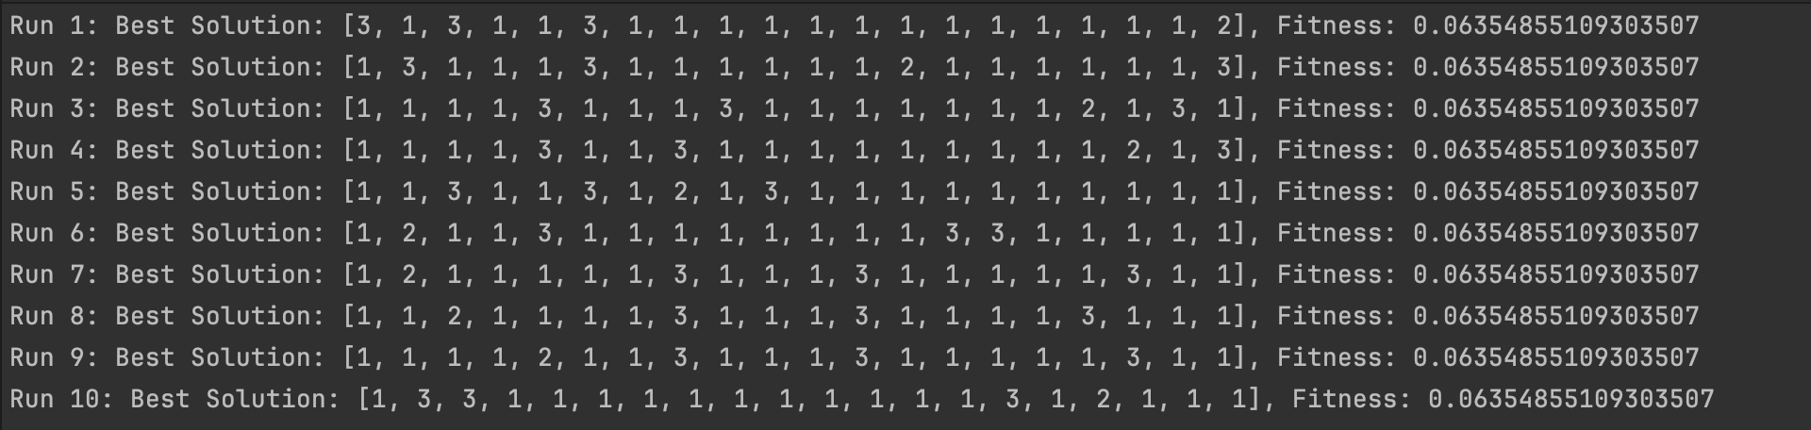

10000 total iterations

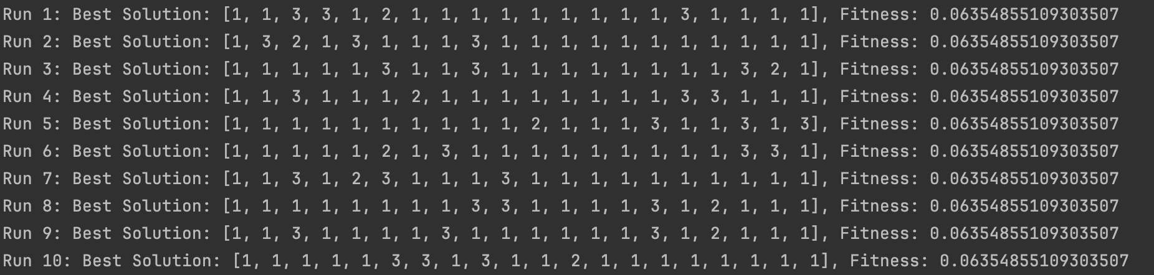

With normalised weights:

RandomNeighbour – 10 restarts

100 total iterations

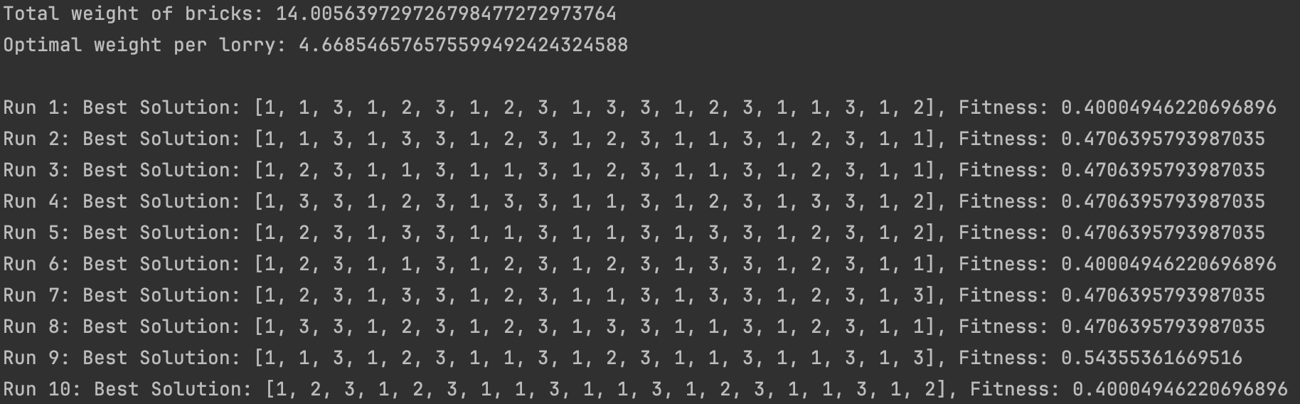

1000 total iterations

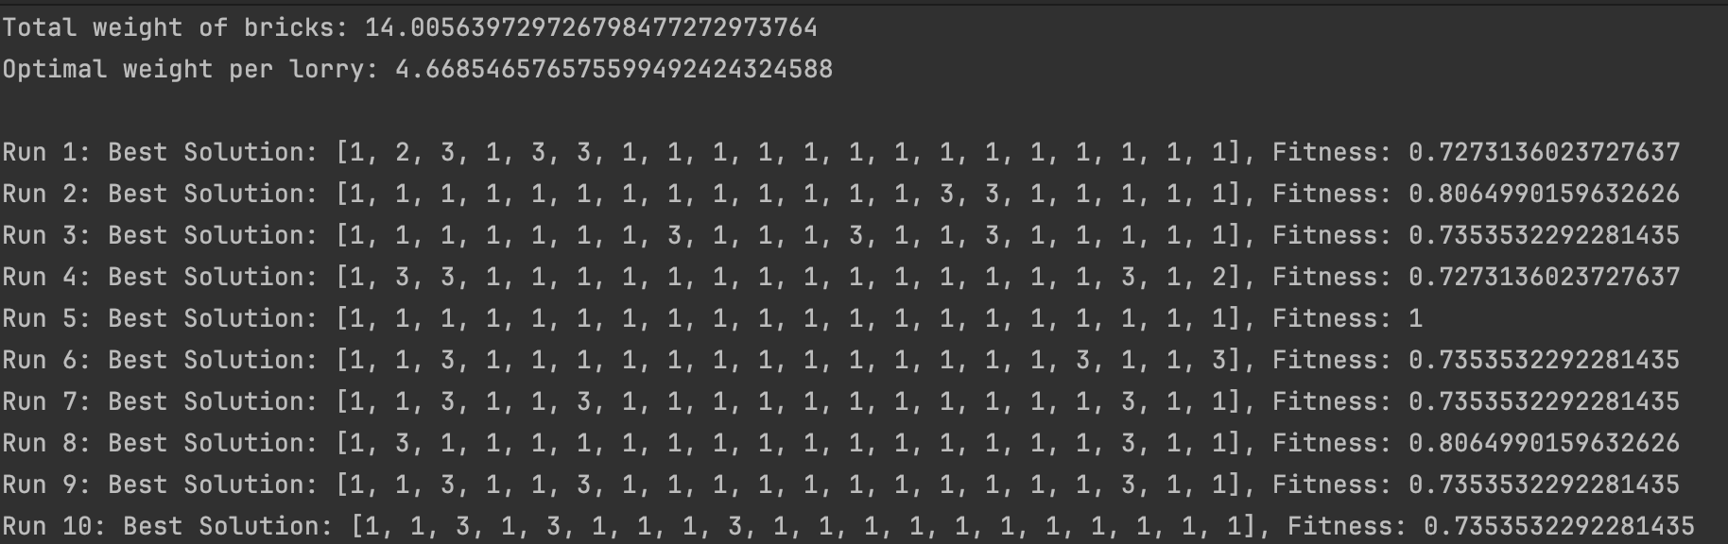

10000 total iterations

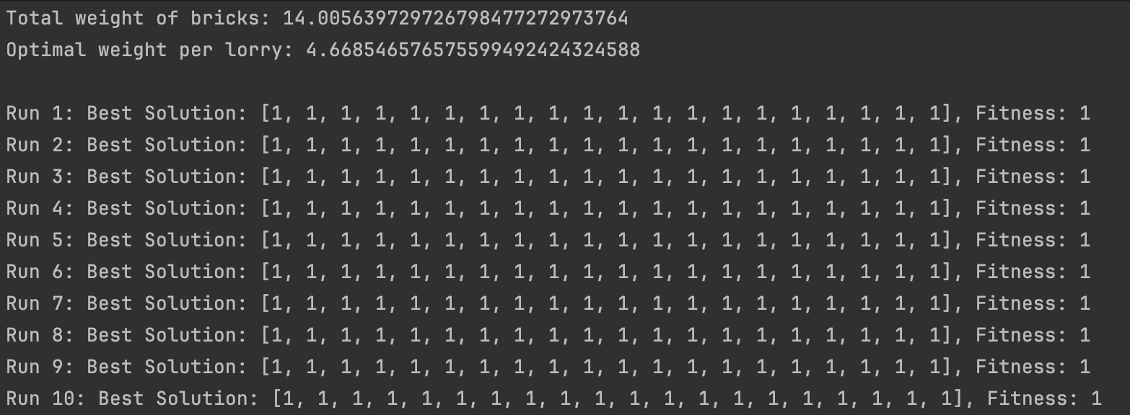

RandomNeighbourSwap – 10 restarts

100 total iterations

1000 total iterations

10000 total iterations

RandomNeighbourMultiple – 10 restarts

100 total iterations

1000 total iterations

10000 total iterations

RandomLorryReassignment– 10 restarts

100 total iterations

1000 total iterations

10000 total iterations

SwapFromEach– 10 restarts

100 total iterations

1000 total iterations

10000 total iterations

## 6.3 Testing

## 6.4 Software and its Presentation, including testing (and video link)

[Project 6 Video Recording](https://shu.cloud.panopto.eu/Panopto/Pages/Viewer.aspx?id=6fe5981e-31d2-4181-926c-b0f400f45a5c)

## 6.5 Incorporation of formative feedback

## References:

Wikipedia Contributors (2019a). *Bubble Sort*. [online] Wikipedia. https://en.wikipedia.org/wiki/Bubble_sort.

Wikipedia Contributors (2019). *Quicksort*. [online] Wikipedia. https://en.wikipedia.org/wiki/Quicksort [Accessed 13 Dec. 2023].

Jim_CS (2012). *Intuitive Explanation for Why QuickSort Is N Log n?* [online] Stack Overflow https://stackoverflow.com/a/10425578/15426928